FOCUS...

SAFE! Reconstructs  
Can Yoj/Do

It's SAFE! To Rem UntA

If You Have /Reservation!.

RepairT

**ICIAL INTERNATIONAL PUBLICATION OF THE ASSOCIATED LOCKSMITHS OF AMERICA, INC**

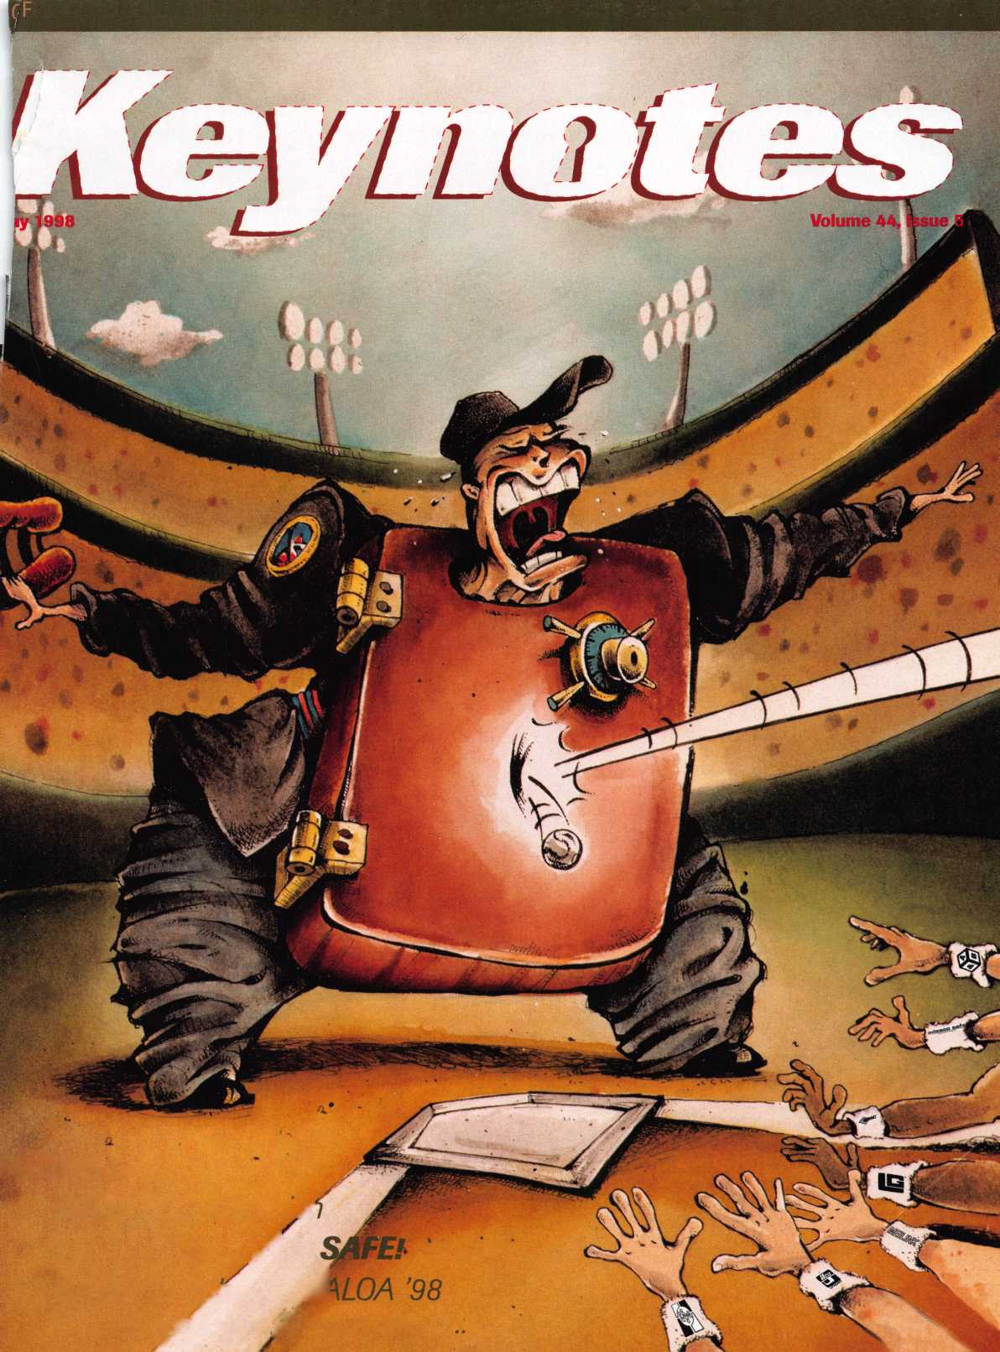

ALOA ’98 International Convention & Security Expo

*‘No one succeeds alone. The*

*input*, *tolerance and sharing*

*of knowledge from others in*

*this industry account for most*

*of my success. My part was to*

*learn—a lifetime process-*

Nashville Convention Center

Dan Graffeo, CRL, CMS  
ALOA Member #8188  
1996 recipient, ALOA Lifetime  
of Outstanding Achievement

Nashville, Tennessee

June 14-20,1998

*Associated Locksmiths of America 3003 Live Oak Street Dallas, Texas 75204*

*e-mail [convtion@anet-dfw.com](mailto:convtion@anet-dfw.com)*

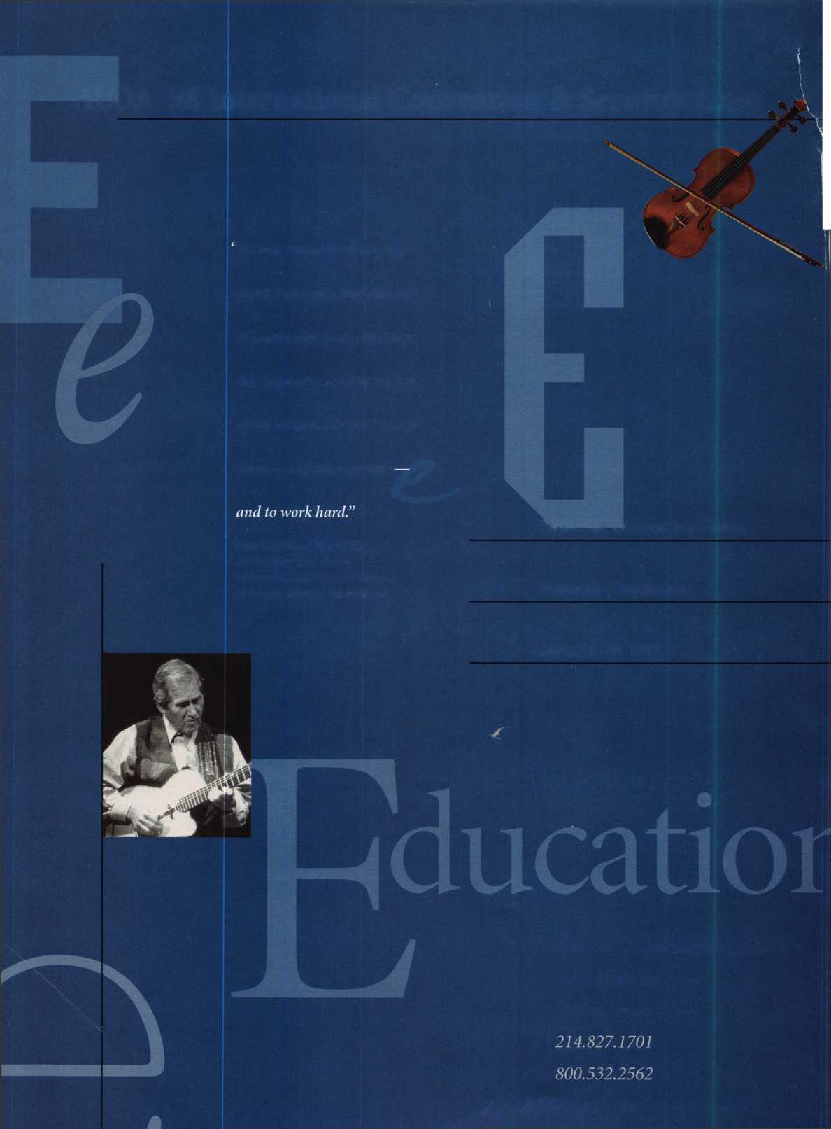

**ce & Exposition**

I Leo System ^ft^tStid-ALone Access Control Certification < Winfield Micro Key^^et'ronic Lock Certification • Electric Strikes Application ^rfimallatioiv^ JpllSihe Complete Door with Door Closers • rviciinum Storefront Doors • Studying For And Pai^wfg. The PRP • Nanotechnology Certification V Detex Hardware Certification •

ESA Certification Basic Electricity A|§ess Control •

**ISC**

**EXPO**

**Customer Service**

800-840-5602

203-840-5602

*Reader Severe till f*

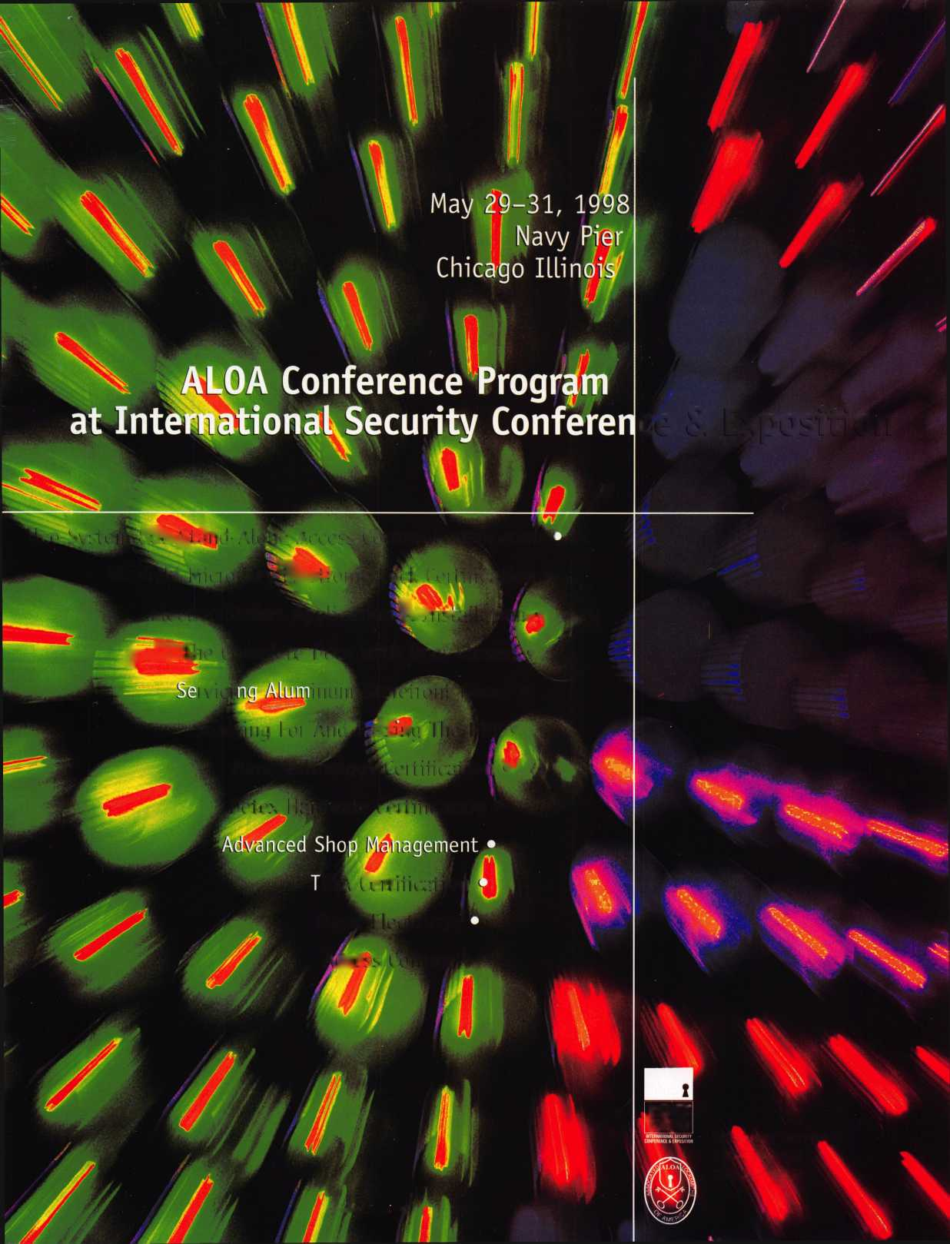

**Advertising**

48

Associate Members

52

Classifieds

55

Buyers’ Guide

58

Ad Index

Contents

**May**

Features

16

So You Can Do Safe Work Too? **cover topic**

Maybe you can and, then again, maybe you can’t. Can we talk about education?

By James Jefferies

May 1998

18

Single Bitted GM Keys

that it’s impossible to impression single-bitted

keys on a regular basis? This author says it ain’t so.

Steven Spiwak, CRL

0

Promoting Your Business

’re a good technician. Now learn how to promote your

technical excellence with advertising and marketing.

By Steven Spiwak, CRL

22

Reconstructive Surgery (for Safes), part 1 cover topic  
Burglars usually leave a safe damaged beyond recognition.

know, you sell replacement safes all the time. But are

you missing part of the picture?

By Daniel Graffeo, CRL, CMS

26

The Ethics of “Do Not Duplicate”

This is the first of a series of articles exploring various

in which many locksmiths engage, and the varied

opinions of how professionalism and/or ethics apply.

By Sal Dulcamara, CML

The Cover Hands down, a real safe professional knows how to call the play when it comes to safes, their intended uses, the best way to open them and the proper questions to ask when selling them.

Cover illustration © Artman Art direction/design Valerie Rowe

30

Locked in Space

Battling large reptiles and launching heroic explorers  
into outer space ... the next George Lucas movie? Nope.

Just a day in the life of Bill Nichols.

By Mike Emery

32

HPC’s in-A-Minute Auto Lock Decoder

This product could come in handy when trying to decode

directly from auto lock tumblers.

By Sal Dulcamara, CML

34

Sneak Peek ALOA *98

The latest bulletins from Nashville, the exhibitor list and trade show floor, and more than 40 product previews. Registered yet? Looks pretty good.

43

New ALOA Bylaws

Here’s the final version. Be ready to vote on June 20!

46

The Importance of Home Security

Crime is everywhere—from the smallest towns in the most remote rural areas to the most exclusive suburban developments! Help your customers fight back

By Steven Spiwak, CRL

4

President’s Journey

Take responsibility for your association

Vote on June 20.

9

Focus on Education

A few changes in the class line-up  
ALOA ’98

10

Legislative Comment

Scoring some major legislative victories

56

PRP Report

Follow up on your e-mails

ijgKIfflSSS

Upcoming Events

Mark June 14-20, Nashville.

8

Applicants for Membership  
Scheduled for clearance June 1

12

Industry News

BIG NEWS! ASSA ABLOY

acquiring Medeco

u

Security' Marketplace

57

Chapter Roster

58

ALOA Extra

60

Back Page

I Keynotes

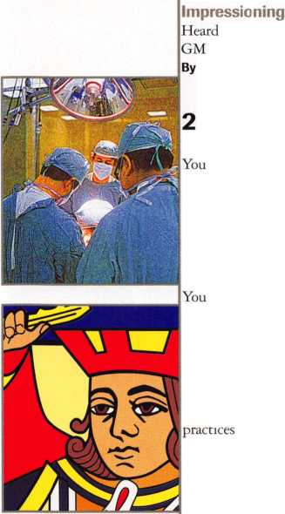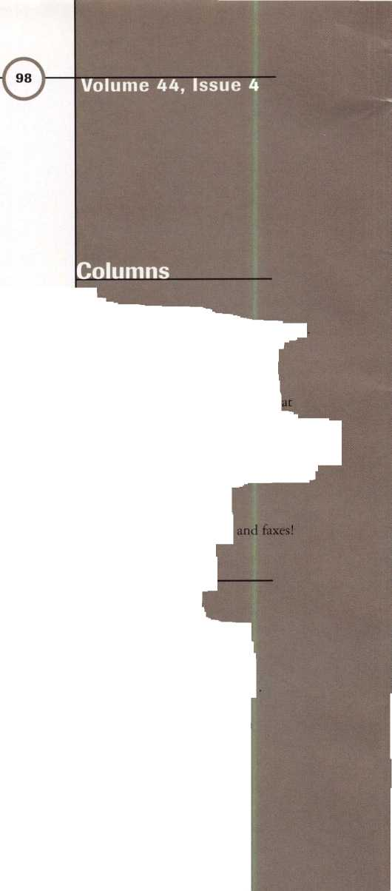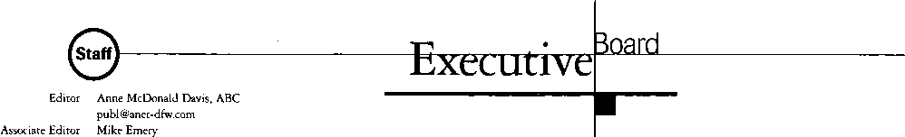

Technical Editor Editorial Advisor Advertising Sales Manager Contributing Authors

ALOA Professional Staff Executive Director

Office Manager

Receptionist Comptroller Financial Assistant Meetings Manager

Meetings Assistant Legislative Manager

PRP/Education Manager

Education Assistant

[publ@anet-dfw.com](mailto:publ@anet-dfw.com) David Lowell, CML, CMS david @aloa. ioffice.com John D. Cannon, CML [jdcannon@worldnet.att.net](mailto:jdcannon@worldnet.att.net) Anelia M. Banda [anelia@aloa.ioffice.com](mailto:anelia@aloa.ioffice.com) Jerome V. Andrews, CML Paul Chandler, CRL Claire Cohen, CML Brian Costley, CML, CMS Bob De Weese, CPL Ray D’Adamo, CML Sal Dulcamaro, CML James Glazier, CML Daniel Graffeo, CRL, CMS Wayne Gurnee, CRL A.J. Hoffman, CML Ken Holmlund, CRL Ray Lusk, CML Mark Ohno Randy Simpson, CML Steven Spiwak Robert Stafford, CPL Dave Thielen

Charles W. Gibson, Jr. [charlie@aloa.ioffice.com](mailto:charlie@aloa.ioffice.com) Mary May

[mary@aloa.ioffice.com](mailto:mary@aloa.ioffice.com) Margo E. Vela Kathy J. Romo Debra Bradshaw Jessica Vasquez [jessica@aloa.ioffice.com](mailto:jessica@aloa.ioffice.com) Janelle Vergara Tim McMullen [tim@aloa.ioffice.com](mailto:tim@aloa.ioffice.com) David Lowell, CML, CMS [david@aloa.ioffice.com](mailto:david@aloa.ioffice.com) Ashley Spenser

Additional contact information for the ALOA Board and most Keynotes authors are available through “Locksmith Search" on the ALOA website-[www.aloa.org](http://www.aloa.org) or by contacting the ALOA office at 3003 Live Oak Street; Dallas, TX 75204; (214)827-1701; FAX (214) 827-1810; e-rnaii [aloa@aloa.org](mailto:aloa@aloa.org).

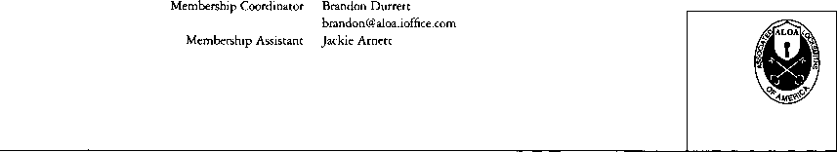

Mission Statement: The Associated Locksmiths of America. Inc. is dedicated to enhancing the professionalism, education and ethics among locksmiths and those in related sectors of the physical security industry. With approximately 10.000 members in the United States, Canada and the freeworld, ALOA is poised to help members obtain the knowledge, the strength, and the confidence to perform their role in the physical security field with pride and dignity. But it is only through active involvement and participation that ALOA can fully achieve its potential-and can help members to achieve theirs.

Policies: Keynotes® is the official publication of the Associated Locksmiths of America, Inc. (ALOA). Keynoted acts as a moderator without approving, disapproving, or guaranteeing the validity or accuracy of any data, claim, or opinion appearing under a byline or obtained or quoted from an acknowledged source. The opinions expressed by the authors do not necessarily reflect the official views of ALOA. Also, appearance of advertisements and new products or service information does not constitute an endorsement of products or services featured by the Association. The Association does not accept responsibility for the inaccuracy of any data, claim, or opinion appearing in this publication, due to typographical errors on the part of the authors, Association staff or its agents. Editor’s Note: This publication is designed to provide accurate and authoritative information in regard to the subject matter covered. It is provided and disseminated with the understanding that the publisher is not engaged in rendering legal or other professional services. If legal advice and other expert assistance is required, the services of a competent professional should be sought.

Authors’ Payment: Payment for eligible submissions to Keynotes will be based on the following criteria: topic, time spent and past contributions. Authors who regularly submit to Keynotes are generally paid a higher rate. The latter is especially true of authors who write to fit specific editorial needs and submit said copy by Keynotes deadlines. As a general guideline: Average payment for a 750 word, business or ‘light’ technical article would be $200. Payment for a 1500 word article involving significantly higher time and research efforts would be $400.

Payment will not be offered for articles submitted by ALOA employees or members of the ALOA Board of Directors (unless material is of a technical nature), nor for articles submitted by a company that promote that company’s products or services. ALOA reserves the right not to pay for articles submitted by an individuals) that promote a particular company’s products or services.

Disclaimer: The Associated Locksmiths of America, Inc., (ALOA), reserves the right to refuse any article for any reason. Additionally, ALOA reserves the right to edit, amend or modify any article submitted for publication in order to preserve technical accuracy, clarity, fairness or grammatical correctness. ALOA will make the best efforts to notify the author of any changes. The extent of ALOA’s liability for any article or information contained therein will be a notice of correction or retraction in the next possible issue.

Keynotes® (ISSN 0277 0792) is published monthly except for the combined June/July issue by The Associated Locksmiths of America, Inc., 3003 Live Oak St., Dallas, TX 75204-6186. Telephone: (214) 827-1701; FAX (214) 827-1810; e-mail [aloa@aloa.org](mailto:aloa@aloa.org). Subscription rates for members-$15.00 per year. Second class postage paid at Dallas, Texas. POSTMASTER: Send address changes to: Keynotes, 3003 Live Oak St., Dallas, TX 75204-6186. © Copyright 1998, All rights reserved. No part of the contents may be reproduced or reprinted in any form without prior written permission of the publisher.

President

Dallas C. Brooks (334) 826-8990

Regional Vice Presidents Southeast

•Jeffrey S. Nunberg, CML, CMS

(305) 324-8800

North Central

•John J. Greenan

(773) 486-2030

South Central

•Randy L. Simpson, CML

(713) 780-7026

Southwest

John I. Shandy, CML

(303) 776-7898

Northeast

James H. Glazier, CML

(301) 831-5454

Northwest

Raymond C. Lusk, CML

(509) 624-3152

Secretary

John D. Cannon, CML

(703) 960-6413

David M. Lowell, CML, CMS (214) 827-1701 Breck H. Camp, CML (770) 455-6244 Henry H. Printz, CML (201) 538-2737 Leonard J. Passarello, CPL (416) 752-7210 Edwin Toepfer, RL (416) 225-5589 Directors

*These officers also serve as directors.

Dana L. Barnum, CML (610) 565-9900 Mark E. Blum, CML, CPS (517) 482-5809 AJ. Hoffman, CML (714)572-6008 Barry K. Leas, CRL (610) 272-9292 Clyde Roberson, CML, CPS (540) 380-5000 Donald E. Rul6, CML (601) 324-2658

Anthony J. Ramunno, CML, CPS

(330) 782-6204

Robert H. Stafford, CPL

(860) 768-7917

Bruce J. Tarbet, CML

(601) 924-4184

Chairmen of International Affairs

Laurence P. Mills/Australia (129) 958-0445 Hans Mejlshede, CML/Europe FAX (453) 139-1004 **Members-at-Large** Jerome V. Andrews, CML (860) 621-3601 Steven G. Engel, CML, CPP (414) 731-5400

Past Presidents

1995-1997 David-Lowell, CML, CMS 1993-1995 Breck Camp, CML 1991-1993 Henry Printz, CML 1989-1991 Evelyn WersonicK CML 1987-1989 Leonard Passarello, CPL 1985-1987 Joe Jackman, CML 1983-1985 Stanley Haney, CPL 1981-1983 Louis LaGreco, CPL 1979-1981 John Kerr, RL 1977-1979 Clifford Cox, CML 1974-1977 Charles Hetherington 1972-1974 Gene Laughridge 1970-1972 William Dutcher, RL 1968-1970 Constant Maffrey, RL 1966-1968 Harold Edelstein, RL 1964-1966 William Meacham 1962-1964 Robert Rackliffe, CPL 1960-1962 Edwin Toepfer, RL 1956-1960 Ernest Johannesen

**May 1998**

Keynotes ***1A***

President’s Journey

_

’98 Membership Meeting - A Milestone for ALOA

By the time you get this issue of Keynotes in your hands, it will be only six weeks from the main event of the year-the ALOA ’98 Security Expo. If you have not already registered and made your plans to attend, maybe it is not too late to pack up and head to Nashville. Come on, it is fun to take a trip on the spur of the moment!

I truly believe this will prove to be one of the most important convention weeks in the history of our association. I hope you will be one of those who can look back in a few years and say, “Yes, I was there. I attended the MEMBERSHIP MEETING in 1998 and I voted YES to giving every member a way to participate in the governance of THEIR association.

I voted YES to a Mail-In Proxy Ballot. I voted YES to changes in our association that allowed it to grow, prosper and to better serve our needs.”

I would especially like to get a message across to the few thousand ALOA members who will be in Nashville the week of June l4-20th and would NORMALLY not attend the Membership Meeting. I would like to say to you, please do not use the excuses used in the past for not attending like ...“The meeting will be too long,” “I do not like the politics,” “It will not matter if I go or not,” “The out come will not affect me,” “I would rather sleep late,” etc...

We could all find an excuse and, in the past, based on our shameful attendance at meetings, most have.

Really, when we have three or four thousand members at a convention and we have less than a quorum (250) show up at the membership meeting, you know something is wrong. So What Do YOU Do? Not go? Not participate? NO, you should make a SPECIAL EFFORT to show up and find a solution to the problem! When you make the decision not to attend you become part of the problem, not part of the solution to it!

OK, I apologize for preaching to you, but I can not help myself. For those of you who really know me, you know how passionate I am about OUR association. I am passionate about making all of our members feel like they OWN the association. It does not belong just to the few members who attend the annual meetings. Or maybe it does! That question will be answered at the Membership Meeting in Nashville, WILL YOU BE THERE?

I sincerely hope that you will.

*MLc&JL*



|  |  |
| --- | --- |
| Kwok-kei Leung | 161 |
| Henry Raymond | 93 |
| Toshihiro Asano | 72 |
| Stewart Levine, CML | 67 |
| Mary Ohmit, CPL | 63 |
| Charles Robertson. CML | 49 |
| Yuriko Yanai | 49 |
| Allen Konrath | 49 |
| Jack Hobin, CPL | 48 |
| Salvatore Dulcamaro, CML | 36 |
| Myeong-Rae Cho | 36 |
| William Neff, CML | 35 |
| Thomas Freehling. CML | 32 |
| David Lowell, CML | 28 |
| John Heckman. CML | 27 |
| Jeanne Lodge. CML | 27 |
| Roy Renderer, CML | 25 |
| Danny Rudd. CPL | 23 |
| James Watt. CML | 23 |
| Robert Carroll, CPL | 23 |
| David M A Federico | 23 " |
| John Elliott, CML | 22 |
| Diana Barnum, CRL | 22 |
| Barbara Watt | 22 |
| J Thomas Hood. CML | 22 |
| Robert DeWeese, CPL | 22 |
| Jim Williams | 22 |
| Larry Warnick, CML | 21 |
| Jerome Cohen, CML | 21 |
| Eugene Altobella | 21 |
| D Michael Lee, CPL | 18 |
| James Fowler, CML | 18 |
| David Harris, CML | 18 |
| Elvis Hammerschmidt, CPL | 18 |
| John Kerr. RL | 17 |
| Marian Swann, CRL | 17 |
| John Dorsey, CPL | 17 |
| Charles Cole. CML | 17 |
| Ronald Heidzig | 17 |
| Joseph Ferrero, CML | 16 |
| William Grant, CRL | 16 |
| Brian Reetz | 16 |
| Walter Lascar, RL | 15 |
| Thomas Vandersteen, CML | 15 |
| James Cawby, CML | 15 |
| Gary Teams. CPL | 15 |
| William McElheney, CML | 15 |
| Michael Robinson, CRL | 15 |
| Rex Parmelee, RL | 14 |
| Philip Rovenolt, CPL | 14 |
| Edwin W Scott | 13 |
| James Gruber, CRL | 13 |
| Peter Gauthier, CPL | 13 |
| Russell Fuller, CRL | 13 |
| Robert Rodocker, CRL | 12 |
| Frank Hartung. CML | 12 |
| Rolando Bouza | 12 |
| Robert Duman, CML | 12 |
| Lonnie McKinney, CML | 12 |
| James Brickler, CRL | 12 |
| Richard Sievers | 12 |
| Eric Veal | 12 |
| Herbert Dusenberry, CML | 11 |
| Jon Griswold, CML | 11 |
| Robin Horsley | 11 |
| John Engel. CRL | 11 |
| Daniel Landry | 11 |
| Thomas Demont, CML | 10 |
| Ernest Wright | 10 |
| William Wickward, CML | 10 |
| Lester Brodsky | 10 |
| Joseph Whitaker, CPL | 10 |
| Dale Knowles, CPL | 10 |
| Paul Souber | 10 |
| Donald Shiles | 10 |

The Brightest

And The Best

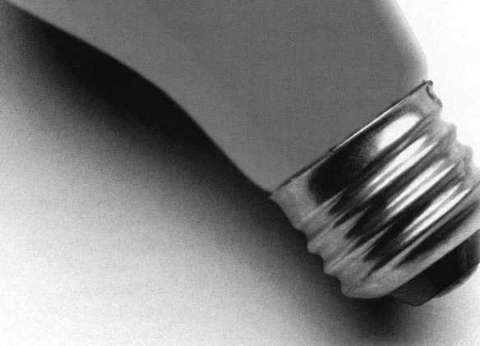

How can I join the President's Club?

You can earn membership in this prestigious club by recruiting just 10 new members for ALOA.

*Any ALOA member may participate.

What do I get?

When you recruit 10 members, you receive a handsome blue blazer with a President's Club crest. For each additional five members you recruit, you receive a lapel pin with gold-filled numbers, indicating your recruiting successes.

You also get the satisfaction of knowing that you are helping your association, helping your industry grow, and you are helping fellow locksmiths achieve success.

How do I get started?

Contact the ALOA office for a supply of applications (214) 827-1701 or FAX (214) 827-1810. One President's Club credit is awarded for each new applicant. Credit is awarded only after the membership application is approved. However, the credit will apply for the period in which the application is received. Failure to identify yourself as the sponsor on the application form at the time it is submitted to ALOA for processing will forfeit any credit.

*AL0A Board of Directors not eligible for membership in the President's Club.

**Upcoming**

Events



Dept

/" Future Conventions

1998

ALOA ’98 June 14-20 Nashville, Tenn.

SAFETECH ’98 May 18-23 Valley Forge, Pa.

1999

ALOA ’99 July 23-31 Cincinnati, Ohio

SAFETECH ’99 May 3—8 Las Vegas, Nev.

MLANJ 1999 March 18-21 Somerset, NJ

2000

ALOA 2000 Date TBA Las Vegas, Nev.

SAFETECH 2000 May 5-6

Birmingham, Ala.

MLANJ 2000 March 5-9 Somerset, NJ

2001

ALOA 2001 July 15-21 Baltimore, Md.

MLANJ 2001 March 5-9 Somerset, NJ

2002

ALOA 2002 July 21-27 Rosemont, 111.

J

MAY’98

**7-10**

Clark Security Products D.C. Trade Show Contact: Terri Burges (800) 854-2088, ext. 273

17

MBA

Time Locks Nicholasville, Ky.

(888) 622-5495

18-23

SAFETECH ’98 Valley Forge, Pa.

(214) 827-SAFE (7233)

(214) 827-1810 fax

e-mail: [convtion@anet-dfw.com](mailto:convtion@anet-dfw.com)

27-31

National Independent Bank Equipment & Systems Assoc. Annual Convention Montreal, CANADA (800) 843-6082

1. 31 New Event

**ALOA ACE Classes at ISC Central Expo** llco System 800 Stand-Alone Access Control Certification Winfield Micro Key Electronic Lock Certification

Electric Striked Application and Installation The Complete Door with Door Closers Servicing Aluminum Storefront Doors Studying for and passing the PRP

Nanotechnology Certification Detex Hardware Certification Advanced Shop Management TESA Certification Basis Electricity Access Control **Chicago, 111.**

(800) 840-5602 (203) 840-5602

JUNE’98

14-20

**ALOA ’98 Security Expo** 59 full-day class sessions 34 half-day class sessions Six evening seminars Exhibits from leading security products/systems manufacturers and distributors City tours Annual banquet ALOA Membership Meeting **Nashville, Tenn.**

(800) 532-2562

(214) 827-1810 fax

e-mail: [convtion@anet-dfw.com](mailto:convtion@anet-dfw.com)

20

ALOA Annual Membership Meeting (breakfast)

NEW BYLAWS VOTE 6:30 am breakfast 8-11 am meeting Renaissance Hotel Nashville, Tenn.

(800) 532-2562

(214) 827-1810 fax

e-mail: [convtion@anet-dfw.com](mailto:convtion@anet-dfw.com)

25-28

National Burglar and Fire Alarm Association Annual Meeting San Antonio, Texas (301) 907-3202

JULY ’98

17-19

S. C. Association Meeting Columbia, S.C.

(803) 735-1600

22-25

Institutional Locksmiths Association Annual Education Symposium and Conference New Haven, CT (202) 645-6238 (202) 645-6530 fax

23-25

South Carolina Locksmiths Association Quarterly Meeting Columbia, S.C.

Contact: Jean Griggs (803) 532-9008

25-26

California Locksmith Association Anaheim, Calif.

Contact: Kimber Smith (714) 632-6800

1. August 2

Clark Security Products Chicago Trade Show Contact: Terri Burges (800) 854-2088, ext. 273

AUGUST ’98

6-9

New Mexico Locksmith Association Las Cruces, N.M. (505)247-9413

13-16

SAVTA Fall Board Meeting Las Vegas, Nev.

(214) 827-SAFE (7233)

(214) 827-1810 fax

19-23

SERLAC Trade Show Orlando, Fla.

Contact: Bill Norris (850)433-5118

SEPTEMBER ’98

1-3

New Event

ALOA ACE Classes at ISC New York New York, N.Y.

Contact: (203) 840-5602 (800) 840-5602

1-13

The Association of Ontario Locksmiths Scarborough, Ontario (888) 272-8265

Keynotes

**May 1998**

|  |  |
| --- | --- |
|  | Upcoming |
|  | Events |

10-13

Greater Philadelphia Locksmith Association GPLA Annual Convention Philadelphia, Pa.

Contact: John C. Magee III (609) 845-3434 (609) 845-3024

14-17

ASIS

44th Annual Seminar and Exhibits Dallas, Texas (703)519-6200 (703) 519-6299 fax

17-20

Clark Security Products Southern California Trade Show Contact: Terri Burges (800) 854-2088, ext. 273

23-26

Lou-Miss Locksmith Association Alabama

Contact: Thomas L. Hunt (205)833-3333; (205)836-3333

OCTOBER ’98

1-4

POLA Trade Show ’98 Penn Ohio-Locksmiths’ Association, Inc.

Independence, Ohio (Cleveland area)

Contact: Martha Eggler (216) 676-8464

Fax (216) 267-2411 e-mail: [PAL01l6@aol.com](mailto:PAL01l6@aol.com)

10

Lock Museum of America 26th Annual Lock Collectors Show Contact: Geri S tut tig (203) 869-6260

17-19

S. C. Association Meeting Columbia, S.C. (803)735-1600

19-25

25 th Tri-Regional Locksmith Conference Portland, Ore.

Contact: Stan Hauer (503) 325-6003 phone/fax

21-25

Yankee Convention Providence, R.I.

Contact: Rob Mahoney (800) 209-8266

1. Nov. 2

Door & Hardware Institute Orlando, Fla.

(703) 222-2010

For PRP dates, see p. 56. For ACE dates, see p.9. Send in the dates of your organization’s activities today!

"Mas Hamilton locks, parts and accessories... the professional's choice when only

the best will do!"

Model

Introductory Price: $119.95

FEATURES

/Master code  
/ Audit-trail  
/Requires no batteries

/Five user codes / Time-delay / Self-powered

ASTER

127 SE 29th Street ♦ Topeka KS 66605 888 798 8464 ♦ Fax 800 798 TIME (8463) 785 232 8705 ♦ Fax 785 232 2603

May 1998

Keynotes



Reader Service #2

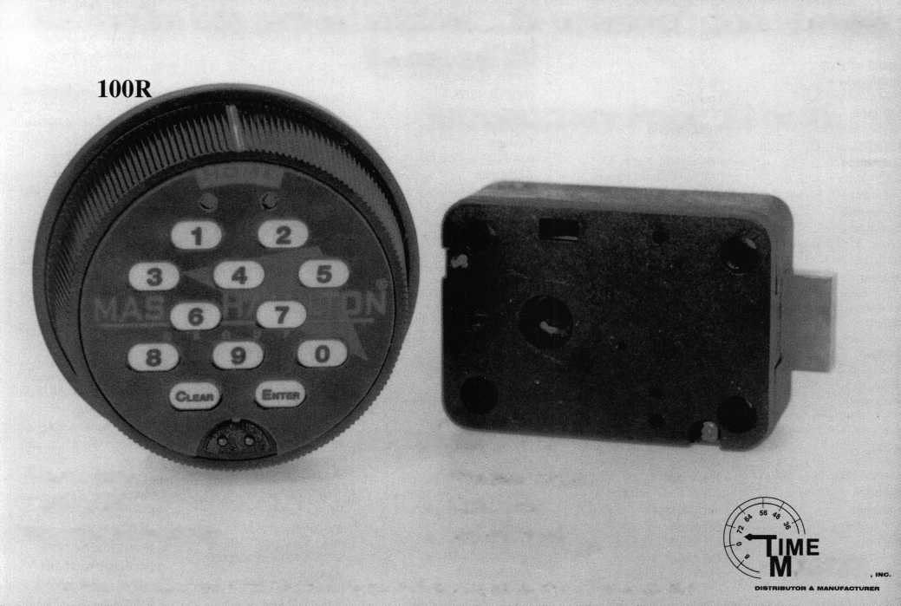

Applicants

For Membership

Dept

***The following applicants are scheduled for clearance as members of  
ALOA. The names are published for member review and comment prior to  
June t, 1998, to ensure applicants meet standards ofALOA’s Code of Ethics.  
Protests, if any, should be addressed to the Membership Department and  
must be signed. Active Membership applicants (A) have worked in the  
industry two or more years. Allied Membership (AL) applicants are not  
locksmiths, but work in a security-related field. Apprentice Membership  
(APJ applicants have worked in the industry less than two years. A***

|  |  |
| --- | --- |
| ALABAMA | 027966, Jennifer L Peterson, AP |
| Duthan | SPONSOR: Charles Byars |
| 027957, Amanda S Floyd, AP | Cedar Falls |
| SPONSOR: James Turner | 027936, Lee G Parker, AP |
| Selma | SPONSOR: Myron Piehl |
| 028014, Russell Alsbrook, AP | Des Moines |
| 028013, Tom Seroogy, AP | 028022, Andy Gay, AP |
| ARKANSAS | Ottumwa |
| Fayetteville | 028050, Stephen S Fears, A |
| 027921, Duane C Allen, A | SPONSOR: Luke Pieper |
| CALIFORNIA | ILLINOIS |
| Chatsworth | Aurora |
| 028028, Jerry Levine, A | 028032, Ken Erickson, A |
| Culver City | Beardstown |
| 027928, Robert G Hernandez, A | 027986, Wayne F Dyer, A |
| Los Angeles | SPONSOR: Michael Webb |
| 027925, Chae H Kim, A | Chicago |
| Paramount | 027997, Alredo B Aguilera, A |
| 028011, Chuck Basso, A | 027978, Amado Avila, A |
| 028012, Gary Cromer, A | 028029, Dave Crost, A |
| 028010, Earl Halls, A | Elmhurst |
| San Diego | 028030, Robert Kroplewski, A |
| 027952, Lawson B Cothron, A | Plano |
| SPONSOR: Olen Cothron | 027974, Doris J Wade, A |
| San Dimas | SPONSOR: Steven Wade |
| 028057, Chris M Dilley, A | INDIANA |
| COLORADO | Anderson |
| Greeley | 028060, Jeff L Garretson, AP |
| 027964, David L Roberts, AP | Nappanee |
| SPONSOR: Raymond D'Adamo | 028053, Bobby Prater, AP |
| Longmont | SPONSOR: Steven Youngblood |
| 028058, Michael Matava, AP | Taylorsville |
| SPONSOR: Wayne Overdier | 027962, Marvin A Brodfuehrer, A |
| CONNECTICUT | SPONSOR: Kenneth Hammack |
| Southington | KENTUCKY |
| 028000, Tom Divito, AP | Louisville |
| Willington | 027960, David P Foppiano, AP |
| 027938, John P Luman, A | Nicholasville |
| DISTRICT OF COLUMBIA | 028036, Albert Alsina, AP |
| Washington | 028035, Gary Kepler, AP |
| 027929, John T Cornell, A | 028034, Thomas J Leppert, AP |
| 027930, Louie C Dunigan, A | 028033, Jerry Morgan, AP |
| DELAWARE | MASSACHUSETTS |
| Wilmington | Boston |
| 028049, Carl D Addison, A | 027922, Donald B Howerton, AL |
| FLORIDA | SPONSOR: Jack Hobin |
| Brandon | Brookline |
| 027916, Fonda B Gaffy, A | 028038, Sidney Schwartz, AL |
| SPONSOR: Richard Barnhardt | Newton |
| Haileah | 028039, Marc Schwartz, AL |
| 027956, Mario Rodriguez, AP | 028037, Jeff Shwartz, AL |
| N Maimi | MARYLAND |
| 028026, Rick Mulcohy, AP | Baltimore |
| 028027, Mark Weaverling, AP | 027995, Timothy A Bouis, A |
| Tallahassee | SPONSOR: Michael Jordan |
| 027919, William W Andrews, A | 027981, James K Stagg, AP |
| SPONSOR: Samuel Francis | Rockville |
| Tampa | 027926, John A Oscanyan, AP |
| 024697, Ken Kupferman, A | SPONSOR: Richard Thornley |
| SPONSOR: Ken Kupferman | Thurmont |
| GEORGIA | 027965, Craig E Mayne, A |
| Armuchee | MICHIGAN |
| 027958, George C Brothers, AP | Brighton |
| Clayton | 027983, David E Burger, A |
| 028056, Paul S Crowder, AP | Dexter |
| Duluth | 028020, Fred Fischbach, A |
| 027991, Alan B Clay, A | 028019, Carl Maymard, A |
| SPONSOR: A1 Morris | 028018, Ken Tyler, A |
| IOWA | Royal Oak |
| Burlington | 027954, Gerald Campagna, A |
| Keynotes | May 1998 |

SPONSOR: Michael Cutler

MINNESOTA

Austin

028046, Bruce W Lees, A

Maple Grove

028021, Richard Wichmann, A

MISSOURI

Bronson

027932, Jeanne B Hendricks, A SPONSOR: Dennis Hendricks Kansas City 028024, Tim Compton, A 028023, George Doetzl, A 028025, Charles Doile, A St Louis

028031, Rob Schaffer, A

MISSISSIPPI

Tupelo

028048, James T Sonwineski, A SPONSOR: Sam Carter

NORTH CAROLINA Charlotte

027941, Teddy S Poulos, A

Greensboro

027940, Richard R Butcher, A SPONSOR: Keith Lewis

NORTH DAKOTA Grand Forks

027968, David T Noye, AP 027967, Noel L Schanilec, AP

NEBRASKA

Omaha

028003, Steve Thilliander, AP 028004, Howard Westerberg, AP

NEW JERSEY Fort Lee

027931, Pedro L Vaigasi, A

Newark

028015, Philip Haselton, A

Secaucus

028009, Rich Chakov, A 028008, Eric Hagee, A

Union

028007, Robin Cherkes, A 028005, Stan Gabay, A 028006, Daniel Goldstein, A

NEVADA

Reno

028017, Ernie Kaufman, A

NEW YORK New Rochelle

027943, Luigi M Camia, A

New Suffolk

027944, James G Nakerman, A

Rochester

027989, Steven M Trumbull, A 027990, Dan A Vandesande, A

OHIO

Columbus

027979, Craig E Wadding, A SPONSOR: Timothy Moore

Warren

027982, Edward J Danko, A SPONSOR: Ed Danko

OKLAHOMA

Mustang

028042, Bill Dillard, A 028041, David Myers, A 028040, Jean Shuford, A

028043, Beverly Swisher, A

PENNSYLVANIA

Easton

027924, Tony Catalano, A

Horsham

027999, James C Handschuh, A SPONSOR: Joe Lee

Media

027987, Stephen R Miller, A

North Wales

028059, Terence S Haas, A SPONSOR: James Bell SOUTH CAROLINA

Newberry

027970, Edward G Mills, A SPONSOR: Patrick Sullivan

TENNESSEE

Cookeville

027972, Brian R Williams, A

Knox

027950, Frank A Brymer, A SPONSOR: Gary Teams

Knoxville

027951, Harlan S Kinkead, A SPONSOR: Gary Teams

LaVergne

027959, Samuel O Miller, A

Nashville

027994, Rick B Elmore, A

TEXAS

Austin

028054, James L Hancock, A SPONSOR: Jearl Hancock 028055, John D Ray, AP SPONSOR: Olen Cothron

Dallas

027920, Robert A Clendening, A SPONSOR: Jack Kilgore 028002, Reid Hill, A

Flint

027984, Anthony B Scott, AP

Huntsville

027980, Michael W Flanagin, A

New Braunfels

028016, Greg Drake, A

Richardson

027996, Mike R Herrman, AP

Snyder

027933, Pete N Wadleigh, A

VIRGINIA

Alexandria

027915, Ronald Spiller, AL

Arlington

027988, John S Conrad, AP SPONSOR: Charles Robertson

Virginia Beach

027993, Gregory A Demont, AP SPONSOR: Thomas Demont

WASHINGTON Mercer Island

028001, Fred D Martino, AP

WISCONSIN

Madison

027918, James P Feuling, A SPONSOR: Jeffrey Beckmann

Waupaca

027942, Edward C Hokens, A SPONSOR: Roger Coenen

Wis Dells

027923, Chuck S Hegel, A

WEST VIRGINIA Webster Springs

027961, Brian R Brake, AP SPONSOR: Donald Shiles

CANADA

NEWFOUNDLAND Happy Valley

027985, Michael E Kearney, AP

ONTARIO

Hamilton

027955, Kyle A Stubbins, A

Orillia

027939, Gary A Beard, A

Toronto

028047, Lome R Davis, AP

HONG KONG Happy Valley

027973, Chi-Yin Lam, AP SPONSOR: Kwok-kei Leung

JAPAN

Asaka-City, Saitama

027949, Toshio Hosoda, A SPONSOR: Toshihiro Asano

Fukuoka City

028052, Noboru Takada, A SPONSOR: Yuriko Yanai

Gifu City, Gifu

027934, Makito Yamamoto, A SPONSOR: Yuriko Yanai

Itabashi-Ku, Tokyo

027946, Mitsutoshi Kikuchi, A SPONSOR: Toshihiro Asano

Kobe

027935, Takeshi Yoshimura, A SPONSOR: Yuriko Yanai

Kodaira-shi, Tokyo

027971, Yuuji Sagawa, A SPONSOR: Keizo Takahashi

Machi Shibuya City

028051, Inaba Chinaru, A SPONSOR: Keizo Takahashi

Musashino-City Tokyo

027947, Masao Sasaki, A SPONSOR: Toshihiro Asano

Onomichi, Hiroshima

027927, Yoshiyuki Fujita, A SPONSOR: Koichi Fujii

Ota-Ku, Tokyo

027937, Tanaka Yoshiyuki, A SPONSOR: Yoshizawa Makoto

Shiga-Ken

027948, Naiki Naosuke, A SPONSOR: Toshihiro Asano

Tokyo

027992, Kinji Ichinose, A

Yokohama, Kanagawa

027969, Tokuno Shigeru, A SPONSOR: Keizo Takahashi

UNITED KINGDOM Basingstoke, Hants

027945, Tsui Yung-, A

Swansea

027963, Keith K Cole, A

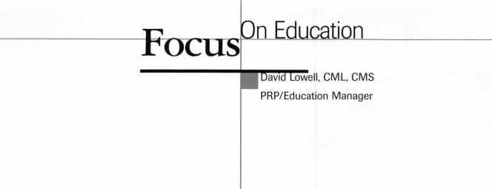

As baseball season begins, I’m somewhat forced to root for my new home team, the American League’s Texas Rangers (lest I feel the wrath of the staff here in the Dallas headquarters). Truth be told, however, my heart is with my old home’s new expansion unit, the Arizona Diamondbacks of the National League.

Despite their relatively slow start, I can look forward to my beloved ’Backs rolling into the Dallas area a few times before the end of the season. And to think that some people actually tried to veto interleague play!

But before I completely digress from the subject at hand and start making some predictions for the playoffs (Can you say “Diamondbacks World Series Champs ’98”?), it’s time to talk turkey, or should I say education? As always, there’s activity on the education front (much like in the ’Backs’ bullpen) and I’ll get right to it.

First off, there have been some slight modifications with the ALOA ’98 class lineup. The Allstate Insurance seminar has unfortunately been canceled. In its place, however, is a most competent replacement seminar entitled “Labor Saving Devices,” something everyone can certainly use if not learn more about. This will be a three-hour seminar that gives various tips on wiring techniques, access control installation techniques and other assorted helpful hints.

As far as PRP goes, we are currently working to modify six categories that have been outdated within the past few years. For example, Life Safety Codes will be revised as it was written in 1992 and there have been significant changes since then. Likewise, categories in automotive, alarms and mechanical access control will be adjusted as well.

For those of you who happen to be in the Dallas area, stop by and take your PRP tests here at the International Headquarters. Not only will it give me and my education assistant, Ashley Spenser, an opportunity to meet you, but you’ll receive a discount on the testing fee. In addition you can even take a tour of our own Lock Museum and see the friendly staff of Keynotes. How’s that for a bonus?

In other goings on, many large lock shops will be pleased to note that the ALOA Apprentice Program (as developed by the Department of Labor) has also been updated. This will help in providing financial and

structural assistance for lockshops to train locksmiths and outline necessary curriculum.

More than likely, if a lock shop is of a large enough size, this should assist in structuring the training so nothing is left out and the staff becomes prepared for certain cases, as opposed to learning while on-the-job.

To perhaps give you a better idea of what this program is designed for, the following outlines the purpose.

1. To encourage careful selection of persons entering the trade with due regard to health, physical fitness, aptitude, attitude and physical characteristics.
2. To provide an approved plan of training that will equip such persons for profitable employment.
3. To relate the future supply of skilled workers to probable employment demands.
4. To assure that the employer may obtain the services of proficient workers.
5. To provide the public with the highest possible grade of products and services in conformity with approved practices of safety and skilled craftsmanship.

If you’d like some documentation or more details on how this program can be applicable for your shop, just call me or Ashley here at the Dallas office.

Well, that should be it for this month. Don’t forget to sign up for your respective classes before convention to assure you a spot in the classroom and most importantly, don’t forget to register and/or attend what should be the best ALOA Convention yet.

Until next time, Go Diamondbacks...oh,

I mean Yay Rangers!



About the Manager: David Lowell,

CML, CMS, is ALOA’s immediate past president  
and an ALOA Trustee. David has served on the

ALOA board for 10 years. He owns and operates Phoenix Lock & Key in Arizona, and has been an ALOA member since 1981.



Upcoming ACE Classes

Gateway Locksmith Association

May 17 St. Louis, Mo.

Contact: James R. Arnold Tricks of the Trade

ISC Central

ALOA

May 29-31

Navy Pier, Chicago, 111.

ISC Central

Contact: David Lowell, CML, CMS (214) 827-1701; (214) 827-1810 fax

ALOA ’98 Security Expo

June 14-20 Nashville, Tenn.

Contact: David Lowell, CML, CMS (214) 827-1701; (214) 827-1810 fax 59 full-day classes; 34 half-day classes; Six evening seminars

New Mexico Chapter-ALOA

August 7-8

Las Cruces, New Mexico

Contact: Stephen W. Smith

(505) 281-8777; (505) 292-7993 fax

Basic Locksmithing

Tricks of the Trade

Shop Management and Pricing

Exit Devices

Servicing Aluminum Storefront Doors Door Closers

S&G Group 2 Certification Electronic Safe Lock Servicing

ISC East

ALOA

August 31-September 2

New York, NY

Contact: David Lowell

(214) 827-1701; (214) 827-1810 fax

Lou-Miss. Locksmith Association

September 23-26 Alabama

Contact: Thomas L. Hunt (205) 833-3333; (205) 836-3333 Nine classes TBA

MINK

October 15-18 Omaha, Neb.

Contact: Elmer Howard (420) 330-4758; (420) 330-8701 fax Basic Electricity Access Control

Servicing Aluminum Storefront Doors

PRP



May 1998

Keynotes

Legislative

omment

im McMullen-Legislative Manager

Win! Win! Win!

“Winning isn’t everything, but the will to win is everything.”

- Vince Lombardi

ALOA is taking charge this year, scoring major legislative victories for our members! To date, 11 states have introduced over 15 bills that in some way affect the mechanical and electronic locksmithing industry. Three of those bills were VERY detrimental to locksmiths by requiring unnecessary alarm training beyond the scope of locksmithing. But through hard work with local members, ALOA was able to protect locksmith’s interests and derailed these bills.

In Maryland, Senate Bill 61 was introduced by the state police department. It would have required locksmiths who install, repair or service dead-bolts, locks and other mechanical systems to be placed under the new security systems technicians regulations, which speak more to electronic security rather than mechanical systems. ALOA worked closely with the Maryland Locksmith Association (MLA), the Locksmith Association of Washington, DC (LADC) and members of the ALOA Legislative Action Network (LAN) on defeating this bill. We tried to convince the Maryland legislature that locksmiths should have been consulted from the beginning. Victory was ours, and the bill died in committee!

In Arizona, House Bill 2433 was introduced by the Arizona Burglar and Fire Alarm Association (AZBFAA). The way the bill was worded, it would have required locksmiths who do access control work to have an alarm license. ALOA, its Grand Canyon Chapter and the Professional Association of Locksmiths of Arizona (PALS) all worked closely with the AZBFAA to have locksmiths exempted from this law.

However, as safety insurance, ALOA sent a letter to all members in Arizona asking them to contact their representative to oppose the bill. There must have been a lot of letters sent and phone calls made, because the bill died

**10**1 **KeynotesMay 1998**

on the House floor. Again, victory was ours!

In Missouri, House Bill 1720 was introduced by the Missouri Burglar and Fire Alarm Association (MBFAA). As with Arizona, this bill would have required locksmiths who do access control work to have an alarm license. ALOA, LAN members and the Missouri-Kansas Locksmith Association were able to slow down this detrimental legislation and, in fact, the bill died in committee. We’ll take a victory any way we can!

In Tennessee there’s been a flurry of legislative activity. ALOA is working closely with LAN members, the Tennessee Organi­zation of Locksmiths (TOOLS) and the ALOA Smokey Mountain Chapter on legislation that would greatly benefit locksmiths installing access control systems. If we can succeed, this would be a GREAT victory for our members!

As you can see, ALOA’s out front, going to bat for its members at every turn. But we’re also behind the scenes working for our member’s benefit in other security-related organizations as well. As noted in previous Keynotes (see March 1998), ALOA spearheaded the formation of the Electronic and Physical Security Coalition (EPSIC) to iron out problems with model legislation proposed by the National Burglar and Fire Alarm Association (NBFAA). The coalition was also formed to bring everyone in the security industry to the legislative table.

The first meeting of EPSIC was held on Monday, March 23, 1998. Industry associ­ations represented were NBFAA, Consumer Electronic Manufacturers Association, Canadian Alarm Security Association, Central Station Alarm Association, Custom Electronic Design and Installation Association, Door and Hardware Institute, Electronic Industries Association, Home Automation Association, National Systems Contractors Association and the Security Industry Association (SLA). All of these organizations play a major role in the

security industry as a whole. As the leader in access control installation, it was important that ALOA organize these groups to sit down and discuss the future of industry legislation. In fact, the coalition agreed that whatever legislation others introduced, it should not “step on each other’s toes.”

General discussion centered on the types of issues important to all groups: fire and life safety; background checks; insurance; basic level of skill; ability to do your job without unnecessary training requirements. The group will meet again in June to discuss standard definitions and skill sets for model legislation.

ALOA was active at this year’s ISC West show as well. Our mission was to garner key endorsements for ALOA’s Industry Position Paper (see Keynotes February 1998). One key endorsement sought was from SIA’s Access Control Interest Group. ALOA associate member, Bob Cook of Securitron Magnalock Corp., made a presentation regarding locksmith market share and why fair licensing legislation for locksmiths was key to a security manufacturer’s bottom line. Together, we secured endorsement for the Industry Position Paper. The paper will now go before the SIA Board for their approval. If ALOA is successful, then we will add another 150 manufacturers and distributors. This would mean that ALOA was able to secure over 230 manufacturers and distributors who have our best interest at heart.

ALOA also made a presentation to NBFAA’s Government Relations Committee. We gave a brief history of the paper, emphasizing the ad-hoc committee members involved (Ilco/Unican, Medeco, etc.), the current company endorsements and the SIA Access Control Interest Group’s endorsement just an hour before. ALOA was successful in gaining this group’s endorsement, and the position paper will now go before the NBFAA Board for approval. This endorsement is important in helping to work with NBFAA on an even playing field.

ALOA will continue to defeat legislation

ASSOCIATED LOCKSMITHS OF AMERICA, INC  
MEMBERSHIP APPLICATION

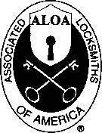

Welcome to the Associated Locksmiths of America, Inc., an association for persons involved in the security industry as locksmiths, security consultants, educators, manufacturers, or distributors.

To apply for membership, please complete this application and submit it with the application fee, dues for the current year, and your business card, company letterhead, or suitable proof of employment.

All of the following questions MUST be answered before this application may be processed: (Please Print)

PERSONAL INFORMATION

Mr. Mrs. Ms. (circle one)

Business Mailing Address Home/Other Mailing Address

|  |  |  |  |  |  |
| --- | --- | --- | --- | --- | --- |
| (Last Name) | (First) | PH3H5 |  |  |  |
| Business Name |  |  | Address-Street and Number |  |  |
| Mailing Address-Street and Number | |  | City and State |  | Zip Code |
| City | State | Zip Code | Phone | FAX |  |
| Phone  Mail: Bus.D | FAX  Home D |  | Social Security No.  Directory Listing: Bus. 0 | Date of Birth  Home Q None □ | |

PROFESSIONAL INFORMATION

Are you a sole owner?, Partner, Corp. officer, Employee, Student?

Are you currently engaged in the security industry? Yes No If yes, how long?

What percent of your work time is spent in locksmithing?

How did you learn locksmithing or security work?

Are you a member of a local locksmith association? Yes No If yes, please provide name, city, and

state of association(s):

ALOA Member sponsor ALOA #

Please note: If you are sponsored by an ALOA member, your application will be immediately processed with a 90-day probation period. Otherwise, final processing will take 120 days.

Give names and addresses of two industry-related references (required):

1.

**2**.

TYPES OF MEMBERSHIP - Please check only one:

Q ACTIVE MEMBERSHIP - Individuals actively engaged in supplying, servicing, or installing security hardware for a period of not less than two years.

* APPRENTICE MEMBERSHIP -- Individuals who are in initial training and meet all the requirements for Active Membership except for length of time in the security industry.
* ALLIED MEMBERSHIP -- Individuals whose position in the security industry relates to the aims, policies and promotion of the locksmith and his or her craft.

2/27/97

APPLICATION AND FEES

A $40 application fee, appropriate annual dues, and your business card, company letterhead or suitable proof of employment must accompany this application.

ANNUAL DUES: ACTIVE/ALLIED MEMBER SI 25 APPRENTICE MEMBER S75

* Dues include $25 subscription to monthly magazine. Keynotes

NOTE: Your second year's dues will be prorated based on the date your application was received by ALOA.

Have you ever been convicted of a felony? Yes No

If yes, please give details on a separate sheet. All felonies are reported to the Membership Committee for review.

I certify that all statements are true and If accepted as a member, I agree to abide by the rules, regulations, and Bylaws of ALOA and further agree to adopt the Code of Ethics of ALOA as my own and adhere to it to the best of my ability. Should my membership be discontinued, I agree to return my, membership card and cease use of all ALOA Insignia.

Signature**.** Date__V

METHOD OF PAYMENT

* CHECK (Payable to ALOA in US funds)
* CREDIT CARD

□ American Express □ VISA □ MasterCard □ Discover Card Number Expiration Date

Please print name as appears on card

Cardholder Signature

FINAL CHECKLIST:

* $40 Application Fee
* $125 Active/Allied Membership dues □ Letterhead or Business
* $75 Apprentice Membership dues Card or Proof of
* $15.40 for Canadian Air Mail Employment
* $37.40 for Overseas Air Mail

TOTAL ENCLOSED $

Return to: Associated Locksmiths of America, Inc.

3003 Live Oak Street; Dallas, TX 75204 Phone: (214) 827-1701; FAX (214) 827-1810

|  |  |
| --- | --- |
|  | For office use only |
| Received $ | Number |
| AppL Fee | Dues Date Rec'd. |
| By | Date App'd. |
| Apprentice transfer , | Applicant listed |
|  | in Kevnoies |

Legislative

Comment

that is not in our member’s best interest, work with coalitions to strengthen ALOA’s position in the industry and improve the ability for locksmiths to be successful in their chosen profession. A Win! Win!

Win! strategy.

LEGISLATIVE UPDATE

Arizona HB 2479

Relates to alarm businesses and agents; requires alarm agents to be registered with the state. Bill failed to pass House floor:

29 Nays/28Yeas

sional Regulation and Licensing, but bill died in committee.

New York AB 5315

Establishes security requirements to be fulfilled by owners of multiple dwelling units including deadbolt locks, window pins, adequate lighting, solid core door and optical viewers. Recommitted to Committee on Housing.

Rhode Island HB 7376 and SB 2303

Relates to the licensing and regulation of locksmiths. Based on ALOA Model Law. Now being considered by House Labor Committee.

Tennessee HB 2686

Prohibits person with felony record from installing, modifying or servicing burglar alarm systems. Amendment adopted on House floor. Passed House and Senate.

Vermont HB 671

Prohibits electrical installation work to be performed by electrician’s helpers and to permit only journeymen and register apprentice electricians to perform electrical installations under the supervision of a master electrician and only registered apprentice electricians to perform electrical installations under the supervision of a journeyman electrician.

Hawaii SB 2532 and HB 3564

Regulates the alarm service industry by setting up a licensing board. Sent to Senate Committee on Commerce and Consumer Protection.

Kansas HB 2647

Relates to the licensing and regulation of locksmiths. Based on ALOA Model Law.

Bill withdrawn by sponsor.

Louisiana SB 14

Exempts sworn police, fire, or other peace officers or certified emergency medical technicians from locksmith licensing requirements. Passed House and Senate.

Maryland SB 501

Authorizes the Board of County Commissioners of Frederick County to adopt regulations to register alarm system contractors and alarm users with regard to false alarms. Passed Senate and House.

Missouri HB 1720

Regulates alarm businesses and agents. Defines an alarm system as any device to detect and signal a fire or an intrusion into protected premises or to detect and signal a crime. Sent to Senate Committee on Profes

Rhode Island HB 8660

Deletes current Burglar and Hold-Up alarm Business statute, and places all regulation and rule-making in the hands of the director of the department of business regulations. Sent to House Committee on Corporations.

Virginia HB 509

Places electronic security contractors and electronic security employees in equal status by requiring contractors to be registered. Amended in committee to establish compliance agent requirements. Signed by Governor on 3/13/98

South Dakota HB 1131

Exempts locksmiths, locksmith shops, and locks made to individual order from the contractor’s excise tax; makes them subject to sales and use tax. Signed by Governor on 2/20/98.

Tennessee HB 2251 and SB 2294

Establishes certification, licensure and/or registration requirements for any person who provides or offers to provide security services and/or investigative services to the general public by creating the Tennessee Security Commission. Pending in Industrial Impact sub-committee of the Commerce Committee.

Tennessee HB 2454

Changes current law to define an alarm system as an intrusion or departure within a designated area. Also regulates delayed egress locks in nursing homes. Signed by Governor on 3/30/98.

Virginia HB 865

Grants to the Department of Criminal Justice Services the authority to certify private security training schools and instructors, unarmed security officers and electronic security personnel; authorizes the Criminal Justice Service Board to enter into reciprocal agreements with other states. Enacted (effective 7/1/98).

m

I About the Manager: Tim

McMullen oversees legislative affairs for ALOA. He  
is a graduate of the District of Columbia School of  
Law and has an extensive background in legislative  
work. If you have information for Tim concerning  
federal or state legislation affecting the locksmithing  
industry, contact him at: ALOA; 3003 Live Oak  
Street; Dallas TX 73204; (214) 827-1701;  
(214) 827-1810; email: [tim@aloa.ioffice.com](mailto:tim@aloa.ioffice.com)

May 1998

Keynotes

Industry

News

ASSA / Medeco Alliance

An agreement in principle has been reached to sell Medeco Security Locks to Stockholm-based ASSA ABLOY.

Linking Medeco, a household name in the U.S. high security market, to the Swedish giant is big news for the locksmithing com­munity. Many are already speculating about what kind of changes may be in store.

“Actually there’s not a ‘big plan’ to change anything right now,” says Medeco President & CEO Tim Layton. “And I don’t foresee any negative impact on our customers—I think the impact will all be positive. For example, I think that we’ve done a lot over the years to produce a quality product for our customers to sell, and we’ve done a lot to help our customers grow their businesses, and we’ll continue that. Medeco will definitely be available to our customers.”

Layton discussed the size of ASSA ABLOY (about a billion in sales a year) and their dedication to lock development, manufacturing and marketing. He went on to say, “As far as we’re concerned here at Medeco, we’re thrilled about this marriage.” Hillenbrand Industries, the parent company for Medeco, issued a release on April 20 indicating that the transaction is subject to regulatory approval and is expected to close later this year.



Good Deed, Indeed!

Five teams of professional locksmiths (all members of the Maryland Locksmith Association) donated time and materials to the Boy Scouts of America. The project is designed to make Broad Creek Memorial Scout Reservation in Dublin, Maryland a safer place for scouts to learn, play and grow. The MLA gift (valued at $24,000) is being made in memory of this project’s creator, the late George Penrod. Penrod is a former vice-president of the MLA and was involved with the Boy Scouts all of his life.

Hard Work Pays Off

The Maryland Locksmith Association recently recognized the dedication and hard working efforts of a few of its members. Sheldon T. Finklestein and Gabe Cocolin were honored for their 15 years of dedicated service to the MLA and awarded the Associa­tion’s “15 year service watches.” Other members who were identified for outstanding service were Pam McElroy for outstanding effort/appreciation, Marianne Sechrist for being an “unsung hero,” Harold Fink “the President’s award,” and Bobby DeWeese for six years of service. In other MLA news, Harold Fink has been named the association’s Advertising Committee Chairman. Fink volunteered for the job and plans to increase the association’s revenues through an aggressive campaign to increase sponsors by giving

Abolition

NFIB’s Campaign to abolish the IRS Code has gained the endorsement of Senate Majority Leader Trent Lott, Speaker of the House Newt Gingrich and a bipartisan group of more than 100 other federal legislators. The lawmakers have joined the National Federation of Independent Business in pledging their support to sunset the Internal Revenue code and replace it with a fairer, more understandable tax law. NFIB is the nation’s largest small-business advocacy group with 600,000 members, including more than 36,000 small manu­facturers across the country. Members of congress showed their support for the campaign by attending an NFIB news conference and adding their names to the growing list of signatures on the petition to abolish the IRS code. Among the lawmakers who appeared were Lott, Gingrich, Senators

Pete Domenici, Sam Brownback and Tim Hutchinson and Representatives John Kasich, Bill Paxon, Steve Largent and Collin Peterson.

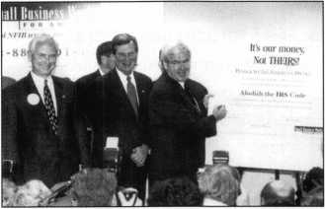

Senate Majority Leader Trent Lott, R-Miss. Csecond from left), and Speaker of the House Newt Gingrich, R-Ga. (at board), were among the members of Congress who showed their support for the NFIB’s Campaign to Abolish the IRS Code. Along with NFIB President Jack Fan's (left), these and other bipartisan lawmakers have united with more than 36,000 small manufacturers and hundreds of thousands of other small-business owners under the banner of the NFIB to repeal the current tax code.

them the opportunity to advertise on the MLA web page and newsletter.

Referrals, Anyone?

The American Society for Industrial Security (ASIS) has announced the Internet release of the Executive Referral Service (ERS) pro­gram. The ERS is a comprehensive, timely career placement resource designed to serve the employment needs of professional security practitioners. It’s available 24 hours a day through ASIS Online (<http://www.asisonline.org>) for ASIS members seeking new employment opportunities and to companies looking for accomplished individuals to lead or augment their current professional security staff. Com­panies can submit their job listings in four convenient ways: by fax at (703) 519-6299, by email at [ers@asisonline.org](mailto:ers@asisonline.org), mail at ASIS ERS, PO Box 1409, Alexandria, Va. 22313, or via the internet at <http://www.asisonline.org>. Another way members can use this program is by using the Fax-On-Demand line at (888) 282-ASIS ext. 2747.

Let’s Get Consolidated!

American Security Distribution (ASD) has announced plans to upgrade their customer service by consolidating its distribution and warehouse operations into nine locations throughout the United States. In addition, the company maintains three distribution and warehouse operations in Canada to complement its North American distribution activities. The consolidation has been made possible through improvements in systems, regional sales and service operations, invento­ry and distribution. Reportedly, ASD has made efforts to expand its operations in new systems and software programs, including new wholesale distribution systems for better order fulfillment and enhanced credit procession. The company also negotiated with Federal Express to become the only national distribu­tor of security devices under Federal Express’ “Express Saver” program, enabling customers to receive product within 48 hours by air at ground rates. In addition, ASD has refocused its regional sales and service operations entirely on sales and customer service.

School Time

National School Safety and Security Services, a Cleveland-based national consulting firm specializing in school security, announced the upcoming availability of its latest resource publication for improving safety in our nation’s secondary and elementary

Keynotes

May 1998

schools earlier today. Practical School Security: Basic Guidelines for Safe and Secure Schools by Kenneth S. Trump is currently available from Corwin Press. It is the first and only book written by a career security professional who has worked as a school security officer, investigator, gang unit supervisor, director and 29 state consultant for urban and suburban schools. The 120 page book contains various strategies and facts focused on identifying school security threats, managing politics, conducting security assessments and other information.

Congressional Honor

Ingersoll-Rand facilities across the country served as meeting sites for 13 U.S. congressmen and their constituents last year. These visits allowed members of congress a first-hand look at modern manufacturing methods and gave legislators opportunities to meet and interact with Ingersoll-Rand’s employees. Among the congressmen who visited the Ingersoll-Rand plants last year were Representatives Bob Goodlatte who visited the Roanoake, Va. facility, Bob Clement who visited the company’s White House, Tenn. Facility, Cass Bellenger who visited the Mocksville, NC facility and Pete Sessions who visited the Garland, Texas facility. The success of these visits should inspire more within 1998.

The Cable Guys

ADI recently announced its expansion into structured cabling and will provide products, support and service in this area. ADI currently has over 100 locations and can stock local to the customers’ job or office site. All the major manufacturers and necessary components are available so the company can design full structured cabling systems. For more details, ADI can be reached at (800) 233-6261.

In other ADI news, the company applied for and earned its ISO 9002 certification. This encompasses sales, purchasing, manufacturing (N/A), inspection, shipping delivery and installation standards.

Big Agreement

Detection Systems, Inc. today announced that its Radionics subsidiary has executed two significant agreements that include a Serial Subscriber Terminal Unit (“STU”) License and an International Sales Represen­tative Agreement. In the terms of the serial STU Agreement, Radionics will manufac ture and sell the Serial STU’s that embody

|  |  |
| --- | --- |
|  | Industry |
|  | News |

DCX’s patented Derived Channel Technology, providing full serial data as a primary means of alarm reporting. Radionics will sell the Serial STU product to its established Direct Sales Network in the United States, Canada and Australia for use in security alarm transport applications. The Sales Representative Agreement grants Radionics the exclusive right to market the technology in Asia.

New Company

NKL Industries, Ltd., a manufacturer of safes and security equipment located in Chesapeake, Va. announced the completion of its acquisition of Allied Gary International, of Waynesboro, Ga. The new division, renamed Gary Safe International, manufac­tures premium safes and products for the retail banking, and convenience industry. Its trade brands include the successful AutoBank, Validator and Auditor security safes. NKL’s safes and security products include the AuditLok series of computerized safes and preassembled security doors. Combination of the two companies creates a dynamic organization poised to service the growing world market for security technology in the 21st century.

■ Executive News

A Good Man Isn’t Hard To Find

Hanchett Entry Systems recently announced the addition of Stephen Good as their new National Sales Manager. Steve has a business degree from Stanford and exten­sive sales and management experience with a large international corporation. He rounds out a sales team of individuals committed to furthering the company’s commitment to innovation within the industry.

Wayne’s World

Wayne O. Wilkerson has been named president and chief executive officer of Intellikey Corporation in Melbourne, Fla. Intellikey provides design, production and marketing of stand-alone, battery-operated, programmable high-security replacement cylinders and keys. Wilkerson has worked with various high security and lock compa­nies. He was CEO of ASS A High Security Locks, Inc., a subsidiary of Swedish-owned ASSA ABLOY. He was also vice President of Sales and Marketing for Ilco Unican Corporation, the world’s leading producer of keys, key machines, safe locks and push-button locks.

Hello, Heller!

Neil Heller, a security industry veteran  
and a product development/marketing  
expert, has been named national product  
manager of the Sanyo Video Products Division.  
Heller was a special consultant for Sanyo  
Fisher Company for more than nine years,  
during which time he worked for Sanyo in  
Europe and Asia, as well as the United States  
in product development and marketing.  
Sanyo Fisher Company located in  
Chatsworth, Calif, markets a complete line of  
high quality multimedia, consumer audio  
and video, security video, office automation  
and home appliance products.



Conrad Henry

The Napco Guys!

Napco Security Group  
recently made a few new  
additions to their team. Conrad  
Henry was appointed to the  
positions of regional sales  
manager for all of Eastern  
Canada. Meanwhile Anthony J.

Grosso was made senior vice  
president of Sales and  
Marketing. Henry has over  
15 years of security industry

experience. Previous positions Anthony J.  
include outside sales representa- Grossotive for companies such as Dicon, Arius,  
and Burtek SSL Grosso was most recently  
Napco’s vice president of New Product  
Market Development and has been one  
of the company’s brains behind its National  
Account Program.

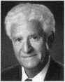

New Man For PCSC

Chris J. Jahnke joined Proprietary Controls Systems Corporation as the new eastern distri­bution manager. He replaces Gene Daniel who stepped into pre-sale support with PCSC and will remain on the East Coast. Jahnke has nine years of experience within the access control industry, with formal training in computer inte­gration, electronics and software development. He will be responsible for dealers, distributor and OEM sales support for the eastern half of North America and will office out of Minneapolis, Minnesota. Proprietary Controls Systems Corporation supplies products and services for electronic access control and facility management applications in both domestic and international markets. PCSC is a subsidiary of TTIK, Inc. and has been in business for over 15 years.

May 1998

Keynotes



Security

Marketplace

Corbin Russwin

Corbin Russwin offers the Security Deadbolt Exit Device to complement its current range of exit devices that provides a physical barrier and level of security over exit devices using rim latchbolts. The new Security Deadbolt is engineered to provide security without compro­mising safety. It features a hardened latch constructed of high grade, heat treated corrosion resistant nickel steel alloy. The unit incorporates a slide action deadbolt that utilizes a roll back lever to eliminate friction with the strike during relocking. Plus, it can be used on wood, metal or composite doors and is non-handed.

Corbin Russwin 1902 Airport Rd.

Monroe, NC 28110 (704) 283-2101 (704) 282-2346fax Reader Service #3

Rudolph-Desco Company

Underwriters Laboratories Inc. have revised the fire rating of the Door Spy DS-6 security door viewers from one hour to one and a half hours. This is important for all distributors serving the institutional and building sectors where the higher rating is increasingly being written into specifications. Specifiers for residential, lodging and commercial projects now can select a viewer that not only has four­way viewing but a high fire rating.

Rudolph Desco Company, Inc.

580 Sylvan Ave.

PO Box 1245

Englewood Cliffs, NJ 07362 (201)568-4920 (201) 568-0971 fax Reader Service #4

Panasonic

Panasonic Video Imaging Systems Company (PVISC) has introduced a new system control emulation software with advanced capabilities. The program, called Proteus For Windows 100 (PFW 100), emulates and controls a wide variety of Panasonic CCTV products and system components with electronic feature enhance­ments. PFW 100 expands existing systems with additional control locations. PFW 100 is designed to emulate up to two locally connected Panasonic systems components from a Pentium lOOMhz PC running Windows 95. A dedicated PC is not necessary providing sufficient memory is available. **Panasonic Video Imaging Systems Company**



One Panasonic Way Secaucus, New Jersey 07094 Reader Service **#5**

Security Door Controls

The new SDC 601RFL Regulated Power Supply has dual 12 VDC and 24 VDC secondary outputs. 1 Amp maximum load whether using one or both outputs at the same time. To insure outputs do not exceed 12 and 24V, the higher voltage battery charging circuit is separate from the secondary outputs and provides battery backup for both 12 and 24V outputs. Additional batteries can be added for increased AMP hours. The secondary output is not de-rated and maintains a continuous 1 Amp output when charging batteries. The SDC 601RFL is a UL Listed Access Control System Unit with a Class II output.

Security Door Controls

3589 Willow Lane

Westlake Village, CA 91361-4921

(805) 494-0622

(805) 494-8861 fax

Reader Service if 6

Lockmasters, Inc.

Lockmasters recently announced the addition of LAB universal pinning systems to its product line. Available are universal pins, original manufacturers pins, original pinning kits, Semi-Pro series kits, Mini Dur-x kits, original 3-in-l Auto kits, inter­changeable core kits and more. Also from Lockmasters comes a keyless garage entry tool. It enables the security technician to unlock virtually any overhead garage door that utilizes an electric, automatic opener. While standing outside the garage door, insert the tool between the door and the frame, hook the emergency release rope and push the door up manually.

Lockmasters 5085 Danville Rd.

Nicholasville, Ky. 40356-9531 (800) 654-0637 Reader Service **#7**

Napco Security Group

Napco Security Group recently introduced the T2 Trilogy. This stand-alone access control system is a keyless, self-contained, battery powered access control system with features that include: programmable passage function, one-time emergency access/service code, individual, group or total user code lockouts, master and management codes that can set entry allowance from five to 30

seconds. New audit trail models provide PC or printed logs of whoever entered, when and where. Also available from Napco is the Wizard II with Fast Track. It s a talking phone- in alarm and appliance control module, enhanced with the new “Fast Track,” which immediately announces the status of a subscriber s security system with which it works.

Napco

(800) 645-9445 ext. 64 Reader Service #8

Mariee Electronics

Marlee Electronics Corporation is delighted to announce the introduction of the new VF Series telephone entry and access system. This new model features a four line scrolling vacuum fluorescent display, an enlarged keypad, one touch dialing, a cast aluminum cover and a self diagnostics module. In addition, the new system features Windows PC software to remotely program the system and up to two card readers can be attached for access control. **Marlee Electronics Corporation 2501 South Front Street Philadelphia, Pa. 19148 (800) 463-4842 (215) 755-7877 (fax) [entguard@aol.com](mailto:entguard@aol.com) Reader Service #9**

Ingersoll Rand/Von Duprin

A new trim option is now available from Von Durprin for use on its 237L two-point, lever operated latch assembly for fire doors. Available as a standard product, the 237 two-point vertical latch uses a latching mechanism similar to the firms 8847-F and 5547-F vertical rod and latch assemblies.

The device is furnished with one 378L-BE lever control, which is always unlocked, for mounting on the push side. A second 378L lever control can be ordered separately for the pull side if desired. As part of the product expansion, the lift: cam used to activate the rods in the 378L has been changed by extending the ears on the cam. This reduces the amount of travel required to release the latch assembly. The 237L assembly is often used in warehouses and other industrial facilities on applications such as pairs of active fire doors that do not require fire exit devices. **Von DuprinlIngersoll Rand Company 2720 Tobey Drive Indianapolis, In. 46219 (317) 897-9944 (317)899-9302 fax Reader Service #10**

Security

Marketplace

Marks USA

The custom lockset division was created to quickly respond to customers with special requirements for either lock or function or design. As a result, Marks USA has developed a product line which provides commercial locksets that meet and exceed the most stringent UL and BHMA/ANSI specifications. All of these products feature a lifetime mechanical warranty. A brochure is available, listing detail specifications for available locksets that have been developed for New York City and Los Angeles School Systems, the Chicago and New York City Housing Authorities and other municipal and commercial applications.

Marks USA

5300 New Horizons Blvd.

Amityville, NY 11301 ***(***516***)***225-5600 (516) 225-6136fax Reader Service #11

GBC/CCTV Corp.

GBC introduced a new line of “ball cameras.” The black and white BC-450 and Color BC-935C are as small as baseballs and are adjustable. Each swivels a full 350 degrees horizontally and can be positioned plus or minus 90 degrees. They can be mounted on walls or ceilings and come with a wall mount, allowing them to fit over a single gang electrical box for pre-wiring. The BC-450 and BC935C are also compact, measuring just 3 1/2 inches with a diameter of only 3 1/4 inches. In addition to being decorative, they are also weatherproof and able to withstand “elements” ranging from minus 19 degrees to 140 degrees Fahrenheit. **CCTV Corp.**

280 Huyler Street South Hackensack, NJ 07606 (800)221-2240 (201) 489-0111 fax Reader Service #12

MONITEQ Research Laboratories

MONITEQ Research Laboratories recently introduced a “smart” Power Supply Module, the Model CC-8500 that makes it possible for MONITEQ s and other access control systems to operate the heavy duty locking devices now used in many commercial and government high security applications. Heavy duty electric locks such as the Sargent and Greenleaf, Inc. “Brute” and others require high “in rush” currents to open reliably, yet these same locks cannot withstand high current for more than a short

period of time. The Model CC-8500 provides sufficient in-rush current to open all commer­cially available locks and after the lock has opened, automatically limits the current to a level that both holds the lock open and prevents damaging its solenoid. As a result, heavy duty locks can now be used in systems where they may be held open for long periods of time. **MONITEQ Research Laboratories 7640 Fullerton Road Springfield, Va. 22153 (800) 989-9891 (703) 569-0196fax Reader Service #13**

Signal Communications

Signal Communications Corporation (SigCom), a leading manufacturer of quality fire alarm systems and peripherals, recently announced the introduction of their new Spectrum series of pull stations. Pull stations can report for either indoor and outdoor “Active Duty.” Mounting options include a single gang backbox, as well as SigCom s interior surface metal and cast weather-proof backboxes. It is a single-action device with key reset and terminal connectors. Corrosion resistant SPST gold contacts are standard on all stations. The SigCom pull station is UL listed as ADA compliant.

Signal Communications PO Box 2588

Woburn, Mass. 01888-1188 (617)933-0988 (617) 933-5019fax Reader Service #14

Vision Systems, Inc.

Vision Systems, Inc. manufacturer of ADPRO Remote Video Transmission and Motion Detection products, today announced the release of major enhance­ments to their VSTlOCA-plus receiver and transmitter. These improvements include: improved image update rate, “alarm type” at the transmitter to provide two screen display options for each alarm input (either quad or live), additional receiver special options menu to include, date format, intercom options, intercom delay period, to eliminate feedback, alarm beeper timeout and push to talk option. **Vision Systems, Inc.**

(781) 741-2223 cathy 19 @ idt.net Reader Service #15

Thomson Industries

The Thomson technical bulletin for the FlouroByliner Bushing Bearing contains current product specifications, features and benefits information. Low friction movement in either linear and rotary modes and exceptional tolerance of the harshest operating environments define the advantages of the FluoroByliner Bushing Bearing. The product requires no additional lubrication. A proprietary composite liner is wear resistant and able to withstand shock, vibration and temperature extremes up to 600 degrees Fahrenheit. **Thomson Industries 2 Channel Drive**

Port Washington, NY 11050-2214 (516) 883-8000

1. 883-9039 fax Reader Service #16

TESA Access Control

TESA has created an access control system that brings new capabilities to the market. The Integra3 is TESAs newest creation, and can manage up to 65,000 doors and 65,000 users with up to 3,000 users per door without requiring a single metal key. Prior to this, management of this capacity was virtually unheard of for stand-alone access control products. The Integra3 has the ability to provide a complete audit trail of all lock events, which are recorded in non­volatile memory. And because the Integra3 features stand-alone electronic locks based on magnetic stripe technology and powered by standard AA batteries, no wiring is required. **TESA Access Control PO Box 620138 Atlanta, Ga. 30362-2138 (800) 472-TESA Reader Service #17**

Continental Instruments LLC

Continental Instruments LLC announced the addition of an Auto Learn feature in its family of true distributed processing access control panels. Continental manufactures four different sized controllers with the capability of handling from one to eight doors offering dealers range in size and function. The Microterm (two card readers), Miniterm (two card readers/keypads), Smarterm (four card readers/keypads) and Superterm (up to eight card readers/keypads) comprise the family of Continental Controllers.

Continental LLC

1. 254-0044 (516) 254-3043 fax Reader Service #18

**May 1998**

Keynotes in

I am writing

this article because of several incidents that I have run across in the past couple of weeks. These have prompted me to write this in the hope that maybe security professionals as a whole can get some of the ones who think that they can do safes (but in reality don’t know how) interested in furthering their education about safes, their intended uses, the best way to open them and the proper questions to ask when selling them.

If you have decided that you are going to work on safes, one of the first things to think about is cost. In order to do safe work properly, one must have several tools in order to do the job.

Magna Cum SafeTech

The most important is education. I know that many of us don’t think about education as an actual tool, but that should be the first item on your tool list.

You can educate yourself in several different ways. You can do so through your local association - ask just what classes are available. If none are available, ask if they have any scheduled. Sometimes your supplier in conjunction with your association will set up classes for this purpose. Also, ask your local supplier if they have any classes set up and if not, are they going to have any soon?

Another good way to gain knowledge is through your national associations, (ALOA and SAVTA) classes that are held each year at their respective convention sites.

Trade schools such as Lockmasters are also helpful. No matter where you get the education, it is a much needed tool required for safe work. Costs of these classes vary from hundreds to thousands of dollars depending on just what classes you take and how far you want to go. To point out just how important education can be, I will tell you about one of the service calls I went on recently.

He should have asked for help.

It all started out innocently enough. I received a call from the manager of a restaurant who couldn’t get into their safe. I asked the usual questions: what brand of safe, how long had it been since the last service on it, and exactly how was it operating before the problem was discovered?

After jotting down the answers, I set a time to be there to try to open the unit.

Upon arriving at the restaurant, I was shown to the safe — a nice little Amsec TL15 unit. When I tried the combination, I discovered that the Lagard dial stopped at 97, giving me the idea that the back of the lock was loose and had caused the relocker to fire, thereby stopping the dial at 97. Then grabbing the handle, I noticed that it just revolved around and around with no point of resistance whatsoever. I then asked the manager just how long the handle had been like this and he replied “ever since the other locksmith was here.” I then asked what should have been asked in the first place - has anyone else tried to open the safe and if so, who tried to open it? A quick phone call to the “other locksmith” brough some answers.

I asked just what had been done and was told, “I tried the hammer to try to get it to turn. And then I told them to call you since you had the special equipment to open it.”

I then asked if he had noticed just what number the combination lock had stopped at.

He replied, “It stopped at the right place. It would not go any further, so it had to be working, so we tried the handle, which was stuck and then it broke free, but it still wouldn’t open. I told them to call you.”

By this time, I was almost ready to tell him that in the future, call me at first and let me do the job right, but I decided that would do no good at all. I just thanked him and went back to the job at hand. I dug out my drill rig and set it up and began to proceed to drill just above and to the right of the right hand mounted Lagard 1800 to pull back the lockcase back and then dialed the bolt back, (which by the way stopped the dial at 89 and not the original 97) then proceeded to drill the handle out to the broken part and turn it open with a sharpened screwdriver driven into the remaining portion of the handle. After replacing the handle, repairing the holes with ball bearings, and welding, sanding and repainting the door, all was good. Most of this job could have been avoided just by the locksmith knowing that the dial does not stop on 97 if the lock is operating properly. This is a very good indication that something is wrong, most likely the back of



***Keynotes***

**May 1998**

the lockcase being loose causing the internal relocker to fire.

He should have also known that hitting the handle with a hammer will not open the safe. Most handles are designed so that entry is not possible by beating on the handle with a hammer, (shear pins, etc.). Had this particular person asked, he most likely could have found the needed answers before the extra damage was done, causing the customer to spend more than was necessary in order to get the job done right. Here, the right education could have saved all parties involved unnecessary headaches as well as made the customer much happier.

Know the product

Also, if you are going to sell safes — by all means learn about the different classes of safes and then decide just what to sell your customer. Does he need a burglary resistant safe or a burglary and fire resistant safe? Identify your customers’ needs and require­ments before trying to sell a safe. Ask just what is going to be protected, determine just how much space is needed and add 25 to 30 percent for future items to be added. Choose the right safe for the job at hand. If valuable possessions are to be protected, then a safe designed for burglary protection is needed or perhaps a safe for both burglary and fire protection is needed. Also, is it needed to protect items in an apartment, a home office or a business? Will the safe need to be anchored to the floor? Where is the safe to be located? All these things must be considered when trying to sell your customers a safe that will meet his or her needs. To try and sell your customer a safe without knowing these things will not only do your customer a disservice, it will hurt your reputation as well.

I have found that most people who are buying safes for home protection are buying them for the protection of valuable posses­sions and fire protection is a secondary issue. Safes designed for fire protection give the impression that they are strong and heavy, having thick doors and walls, when in reality they are made of a light gauge sheet metal and most burglars use common household tools to open these safes. In some cases, they just carry the safe away to open it later, far away from the house they just burglarized.

These safes should never be sold for any reason except for the fire protection they offer. I was asked to change the combination on Meilink model 251 the other day and discovered, much to my horror, that it contained several items of considerable monetary value. I pointed out that this particular safe was not intended for the safe­keeping of valuable possessions and was told that the local locksmith had sold it to them without even asking what they intended to keep in it. He was surprised to hear that the safe was not burglary resistant, and needless to say when I left his place, I had an order and a check for a new burglary resistant safe in my hand.

Since most people buy only one safe in their lifetime, and most of them buy in order to protect their valuable possessions, sell them one that will guard their heirlooms, jewelry, coin or card collection, money, handguns as well as the many items considered priceless to them. The minimum recommended level of burglary protection is usually a safe with at least one inch steel plate in the door with the walls at least one half inch thick steel plate. Typically, the cost is usually figured at eight to 10 percent of the value of the items they need to protect and this will give you a good starting point at which to base your decision on which safe to sell. A residential burglary resistant safe costs from $600 to $10,000 depending on the size and protection needed. Also, if the safe weighs less than 1,000 pounds, anchor it to the floor — this is a point of safety that is really neglected for the most part. What good is their safe is the thief can just cart it off?

If your customer needs a fire protection safe, sell them the safe needed to do the job. Here again, find out what is intended to be kept in it. Fire resistant safes come in a variety of ratings. If they intend to keep media tapes and discs in it, then you need to sell them one that is rated for that purpose. Do not sell them a one hour rating at 350 for this purpose, because they would need one with at least a one hour rating at 125 for this purpose. Again always ask just what purpose the safe in intended to be used for and suggest the proper one for the job.

Play it safe.

And remember, if you don’t  
know exactly what you are doing  
when it comes to safes, don’t  
hesitate to tell your customer that  
you would be happy to  
recommend an excellent SafeTech  
to them. It is not in your best  
interest, nor in your customer’s  
best interest, to be in the dark  
about safes. Learn the product  
and learn the proper way to  
service it and the proper way to  
sell it or leave it alone. You are  
really only hurting your own  
reputation by not doing so. A

good and proper education on safes is one of  
the best investments you can make, that is if  
you are dedicated to working on safes along  
with your lockwork.

So,

You Can Do Safe Work Too?

By James Jefferies

About the Author. James Jefferies, ALOA #025947, SAVTA #5392 is the owner of Jim’s Safe & Vault in Lewiston, Idaho.

/

May 1998

Keynotes

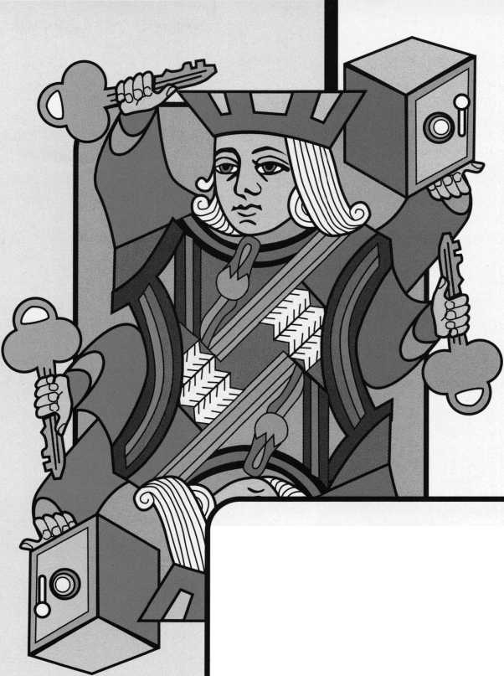

For many years now, I have heard that it is impossible to successfully impression single- bitted General Motors keys on a regular basis. I am here to tell you that it is simply not true. A time-tested method for impres- sioning General Motor Keys that does work every time is called the Ellis Method. It is named after the man who invented and perfected this technique.

This method can be simplified into seven simple steps. So, let us begin our process of impressioning a General Motors single- bitted key.

1. We begin this procedure by preparing the key blank. This is done by notching 1/2

Note: At this point, it is a good idea to make some duplicates of the key as it now stands for future impressioning attempts.

1. Bevel the blade to a knife edge. Filing must include the shoulder area to permit the complete rocking motion necessary to successful impressioning. It is also essential to thin all other areas of the key blank to permit better clearance.
2. Insert the prepared key blank cylinder, using only “finger pressure” (any additional pressure i.e. vise grips will cause irreversible damage), twist counterclockwise only a few times to obtain impression marks. Note: When thinning the shoulder, be sure to

depth cuts in all six wafer positions. This should be done by one of four methods for greatest accuracy. A computerized or electric machine would be my first choice. My second choice would be a mechanical clipper style code machine. My third choice would be depth keys. My last choice would be to prepare the key blank by hand. However, there are only a few locksmiths I have known or known of throughout my life and that can achieve the accuracy necessary without using one of the first three choices, myself included.

**by Steven Spiwak**

*Figure 1*

1. Remove as much material as possible between the six half cuts by forming five “V”clearance cuts. You must remember to round the bottom of each “V”. This is essential to the process as this enables the bypass of the wafer chamber walls as well as preventing any key “hang-up” during the rocking motion (see figure 1).

retain the original stop for proper alignment with the sidebar disc tumblers. Make sure that you keep the knife edge during the entire impressioning process until you have a working key. Without the knife edge, it will be virtually impossible to see the marks.

1. Remove they key and file on the true impression marks only. Only experience will help you cultivate the ability to distinguish

***Keynotes***

true impression marks from false or slide marks. The desired impression marks will run across the blade. This results from the side to side rocking motion of the key blank in the keyway of the lock cylinder. However, the false or sliding marks will be longitu­dinal in character.

Be sure to retain the knife edge and respect the proper depth increments for General Motors single-bitted keys.

1. Repeat this process until proper depth and fit has been attained.
2. When finished, transfer the results to the correct unmodified General Motors single bitted key by code machine. This



ensures that the cuts will reflect true position depths only.

1. Once you have mastered this technique, you will see the enormous variety of opportunities that will lie before you when performing General Motors lock servicing.

€ *About the author: Steven B.*

*Spiwak, CRL is a fourth generation locksmith who specializes in a variety of variety of areas including crime prevention and institutional security. His broad experience in the security field spans 20 years of writing, teaching and consulting. Spiwaks lengthy client list includes Ford Motor Company, Exxon,* The Chicago Tribune, *Sears, Westin Hotels, the U.S. Treasury Department and the Federal Bureau of Investigation. Most recently he*

*formed Lockport*, *Inc.—a security consulting company for industrial, commercial, institutional and governmental clients. Readers with article suggestions or requests for him can contact A LO A at email* [publ@anet-dfw.com](mailto:publ@anet-dfw.com) *or fax to (214)827-1810.*

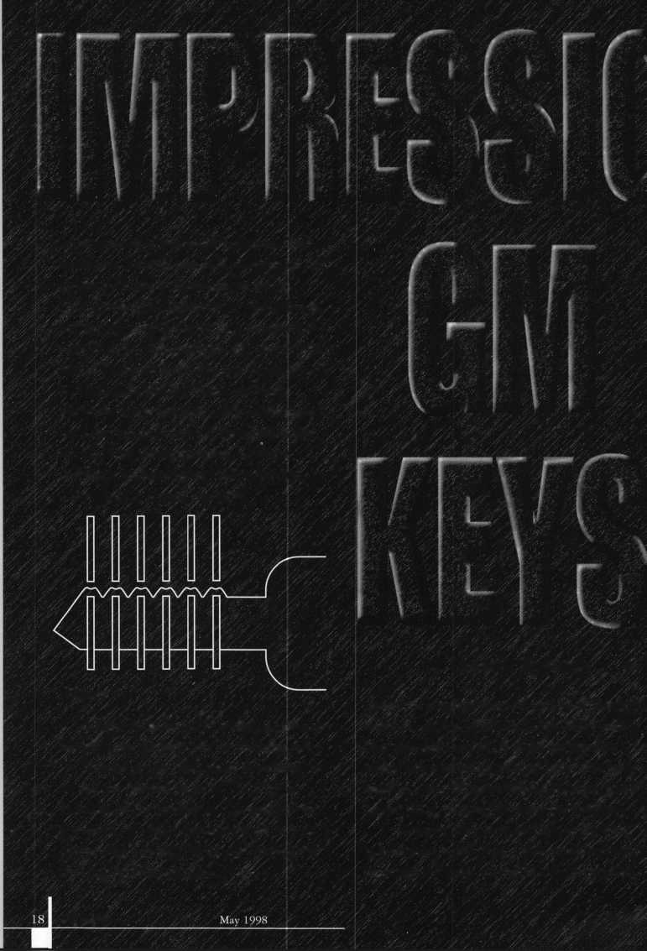

It has been my experience in locksmithing that the vast majority of locksmiths that I meet are good, if not excellent, technicians. The major problem they seem to have is their overall inability to promote their technical excellence with advertising and marketing.

There are approximately 16 methods for promoting and increasing your business. These 16 methods have become the backbone of a popular marketing seminar that I give around the country throughout the year. Last issue, I mentioned these methods in our Q&A section. This month, I will elaborate on them in the hope that you will find one or more of them interesting enough to try out on your own.

(service calls, surveys, etc.). The important thing is to realize is that your existing customer base is not only supporting you and your business, but is also your best source of goodwill and positive public relations. In effect, it is your existing base of satisfied customers that becomes your best source for increasing your business by recommending new customers based on past and present experiences with your business.

Never underestimate. Never judge a book by its cover. However, that enticing book cover is the reason that you pick up that book in the first place. Producing a

One of the first methods that has proven to be very successful at introducing you to new customers in your geographical area is a quarterly newsletter. A quarterly newsletter is a professional and high profile vehicle for announcing your presence to new customers. Newsletters can also enable you to reintroduce yourself to your existing customers. Newsletters can be mailed to businesses in your immediate area or surrounding areas as defined by zip codes, product categories or service classifications.

The second way to promoting your business is “prospecting.”

Prospecting in the same manner that miners do when they are looking for gold, because when prospecting for a new customer succeeds, it is like finding gold.

quality business brochure is no longer an option in business. It is a necessity. It not only explains what you do, but gives prospective customers a more professional image of you and your business. A well-written and produced brochure answers many questions about you and your business. Moreover, a brochure can create the image of you and your business that can put you light years ahead of your competition in the race for customers and market share.

Feedback is one of the most important techniques we have at our disposal for improving. We are not about to correct our mistakes if we do not have tough but fair criticism. Every writer has an editor who can critique and correct his or her work, because it is virtually impossible to edit your own work. So to do business, people need feedback. If you have given someone an estimate and your customer did not call you back, do not be afraid to call him or her. Even if you do not get the job on your second attempt, you will know the exact reason why. This will help enormously in future endeavors. By the way, I can not tell you the countless number of times that I was able

Prospecting can be accomplished with direct mail services targeted to a particular category of customers. For example, if you are seeking to establish business relationships with schools, hospitals, nursing homes, etc., you can include articles about Life Safety Codes or ADA approved products. Targeting can also be done by geographical proximity (i.e. zip codes, towns, etc.) or by commonality of profes­sions (i.e. doctors, lawyers, etc.). Often you can encourage a response by offering these potential customers a free survey of the premises. This enables you to make suggestions to improve their existing security.

Another successful method for promoting your business involves the use of incentives. Offer incentives for those existing customers who frequently refer new customers to you. These incentives can take the form of free or reduced price products (locks, keys, etc.) or services

**A MUST READ, TELL-ALL!**

**STOP THE PRESSES!**

**THAR’S CUSTOMERS IN THEM THAR HILLS!**

May 1998

Keynotes



to get an important job because of persistence. Repeated attempts can be annoying, but these attempts can show a sincerity lacking in many apathetic business people who demonstrate an all too common “take it or leave it” attitude.

**SIGNS, SIGNS,**

**EVERYWHERE THERE’S SIGNS!**

Signs are an essential means of getting your message across to existing and potential customers. Every form of signage should be utilized when practical and cost effective. Outdoors electrical signs are ideal to attract attention from passing motorists as well as pedestrians. If you choose to utilize outdoor signs that are painted, such as billboards or signs or benches, then make sure that the sign is well lit and the bench is in a busy, well-lit street corner. In this way, you will get the maximum benefit from the placement of those signs. Indoor signs are equally important. Make sure that all signs are clearly printed, colorful, eye-catching and placed in a conspicuous location for easy viewing. This will enable the customer to become acquainted with all the products and services that you offer as well as your pricing structure. Signs are also a good way to let your customers know about the special prices and promotions that you are currently offering.

**LET THEIR FINGERS DO THE WALKING.**

Yellow pages advertising can be very important, but due to the increasing costs associated with telephone book advertising, it must be approached very carefully. First, you must determine how many telephone books in which you need to advertise in order to cover the geographical area you are capable of servicing.

This is especially important in areas where the telephone books have been broken down into many separate smaller books. These costs can often become a heavy financial burden.

Another consideration is categorization. Our highly specialized society has spawned a myriad of different categories.

Should you list under locksmiths, safes, alarms, security systems, etc? It is literally impossible to list your business under all the possible categories. Therefore, before you utilize this type of adver­tising, be sure to qualify the areas you will commit to before it gets out of hand. One last thought you - the size of the advertisement in the yellow pages is a factor. Even distinguishing colors can be a factor, but both of these decisions involve a significant increase in money to be paid each month.

How many times have you heard a locksmith say, “I am working to pay for my telephone book ad!”?

The truth of the matter is that you should get together with fellow locksmiths and agree to a standard size ad. This levels the playing field for everyone in your area and at the same time significantly reduces cost. The simple fact is that this type of decision benefits everyone but the person selling this type of advertising.

Finally, it has been proven repeatedly that a large ad in the yellow pages does significantly affect emergency calls far more than any other type of service call. This due to the authority fallacy. This fallacy states that anything in print must be true. Therefore, if you have a big expensive ad you must have a big successful company. Unfortu­nately, this is just not always the case. Therefore, if your business relies on emergency calls and mobility, an ad like this makes more sense than if your business relies on other types of work requiring appointments with regular customers.

One of my friends who is a locksmith was a master of marketing.

He determined that one of the markets he most wanted to capture was that of new homeowners. He reasoned that one of the first things on new homeowners “Things To Do” lists was changing, replacing or installing locks. He also reasoned that along with security privacy was equally important. He chose to specialize in locksmith services, and window shade sales and installation. By choosing this combina­tion he did, in fact, corner this lucrative niche market. I would recommend, in addition to advertising methods we have already discussed that you should consider advertising with the “Welcome Wagons” and “Chamber of Commerce” groups that are the first to be informed of new people and new businesses moving into your area. Offering specials to new people in your area is a sure-fire way to improve business and spread good will.

**EXTRA! EXTRA!**

Newspaper advertising can be important, but is often expensive.

It is important to consider neighborhood periodicals as well as city,  
state and national publications. If you choose a more  
expensive newspaper or magazine, which covers a wider  
area than you serve, be sure to include other  
locksmiths. In this way, you can all benefit from

this high profile advertising while at the same  
time enjoying a lower cost since it will be  
divided equally among the group. It is

also important to consider the type of  
publication in which you choose to  
advertise. Be sure to look for a  
publication whose audience would be  
interested in the services and products  
that you have to offer. For example, a  
magazine like Better Homes and

Gardens would be a wonderful place for  
an ad for a push-button mechanical lock.

You can say that you offer a lock that  
would be installed on the door of a  
suburban home between the kitchen and the  
the garage, The combination would be set to  
match the digital keypad of the garage door  
opener. Should a latch-key child forget the code, he or  
she could just call a parent for the combination rather that  
having the parent leave work to go all the way home to open the  
door with a standard key. Many two-income families would embrace  
that significant change.

**CLIP ’N SAVE.**

Coupons can be a real benefit when advertising. The most successful coupon that most locksmiths have ever offered is now classic, “Two Keys for One Dollar.” Coupons can be used in a a variety of situations including reduced service calls, discounted locks, etc. Everyone wants to feel that they are getting a bargain. Coupons are an outstanding way of giving your customer something that he or she can hold in their hand to obtain that extra value for their dollar. Coupons also demonstrate how successful your advertising has been by the number of customers who take advantage of your offer.

Be sure to see if you have qualified for cooperative advertising or coupons. This method gets the word out for two or more companies. It is significantly more cost effective than advertising alone. Not only do you as locksmith retailer benefit from this type of advertising, but also so does the manufacturer or distributor who offers this incentive

Keynotes

May 1998

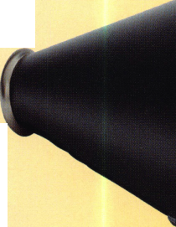

to induce you to buy from them. You should utilize this win-win situation as soon as possible.

HELLO? ANYONE THERE?

Cold calling and bulk mail are bigger gambles, but if you perform in either one in significant numbers, the results can be surprising. For example, a bulk mailing can be a real bargain with even minimal results. Let us say that you mail 1,000 letters and get a return rate of only 3 percent or 30 customers. This figure is the one most expected and accepted as a reasonable rate for this type of mailing. A first class mailing would cost $320. Those 20 new customers each want two deadbolt locks installed at a rate of $100 per completed job. That $320 you invested in that mailing just earned you a gross of $3,000 or almost 10 times your original investment. The other benefit is that you have expanded your existing customer base by 20 satisfied customers who will recommend your business to their friends.

By the way, do not be discouraged just because someone did not respond immediately to your flyer. This may indicate that they will keep your flyer and respond to it later when they need your

NOW A WORD FROM OUR SPONSOR.

Radio advertising, particularly ethnic stations, can be quite effective and a real bargain. Local radio advertising is not as expensive as you might think. It can be expensive if you only choose the most popular shows in the biggest markets during their prime broadcasting time. However, if you carefully choose local radio stations that have a small loyal following in the geographical area in which you perform service then you might just find you have a bargain.

This is particularly true in neighbor­hoods where there are predominant second and third languages being spoken in addition to English. It is a significant advantage to hire qualified people who are bilingual. Speaking the same language will allow you and your business to cater to this clientele. It will reinforce the fact that you are serious about them and their business.

Television advertising can be almost as cost effective as radio. Remember, television advertising does not have to mean half-time at the Super Bowl. It can mean local programming or cable shows at off peak hours. If you are careful about where you advertise on television, it will cost a lot less money than you might think.

For example, when we were relocating, we turned on the television to a new cable station that listed homes for date. They were merely photographs of the available homes with a price, short description, and the agents name and the number to call for additional informa­tion. However, just did some other services that a new homeowner might need, I called for information on advertising. It was inexpen­sive and very effective.

TAKE A HIKE!

Get out and walk around your neighborhood. This is a technique that not enough business people employ. Personally greet people in your neighborhood: residential, commercial, institutional and industrial. The effect is unforgettable. The good will is immeasur­able. Even if you do not see immediate financial rewards, you will.

Sooner than you think.

Think about structuring guarantees in terms of both products and services. Most people are more inclined to do business with a person or a company that has enough confidence to guarantee their work. Remember that your guarantees do not have to be lifetime and unconditional. They may be limited and extendible for a fee to be all encompassing. The important thing is to recognize that many service industries offer these types of service guarantees or warranties because they are both good for business and profitable as well.

Next time, I will share with you some of the most creative promotions and business solutions that I have run across in the last 30 years. Many may be applicable directly to you and your business, while others may have to be adapted to be of benefit. In any case, I believe that you will find the originality and problem solving genius of your fellow locksmiths something to be proud of indeed!

I About the author: Steven B. Spiwak, CRL is a fourth

generation locksmith who specializes in a variety of variety of areas including  
crime prevention and institutional security. His broad experience in the security  
field spans 20 years of uniting, teaching and consulting. Spiwaks lengthy  
client list includes Ford Motor Company, Exxon, The Chicago Tribune,  
Sears, Westin Hotels, the U.S. Treasury Department and the Federal Bureau  
of Investigation. Most recently he formed Lockport, Inc.—a security consulting  
company for industrial, commercial, institutional and governmental clients.  
Readers with article suggestions or requests for him can contact ALOA at email  
[publ@anet-dfw.com](mailto:publ@anet-dfw.com) or fax to (214) 827-1810.

**Are You A  
BWD Certified  
VATSmith?**

**Wanna Be?**

Keys

Locks Kits

Training Certification

For a FREE VATSmith information packet and  
locations of BWD Certified VATS Centers  
Call

800**-**647-4926

See us at [www.alllock.com](http://www.alllock.com)

Reader Service #19

May 1998

Keynotes

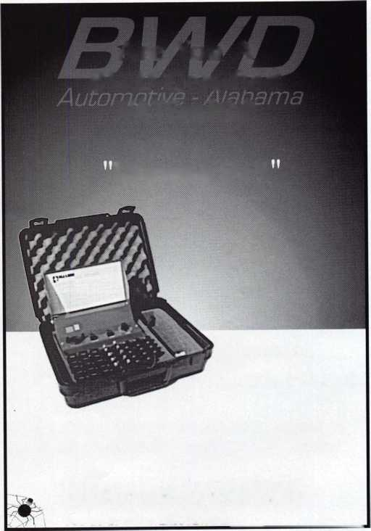

Facelifts, lyposuction, augmentation, reduction and contouring are  
fast becoming the buzz words for the new millennium. For the last  
decade, the number of elective surgeries has risen to an all time high,  
with no end in site. The safe and vault industry has been slow to  
change and even slower when it comes to embracing the art of embell-  
ishing imperfection. Perhaps by now, some of you are wondering how  
a storyline on elective, surgical procedures could in any way have  
anything to do with the safe and vault industry.

The answer is simple, yet as with all simple answers will take a  
more involved explanation.

Burglarized safes are a fact and a part of our industry. In recent  
years, the number of burglarized safes has increased, creating three  
opportunities for the safe technician.

The first opportunity is the initial contact with the customer after  
a safe burglary. The burglar usually damages the container beyond  
recognition, leaving it in a useless, but locked condition. In this  
instance, your job is to open the damaged container in as short a time  
period as possible. After a successful opening, the customer will  
usually inquire about a repair and/or a replacement container, which is  
opportunity number two.

Your options are to sell the customer another safe or repair the  
existing container in a manner consistent with the container’s original  
design constraints. Many times, the customer will not want the  
burglarized safe repaired, even when repair is purely a cosmetic  
makeover. In the customers’ minds, they can only see a blemished,  
bulging pile of exiguous metal.

Burglary is traumatic and the image of that ugly safe is nothing  
more than a constant reminder to your customer that life does have a  
loathsome side.

The other side of the coin presents a cool, detached customer who  
sees repairs as a money saving alternative. In either case, you have the  
opportunity to sell your talents as a “Metal Specialist” who can transform  
this lamentable pile of steel into a pillar of strength and beauty.

When the opportunity presents itself to sell a new safe, what are  
you going to do with that useless safe? If the damage is limited to  
cosmetics, elbow-grease and a new lock, you have stumbled onto  
opportunity three. Depending on how you price the new safe to the  
customer, many times you can charge the customer to remove the old  
carcass or throw in the removal as part of the sales agreement. Either  
way, you will end up with the safe for the cost of moving. Opportunity  
number three is only an opportunity if you meet the following criteria:

1. You possess the basic ability to cosmetically restore damaged safes.
2. You have a workshop with adequate room to store the  
   damaged safe.
3. You have the ability and desire to sell reconditioned safes.

Absent from the list are two other

factors, mainly time and money for  
expensive air tools and supplies. Time  
is not an issue. If you have a facility  
large enough to store a damaged safe,  
usually that storage area will be  
convenient and accessible during  
normal business hours. Proper  
scheduling of your time during the day  
will provide the needed time for

by Daniel M. Graffeo restoration. Plan on taking your time.

Many reconstructive safe surgeries will  
take a month, utilizing your down time during the normal work day.  
The requisite equipment, other than standard tools you already own,  
will cost less than $100. Many of these items are considered  
expendable. Approximately half of your initial investment can be used  
on future jobs.

Air tools are ideal but not essential. Elbow-grease will suffice,  
especially for the first few jobs.

Analyze prior to embarking on any project of this nature. Analyze  
the container, determining exactly what procedures will be performed.  
Classify these procedures into two categories: mandatory and optional.

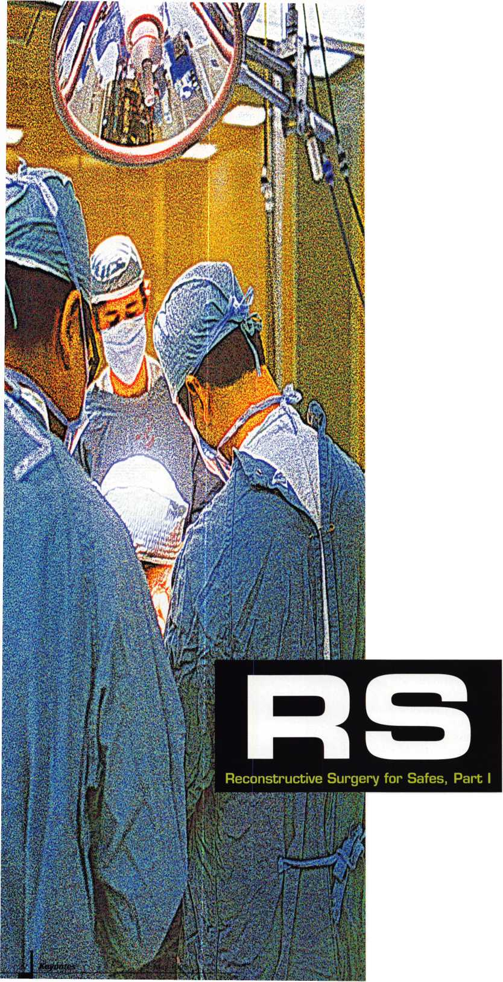

Analytical procedures include:

1. Determining the areas that will require body putty and estimating the amount of putty for purchase at a later date. Body putty should be purchased from an automotive supply house that specializes in auto body repair. Body putty that is classified as “light” is your best choice for strength and flexibility.
2. Determine what percentage of the safe will be repainted. If you are going to change the color of the safe, remember when estimating your paint needs to allow for two to three coats.
3. Will the safe need a new lock or locks? These should be ordered shortly after surgery begins to assure a timely arrival.
4. Will special retrofit components be required to replace old or obsolete locks, handles and trim plates?

After you have a list of mandatory and optional repairs, assemble your shopping list. Mandatory repairs will require an assortment of sandpaper, body putty, an extra hardener for the body putty, a body plane (cheese grater), tack cloth and whatever new hardware you determined necessary to replace or upgrade.

**THE PATIENT**

For purposes of this article, our subject safe will be a TL15 composite chest, manufactured by Fichet-Bauche. Twelve years ago, when I was still heavily involved in the daily routine of selling and opening safes, I had the opportunity to sell this unit to a local restaurant.

Recently, my former customer fell victim to the talents of a local “cracksman” who, in fact, attempted to “crack” this chest.

The burglary was unsuccessful. The morning following the attack, my former customer contacted us to open the unit. I am not involved in the retail side of our industry any longer, but I still felt obligated to make a qualified referral.

Within three hours, the technician I suggested to the customer was on the phone to my office with several inquiries. The safe in question was now minus a dial and dial ring. Visual scars included damage to the upper hinge block and hammer marks that occupied a square foot area just above the handle.

The technician on site had been unable to dial open the safe. After a short confabulation to ascertain the chest’s condition, I remembered several unique characteristics that related to this specific Fichet chest.

I serviced this chest when it was new, 12 years earlier. During the course of service, I noticed that the manufacturer utilized an S&G 6730 combina­tion lock and for whatever the reason, installed an 8500 series dial and dial ring. S&G 8500 series dials utilize a double-splined spindle. The spline paths are positioned at 70 and 20, rather than 50 or 41, which are common spline paths on dials intended for use with S&G 6730 series locks.

This new information allowed the technician to dial the safe open on the third set of trial combinations.

Shortly after the chest was open, the customer asked the safe technician what their options were. After considering the options, the customer opted to purchase a replacement safe. The Fichet-Bauche, which resembled a battered relic from the Titanic was taken in lieu of an opening fee. Shortly after the final arrangements were made for delivery of another safe, the technician that opened the safe contacted me, asking for possible uses for this chest other than a boat anchor. I suggested that he consider reconstructive surgery for this unit, with an eye toward a profitable sale in the future. Begrudgingly, he agreed to follow my advice if I would assist him in assessing and repairing the cosmetic blemishes.

Coffee breaks are quite possibly the most important part of my day. They allow me to assess the events that have transpired and consider my course of action for the balance of the day. During one of these coffee breaks, I pondered the problem of replacing the Fichet-Bauche Monopole “pump-lock.”

The Monopole is expensive to purchase, difficult to get keys for and not designed for field service. I remembered discussing the problem with John Cannon, who mentioned that he might have a solution. Our only problem was that neither he nor I had a Fichet-Bauche chest to test the conversion on. To make a long story short, I took the opportunity to

reconstruct the noted Fichet-Bauche chest with the proviso that I would be able to install a Cannon conversion lock in place of the existing Monopole.

**A FACELIFT FOR A FICHET**

Our subject Fichet-Bauche chest was featured in a technical bulletin I did for SAVTA (Safe and Vault Technicians Association). For those of you who have this bulletin, take note of its former appearance and construction features. The same unit, in a blemished condition is shown in photograph 1. The first step in any reconstruction is to assess the damage. Our subject chest will require a new combination lock, key lock, key lock escutcheon, cosmetic hinge block repair and a door implant in and around the hammer zone. A complete paint job will be necessary to complement the other efforts. After complete assessment of the damage to be repaired, a cost analysis becomes our next step. The feasibility of this repair must be considered before the damaged safe is purchased or traded for. In this case, the safe technician already owned the unit and I needed the chest for several experiments. For your reference, and consideration prior to accepting a reconstruction project, the following is a brief outline of concepts used to determine the feasibility and profit potential for any reconstructive repair.

*“Reconstructive repair, commonly known as “bodywork,” requires a complete understanding of the materials and procedures used by auto body repairmen.”*

1. In used, but fully restored condition this chest will sell for $1200 to $1400. (Pricing is based on average market sales in the Mid-Western United States.)
2. The cost of a new combination lock is $120. (Pricing is based on the use of an S&G 6120 electronic combination lock.)
3. The cost of a new key lock and escutcheon is $80 to $110.

(Pricing is based on using either an S&G 6870 FAS lock or

La Gard 2200 series key lock.)

1. Reconstruction time estimate: eight hours (factor your hourly rate to arrive at a final cost.) In Kansas, the average hourly rate is $40 for a total cost of $320.
2. Expendable materials will cost $60 (Pricing includes paint, body putty, sandpaper and tack cloth.)

Costs can be constrained by installing a less expensive combination lock, using an S&G 6800 series Key-Op lock and a stick-on escutcheon.

This example is based on higher end material, which still leaves you an adequate retail margin. Many technicians will add in the additional revenue derived from installation and removal of the damaged safe.

Regardless of how you measure profit, be assured that profit is essential to the future of your business.

If you determine that a real profit of 50 percent is not attainable, reconsider the viability of your project. Whenever profit falls below 35 percent net, consider scrapping the chest for parts and other useful salvage. Do not allow yourself the luxury of dropping the hourly rate portion noted in item four. Productive time must be rewarded with profit to assure survival of any company.

**BODY MAGIC**

Reconstructive repair, commonly known as “bodywork,” requires a complete understanding of the materials and procedures used by auto body repairmen. The information that follows is not intended to take the place of experience or training. Space and time constraints dictate that the presentations are limited to general procedures and useful considerations.

On a personal note, I hope that this article will stir the creative juices within each one of you. There are few times in our industry where the average technician has the opportunity to be creative. Reconstructive repair is one of those opportunities to create. Body putty is the plaster of the new design. Through judicious use of grinders, scrapers, sandpaper and a generous dose of elbow-grease, you will be able to breathe life into

May 1998 Keynotes hi

an inanimate object. The final reward for your efforts will be the day the reconstaicted safe sells.

**PROCEDURAL OUTLINE**

Reference photos 1-4, which demonstrate in detail a burglarized Fichet-Bauche TL-15 composite chest. Our first step will be to prepare the patient for a major face lift.

1. Draw an imaginary line around the “battered” area shown in photo 2. This line must encroach upon the undamaged area by at least two inches.
2. Using 80 grit sandpaper, sand the damaged area, blending the damaged area into the undamaged area. Blending or feathering is a progressive encroachment into the non- damaged area. This means that the extra two inches we left earlier will be sanded in layers. The first 1/2" will be sanded almost down to the bare metal. The next 1" will be sanded down to the primer level. The final 1/2" will be sanded almost below the paint. Each layer will blend evenly, yet progressively from one to another.
3. Drill a series of 1/4" holes on 1 to 2" centers throughout the “battered” area. Drill your holes half the thickness of the outer door skin. Because the damaged area is large and close to the operative edge of the door, you need anchor points to secure the body putty during times of shock. These anchor holes serve to better secure the body putty and prevent the putty from cracking when spread over such a

large area. If the damaged area is less than three square inches, this procedure will not be required. Our subject chest has a damaged area of approximately 20 square inches.

1. File and sand the hinge block, approximating the original size and shape.
2. “Touch-sand” the remaining blemishes, “feathering” the edges as noted in step two.
3. Apply a light coat of body putty to the most heavily damaged area first. The depth of damage is 1/8" deep on our subject chest. This means that you will need to allow for two more coats of body putty.
4. Apply a “glazing” of body putty to all the remaining blemishes. Blemishes are glazed by using the spatula in a manner similar to applying drywall compound to a nail hole. With any luck, blemishes require a one-shot application and usually, do not require additional build ups.
5. Allow the putty to dry for at least four hours. NOTE: body putty may dry in as little as one minute, but requires at least four hours to harden.
6. Using 200 or finer grit sandpaper; “touch-sand” the blemished areas, feathering the edges for an even blending between putty, primer and paint.
7. Using 80 grit sandpaper, do “flash” sanding in the battered zone. No blending is necessary at this point. The object is to rough-up the putty, preparing it for a second coat.
8. Using a shop rag, wipe down the entire chest. Change rags often.
9. Using a new tack cloth wipe down the entire chest. The sticky nature of a tack cloth, allows it to remove the finer particles missed by the shop rag.
10. Apply a second coat of body putty to the battered area and hinge block. Remember to allow four hours prior to sanding fresh body putty.
11. Using 80 grit sandpaper, dress down all the overlapping areas around the outer perimeter of the “battered zone” and hinge block.
12. Switch to 120 or 160 grit sandpaper and sand down the battered area. Remember to feather all the surrounding edges. Feathering is not used when sanding the hinge block. The object is to reshape the hinge block back to its original size and geometric outline.
13. Evaluate the battered zone, noting defi­ciencies, low spots, high spots and rough areas. High spots must be sanded down flush with the parent metal prior to our final coat of body putty. The eye is not as reliable as an educated finger. An educated finger will feel roughness and surface irregularities that your eyes will miss.
14. Using a fresh shop rag, wipe down the affected area.

19- Wipe the battered zone down with a new tack cloth.

1. Reapply a third and final coat of body putty to the prepared area. This time, pay close attention to leveling the putty with your spatula. Look for any air pockets or peeling

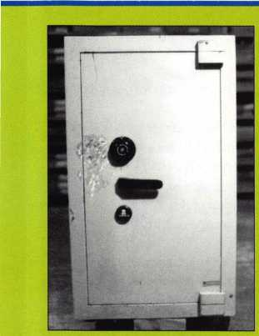

1. Front view of a blemished Fichet-Bauche Defiant, TL15. In addition to the hammer marks, the burglars knocked off the dial, bent the handle and compressed the upper hinge block. To accommodate the customer’s immediate needs, functional repairs were made.

-4

Keynotes

May 1998

2. Close up view of the hammer marks between the dial and handle. The dial and ring were replaced so that the customer could use the safe while waiting for delivery of their new chest.

3. This photo is a macro-view of several hammer marks. From a forensic standpoint the blows were from a right-handed person of at least six-feet tall. The hammer left at the scene was a 16 ounce claw hammer. The evidence suggests that this hammer was the one used to inflict multiple, glancing blows. Several of the blows were delivered with adequate force to compress the door skin approximately 1/16" below the surrounding surface. Overall, compression was almost 1/8". From the amount of damage inflicted in this area, my supposition is that our suspect is male, six-feet tall and right-handed.

4. Close up view of the upper hinge block Note that no attempt was made to remove the cap screws that were hidden underneath the original body putty.

The hinge blocks on this series of chests are machined steel that is counter bored for a hardened hinge pin. Each hinge pin rides on a half-inch ball bearing.

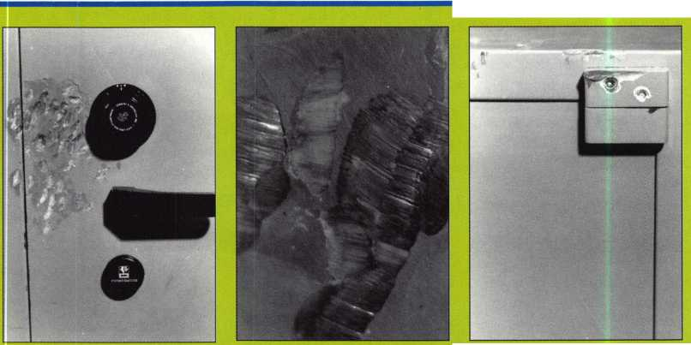

marks that occur with a dirty spatula or almost dried body putty. Air pockets can either be smoothed over or may require a pinprick, followed by light smoothing with the spatula.

1. Check for any blemishes not repaired during the first course of repair.
2. After the requisite four hour curing period, you will start “progressive finish sanding.” Progressive finish sanding means that you will utilize at least three different grits of sandpaper, starting with the coarsest (80 grit) and progressing to 320 grit, which is the finest. During progressive finish sanding, your educated finger will get a tremendous work out. During each phase of sanding, run your finger over the affected area to detect an unforeseen flaw not picked up visually. Correct each flaw as noted, following the outlined procedures. 320 grit sandpaper is used for final feathering and blending. The key to finish sanding is to maintain equal pressure and equal strokes in all affected areas. Avoid canting, twisting or smacking the sanding block against the affected area.
3. Assuming that you have completed steps 1-21, you now have a choice to make. If the painted finish is to be smooth, the repaired areas will require a “finish-glaze.” If the painted finish is to be textured, a final or “finish-glaze” will not be necessary.

“Finish-glaze” is normally supplied in a tube and is premixed. Follow the outlined directions that accompany the product.

1. Primer is mandatory, regardless of the type finish to be utilized. Before applying primer, ascertain that the chest is clean and dust-free. Primer is best applied in a clean environment. Judicious use of a new tack cloth is recommended. Apply the primer as a base coat, following the manufacturers recom­mended procedures. Allow at least a four hour drying time between coats. If more than one coat of primer is required, lightly sand the chest with 400 grit sandpaper in between coats. If400 grit sandpaper is unavailable, you may use 320 grit. While sanding, utilize a light- touch, just enough to knock off the high-spots.

**POINTS TO REMEMBER**

Never sand during the curing time of body putty. Regardless of how far away from the fresh body putty you are, particles become airborne rapidly during sanding and will adhere to uncured putty.

The application of body putty to the hinge block was for the purpose of building up the compressed areas. The edges on a hinge block are not rounded, but rather sharp in detail and form. Try to keep a mental image of the hinge block in your mind as you work the putty down in this area. Tack cloths are not optional.

With current technology, there is still no better method of removing all sanded putty particulate. Do not use compressed air to blow off the chest. Particles of putty when blown will stay airborne for up to four hours, settling exactly where you need them the least.

Earlier, we discussed the need to keep track of your time and the value of estimating repair time accurately. If you are an average mechanic, with a general understanding of auto body repair, you should have spent four hours on this job. My student has spent 10 hours. The time difference of six hours is due in part to his lack of familiarity with working body putty and my annoying habit of finding sanding flaws.

I believe that on a similar job in the future, his time will be cut in half. Developing patience in the early stages of reconstmctive surgery will assure less time on the job and professional results. Anger and frustration when vented towards inanimate objects is the key to longer, less rewarding hours of labor, rather than recreation.

Next month, you and I will explore painting techniques, retrofitting a new key lock and the installation of S&Gs model 6125, their latest entrant into the electronic combi­nation lock arena.

About the Author: Dan Graffeo is the president of Timemaster, Inc. as well as a CRL and CMS. In 1996, he was the recipient of the AW A Lifetime of Outstanding Achievement award.

■Ml

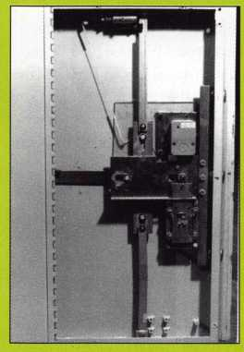

5. The locking mechanism evidenced here is typical of many Fichet-Bauche chests, exceeding the requirements for an entry level TL15. The external relocker can be mounted in the upper portion of the door as shown or inline with the lower bolt The glass relock plate protects the combination lock The external relocker can be fired either mechanically or thermally. The relock cable terminates on and is held in place by a stud on the Monopole key lock

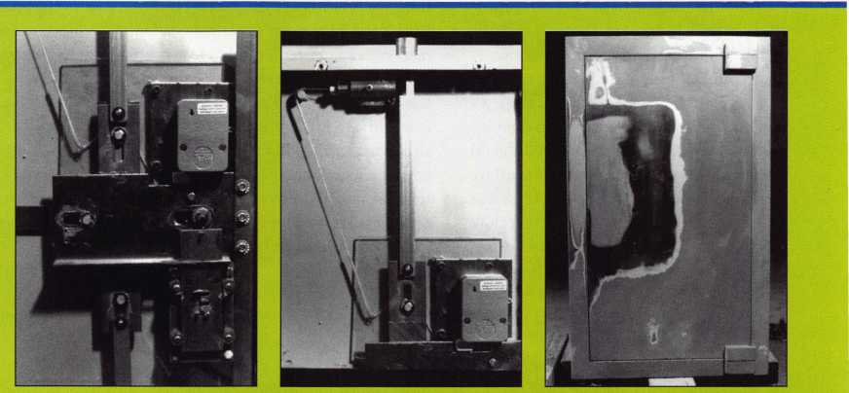

6. Close-up view of the mechanism plate area. Note how both lock bolts oppose each other. The lower bolts that secure the key lock to the chest are nylon. This type of nylon fixation is a hallmark trait of the manufacturer, intended as part of the thermal protection afforded most of their chests. Use extreme caution when removing these bolts. In addition to being easy to break the thread is metric and replacement bolts are not easily acquired. Removal of a broken nylon bolt is easily accomplished with a small butane torch. The nylon melts readily and while in the liquid state, does not adhere to the point of fixation.

7. Close up view of the external relocker, shown retracted. This relocker is deadlock­ing, commonly referred to as “cross-lock­ing." The nut on the rear of the relocker to which the cable attaches is nylon, forming another part of the thermal link protection for which this manufacturer is known.

8. Front view of our repaired chest Note the method used to blend between die areas of putty, steel, primer and paint The area of exposed steel is excessive. Normally, you should end up with an area of steel showing that is approximately 2'\ as demonstrated in the upper portion of the repaired area. This unit will require additional coats of primer to the affected area, prior to applying primer to the entire surface. Note the feathering of the putty as it merges with the steel. The area from the steel to the primer is progressively blended into the existing paint Initial appli­cations of primer will concentrate only on the exposed steel areas. I estimate that two light coats of primer will be required prior to applying primer to the entire door surface.

May 1998

Keynotes



This is the first of what will be a series of articles exploring various practices in which many locksmiths engage, and the varied opinions and definitions of professionalism and/or ethics as is applied to those specific practices. Many of these articles may venture into murky waters and discuss highly contro­versial issues related to our industry. Let me emphasize, however, that this will not be confrontational or shock journalism. Too often, we see various media representations (in print or broadcast) that try to rile up an audience just to boost circulation or ratings. No real solution is actually sought, though, and a debased sense of entertainment is the only real result.

Truth. Like a wisp of smoke, it is a hard thing to get a handle on. Through most of my life, I’ve tried to look past opinions, conjecture and just general “B.S.”, to come as close as possible to find it. I’m not there yet, and I probably will never have the complete truth. If I seek it honestly, though, I should be in fairly good shape. I’m not inclined to force personal opinions on others. If it’s just a matter of taste, I prefer to leave others alone, as long as they leave me alone. Issues of consequence, if credible evidence is available, should give way to legitimate and rational arguments. To that end, my intention is to find answers and not to start fights.

When responding as to the proper way to do something (whether in our personal or professional lives), we tend to follow a script of something that someone taught us somewhere earlier in our lives. Often the first person to get to us ends up forming our beliefs on that particular subject. If we examined most of our beliefs, we’d probably discover that the majority of them are held without knowing the underlying principle or justification for it. In most cases, we've just never asked why. But in many cases, when we ask why, we are told that it is just that way and that we shouldn’t ask questions.

I know many people are content with that

A ***Keynotes***May 1998

answer when it comes to religion, but (as far as I know) locksmithing is not a religion, and legitimate questions deserve to have legitimate answers.

Let me make this final disclaimer before I get to the subject of this particular article.

I may occasionally take the devil’s advocate perspective to examine whether a principle that we follow in our profession will hold up to tough scrutiny. A solid principle should not crumble under such scrutiny. If it doesn’t hold up, it may not have been as solid as we thought. Also, let me suggest that it doesn’t necessarily make a person stupid or bad if they strongly believe something that is wrong. I have, as have most of you, believed things taught to me by someone I had trusted would not give me false or bad infor­mation, only to later learn that it was wrong. In many cases, they learned it from someone else the same way and presumed it to be true. It would be a much scarier world than it already is, if we couldn’t or wouldn’t trust anybody about anything. Paying that price, we must occasionally believe things that are actually false. If we are honest with ourselves, though, we will correct ourselves when we discover the truth.

The Ethics of ‘Do Not Duplicate’

When found on the bow of a key, the short phrase, ‘Do Not Duplicate,’ triggers a variety of different responses from locksmiths. Some refuse to cut a duplicate under any circumstances. Others will make a key copy without a second thought. Most are somewhere in the middle. Applying a variety of tests and rules, they will sometimes duplicate and sometimes not. Some shops have a complicated set of guide lines as to when and how to proceed in duplicating an apparently “prohibited” key. Other shops may rely on instinct or gut feeling.I will attempt to illustrate some important points by creating a variety of scenarios. I wish to examine how the decision to use ‘Do Not

Duplicate’ as a means of key control is made, and what events could follow depending on various key duplication policies. Finally, I’d like to explore the ethical and professional concerns of many locksmiths, and the actual consequences of those ethical and professional choices.

Scenario 1

Fred Aardvark, of AAAA Aardvark Locksmith Services, is a pretty aggressive guy. He thinks that he has developed quit a few surefire techniques to make a lot of money in his chosen profession. He legally changed his name to Aardvark to get his name at the top of the list of locksmith shops in the phone book. Today he is breaking in a new trainee.

“Bobby,” Fred explains, “if you want to generate a lot of repeat business, you’ve got to be more clever than your competition. I’ve already shown you the key machines and key blanks. Now, let me explain how we keep everybody coming back to us for all their key copies.”

“Yes, sir,” the young man replies. “I’m all ears.”

“The key marking stamps,” Fred continues, “are very important. There are two metal marking stamps that you will use every time you cut a key. One is the ‘Do Not Duplicate’ stamp. That makes it difficult for our customers to get anyone to copy it for them. The other is the ‘AAAA Aardvark Locksmith Services’ stamp. That one brings them back to us. After everybody else gives them a hassle for getting copies, they see our name on the key and come to us. There is a big stack of authorization forms in the corner. Any time somebody wants a ‘Do Not Duplicate’ key copied, have them fill out the form and tack it to the invoice.”

A few minutes later, a customer walks into the shop. “It’s showtime, Bobby”, says Fred. “Let’s put what you learned into action.”

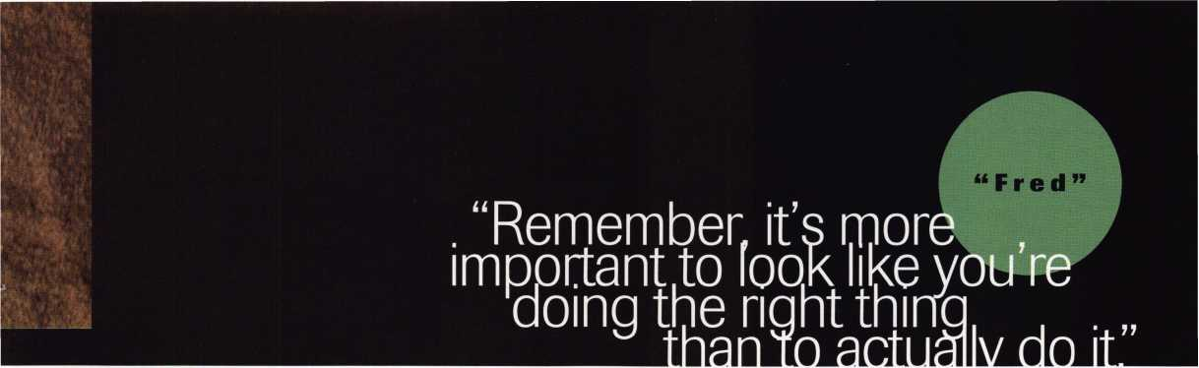

Bobby proceeds to the counter and asks the customer what he wants. Fred watches from a short distance. Bobby quickly returns with an unhappy look on his face.

“What’s the matter, Bobby?”

“The key says ‘Do Not Duplicate’, but it has ABC Lock Shop’s stamp on it. Can we copy their ‘Do Not Duplicate’ keys?”

“That’s the beauty of the authorization form, Bobby. We can copy any key we want, and the authorization form covers our behinds. You watch a pro in action.”

Fred proceeds to the counter to talk to the customer. “Good morning, sir,” says Fred.

“I see you have a ‘Do Not Duplicate’ key. I’ll need you to fill out this authorization form. There’s a $5 processing fee, plus $2 extra per copy we make of this key.”

After the customer fills out the form,

Fred proceeds to cut the keys and write up an invoice. When the customer leaves, Fred calls Bobby back to the counter. “We do it just as if we were copying our own ‘Do Not Duplicate’ keys. There’s no practical way to determine who has authority to order duplicates, because these are non-res trie ted keys and there are no identifying features to tell who the key was made for and who can have copies made. We use the authorization forms to keep the other locksmiths in town off our backs. Most of the other guys use some kind of authorization forms, too. They’re just more self righteous about it. They actually think they’re providing their customers with key control. Those guys are sticklers about the rules, so I go along with it. Remember, it’s more important to look like you’re doing the right thing than to actually do it.”

Scenario 2

Robert Smith is the president of Lone Pine Lock and Safe. He is a third generation locksmith and has a medium sized lock shop. Beside himself, there are five employees. Three service vans run outside calls, while

two employees work the counter. Bob doesn’t actively run service calls anymore, but he does supervise all the technicians and takes care of personnel training. Jim Lietzen, his newest service counter technician, has never had to deal with a ‘Do Not Duplicate’ key up until now. Today is his first test.

An elderly gentleman steps up to the counter, and asks to have a duplicate key made. Jim takes a quick look at the key and can tell (by the shape of the bow) that it is a Schlage key. It’s an after market replacement key, and he sees the key number “SCI” embossed on the bow of the key. Jim proceeds to the key rack and grabs the appro­priate key to make the copy. As he positions the key to place it into the key vise, he notices ‘Do Not Duplicate’ stamped on the other side of the key. Being uncertain about the key cutting policy in regards to ‘Do Not Duplicate’ keys, Jim quietly slips into the back room of the shop to ask Mr. Smith.

“Mr. Smith,” he calls, as he moves toward his employer’s desk. “I....”, he hesitates when he sees Mr. Smith talking on the phone.

Bob Smith signals for Jim to wait a minute until he finishes his call. When the call is completed, Bob inquires, “Is there something you need?”

“A man brought in a key stamped ‘Do Not Duplicate’”, he explains. “I don’t remember what we’re supposed to do.

Should I cut the key or not?”

“Let me take care of this customer, Jim. You watch and listen, and I’ll explain our key duplication policy in more detail after he leaves.”

Mr. Smith walks up to the counter.

“Excuse me, sir.” He approaches the customer. “I notice your key is stamped ‘Do Not Duplicate’. Might you explain what the key is for.”

“It’s just my shop key,” explains the customer.

“Our company policy requires that you bring a request in writing on company

letterhead, before we will copy a key marked ‘Do Not Duplicate’”.

The customer’s pleasant demeanor quickly changes. “What kind of joke is this? It’s my building. I don’t need a note from my mother to get a copy made. Give me my key back. There’s a place across town that will cut it for me.”

Bob Smith returns the key to the elderly man, who promptly leaves the shop.

Meanwhile Jim is observing the event with a stunned look on his face. “Our policy is to alienate the customer?” Jim asks quizzically.

“It’s not our policy to upset the customer.

It is our policy to demand proper ID to copy a ‘Do Not Duplicate’ key. I go by the book.

I learned professionalism from my father, who learned it from his father. Rules are to be followed, and I don’t believe in breaking the rules.”

“But, Mr. Smith,” asks Jim, “how do you know what is proper ID? All the key says is ‘Do Not Duplicate’. It doesn’t say what the key goes to or who is allowed to get copies.

There’s not even a serial number to look up somewhere that might identify the key.”

“You ask too many questions, Jim. This is the way we have always done it. It has worked well for us, and I don’t see any reason to change. If you don’t like our company policy, you don’t have to work here. Either get with the program, or find another place to work.”

“I don’t have a problem with it,” Jim concedes. “I was just curious.” Under his breath, he whispers, “You’re the boss.”

Scenario 3

George Galantin owns Uptown Lock and Key. He and his wife, Lisa, are partners in life and in business, and there are no other employees. He learned locksmithing the hard way, being self taught and with little help or consideration from other locksmiths in town. After more than 15 years of hard work, George has earned a reputation as

May 1998Keynotes k

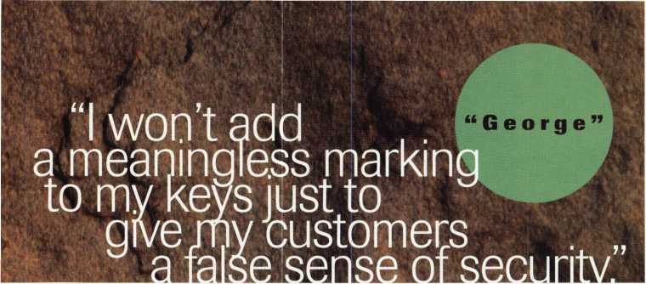

being one of the most skilled locksmiths in town. After a local newspaper called attention to his expertise, the local locksmith association offered him membership. He declined, figuring that if they didn’t want him as a member when they could have made his life a little easier, he wasn’t about to share his skills and expertise to make their lives easier. George is a maverick, and he follows his own path. He deals with 'Do Not Duplicate’ keys in his own unique way.

A middle aged woman walks into his shop one afternoon, and asks for a duplicate key. George sees a plastic cover over the head of the key and proceeds to take the key off the key ring and remove the plastic cover.

On the head of the key was stamped ‘Do Not Duplicate.’

“Excuse me, ma’am,” explains George, “this key says ‘Do Not Duplicate’.”

“You’re right,” she responds. “I’m sorry, I forgot to give you my note.” She then proceeds to hand over a request for duplicate keys on her company’s letterhead.

“I still can’t make the keys for you,” George insists.

“I don’t understand. Before they went out of business last year, Action Locksmiths told me that I would need a request on company letterhead to get copies. I had been getting copies this way for five years since they keyed my locks. They said my employees couldn’t get copies, but I could. They said that this was standard procedure for the industry.

Why won’t you cut my keys for me? I’ve got the letter.”

“First of all,” George explains, “this says ‘Do Not Duplicate’. It doesn’t say ‘except with a letter of authorization’. ‘Do Not Duplicate’ does not list any exceptions.

That means absolutely no duplication.

I will not duplicate such a key under any circumstances. I will tell you, however, the location of five key shops and two locksmiths who will copy this key for you without asking any questions. They will also duplicate the keys for your employees or anyone else who might get their hands on one of your ‘Do Not Duplicate’ keys. I met

28 | KeynotesMay 1998

Gus Walker of Action Locksmiths a few years ago. I didn’t like him. I think he cheated you. He sold you a bill of goods. There are legitimate products that guarantee patented key control. Gus knew about them, but he chose to sell you a fraud. I refuse to copy any key marked ‘Do Not Duplicate’, even though those keys deserve absolutely no protection from security professionals. I refuse to mark any of my keys that way, because it is a lie. There are patented keys that have restricted duplication, but they are already marked. I won’t add a meaningless marking to my keys, just to give my customers a false sense of security. If the lock or key manufacturer won’t back their products with the force of law, I won’t back it up either.”

“I was about to start crying,” the woman said. “You seemed like such a mean man.

But after listening to you, I’m very angry. I believe Gus cheated me, just like you said. He probably deserved to be put out of business. All this time, I thought nobody could get copies of my keys but me. If you don’t mind, I’d like to see something that will give me real key control.”

The Resolution

I’ve created some overly dramatic characters to push some important questions to think about. I personally have some problems with how all three of these make-believe locksmiths dealt with the issue of ‘Do Not Duplicate’ keys. There are, however, some important truths in how each of them saw the issue. In scenario 1, Fred Aardvark is a major abuser in regard to using the ‘Do Not Duplicate’ stamp on keys, and his policy on duplication. But he is correct about the tendency for some to become overly self righteous about people who duplicate such keys. The one who duplicates those keys might be considered unethical, but I believe that those who tell their customers that stamping their keys with ‘Do Not Duplicate’ will give them real key control are even more so

Think about it. We don’t object to

putting ‘Do Not Duplicate’ on a widely available non-restricted key and then claiming to have real key control. Imagine if someone took a low security lock and stamped ‘Do Not Pick This Lock’ on the face of it. If he then proceeded to call it high security by claiming that people would read the inscription and not pick the lock, we would correctly point him out as a fraud. Without patented key protection, and a consistent and reliable method of identification for people authorized to order copies, there is no key control.

Robert Smith, in Scenario 2, properly points out the importance of rules and tradition, but those rules and traditions must have some basis in truth. Not asking questions and burying one’s head in the sand won’t change the fact that a poorly thought- out rule is usually a bad rule.

Lastly, there is George Galantin in the last scenario. He seems to have an industrial size chip on his shoulder, but sometimes the truth is blunt and unpleasant. His person­ality won’t help him persuade many people, even though they may secretly agree with him. He may be unnecessarily harsh in his assessment of those who use the ‘Do Not Duplicate’ stamp on their keys. Those people are probably not cheats or crooks. It’s hard to escape the gravitational pull of those who taught you how things are supposed to be done. It takes a certain amount of guts to go against the grain and do things differently.

Ultimately, the industry (that means all of us combined) has to look at not only key duplication policy, but all things that we define as professionalism and ethical behavior. Before making final judgments, though, dissenting voices must be given honest consideration. Not everything we do can be divided into black and white. There is a lot of gray area, and in those gray areas we need to be tolerant of a range of opinions.

About the Author: Sal Dulcamaro,

CML, has been in the locksmith business for over  
23 years. He is the president of All Pro Security,  
Inc. in Michigan and has been an ALOA member  
for 16 years. A past president of the Locksmith  
Security Association of Michigan. Sal currently  
serves as editor of the association newsletter. He was  
named “Keynotes Author of the Year” for 1996  
and 1997.

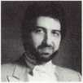

Professionalism Through  
Education"

**c°GJV^**

*°£l*

Technical Reference Manuals

Instructional Videos

• Computer Software

**to provide you, the security**

**information that is both**

**accurate and relevant to your**

**ever-changing role in the**

**marketplace. In addition to**

**serving you each month**

**through the pages of**

**LocksmstP Leo**

**published #Ms t i**

**educational and refet** v

**material to help you prosper**

*Reader Service #20*



A hinny thing happened to Bill Nichols on the way to the office. Well, it wasn’t exactly funny at the time, but at least now the EG&G Florida employee can laugh at the wild (no punjntended) mishap. “I was on my way to the Kennedy Space Center,” says Nichols, ALOA member #11081 who works at that institution through EG&G, the Base Operations Contractor to NASA. “It was in 1994 and 1 was driving to the complex for a launch. It was actually around 4 AM in the morning and 1 was coming down this road that leads to the center through its Wildlife Refuge ("enter. There were no lights on the road, it was very foggy and there was this HUGE alligator on the road. 1 tried to drive around him, but as soon as my headlights hit him he ran right in front of my truck. The truck rolled over into a ditch and 1 was trapped inside until a Fire Rescue team had to come pull me out.”

30 I Keynotes May 1998

Obviously, a head on collision with a large reptile is not a usual occurrence for most locksmiths. Nor is it a regularity for Nichols, but it is an example (albeit a very strange one) of the unexpected things that occur at the Kennedy Space Center’s complex. Nichols’ role as part of the locksmith team at KSC has always called for quick preparation when faced with split second decisions. From those big launch days to solving routine lockouts to the repairing of Icxk hardware, he’s become acclimated to working this high security facility.

“It took over a year to go through training,” he says. “It took that long to leant all the safety precautions and about the different facilities because there’s so many hazardous activities that happen out here.

“For the first several years 1 was out here 1 was a little jittery,” he says. “You really have to be mentally prepared because you never

know when you’re going to get a call at home to come out here and jump into a situation you know nothing about. You just learn how to stay prepared 24 hours a day. It’s some thing that time actually takes care of. You just have to dive in and let the other guys help you out, so you can adjusted to the job.” The Center itself encompasses 140,000 acres, some of which (as Nichols is well aware of) covers a natural wildlife refuge with wild pigs, snakes and alligators among other animals native to Florida.

Although he’s not an “institutional” locksmith, his stable role within KSC’s confines often presents him with some of the usual “institutional” dilemmas. Dealing with

certain equipment, tools and situations each

' *• -:. • • -

day often limits his knowledge of the average jobs most retailers handle.

So, often times KSC co-workers and friends often come to Nichols with various

household and auto problems among other

things. “There’s a lot of employees out there

who will stop you in the hall and ask routine

questions about their car locks or the

* * doorknobs at their house,” says Nichols. “To

be truthful, it can be somewhat embarrassing

to say ‘I really don’t know.’ A lot of times

people just don’t understand that I’m not

around that kind of stuff on a dailf basis.”

Ironically, while doorknobs or car locks

may seep somewhat foreign to Nichols, his

expeffisFwith KSC’s duties and facilities

Allowed him to assist in a crucial operation.

Recently, Nichols was instrumental in

removing a piece of teflon that became lodged

ij ah LH2 pyrotechnic can on the Space

Shuttle vehicle stack for the STS-94 mission.

Thanks to his locksmithing skills, Nichols

successfully removed the piece, allowing the

successful launch of the space shuttle.

With that, he was honored by NASA with its Space Flight Honoree Award, the most prestigious tribute paid to aerospace employees for commitment to mission quality and safety. The award is presented to less than one percent of NASA’s civil service and contractor work force each year.

His contributions to NASA and Kennedy Space Center continue the tradition that was ^set by Nichols’ father who was employed at KSC working on the facility’s air-condi­tioning. But an award under his belt doesn’t necessarily mean Nichols has it easy from here on in. If anything, it means he*ll have to work just as hard if not harder to live up to all expectations from peers and employers. To do that, he simply needs to stay prepared, something that’s allowed him to fit in

perfectly with the unpredictable nature of the Kennedy Space Center.

In the end, Nichols gets a sense of accom­plishment from is duties at the station. • Knowing that he’s helped, makes his job all ’the more rewarding. “When it comes countdown time and that shuttle flies off that pad, or when a succ&sfiil mission comes back, just knowing thati was here and got see everything and help makes me happy,” he says. “Just being involved either directly or indirectly is my favorite aspect of being stationed here.”

*About the Author. Mike Emery is the Associate Editor of* Keynotes *and a freelance mmmurha:*



**by Mike Emery**

**Although Bill Nichols is not an "institutional” locksmith, his stable role within Kennedy Space Center’s confines often presents him with some of the usual "institutional” dilemmas.**

**May 1998**

***Keynotes***



’s **In-A-Minute**

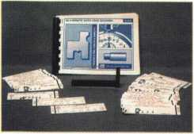

HPC s In-A-Minute Auto Lock Decoder kit comes with a reference guide book, a plastic decoder stand and about 35 decoder cards. (All fit in a compact carrying case.)

HPC has come out with a rather interesting product, the “In-A-Minute Auto Lock Decoder.” It provides a visual reference to the various sizes of tumblers made for many import and domestic auto locks, and could come in handy when trying to decode an auto lock directly from the tumblers.

The HPC reference guide book contains clear directions and diagrams about how to use the decoder. There is a seven-page index near the front that shows car brand, model and year, and lists the page to find specific information. It also lists the decoder card number used for decoding tumblers for particular auto locks.

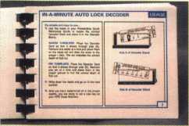

The reference guide book for the HPC s kit is pocket sized and contains both specific directions on how to use the kit and additional general information on auto locks.

Basically you utilize a series of 35 decoder cards and a specially designed plastic stand to decode the depth for each cut. There are two sides to the decoder stand. One side is used for decoding pin tumblers, and the other side is for decoding common automotive wafer (disc) tumblers or sidebar wafer tumblers. There are only two pin tumbler decoder cards that are used on the one side of the decoder stand. One is for Chrysler 1969+ and the other for Ford 1965 + . All the rest of the cards are for disc tumbler (or sidebar tumbler) locks.

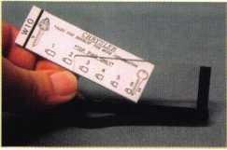

The HPC decoder cards slip easily into the plastic decoder stand. One side of the stand is used for decoding pin tumblers, and the other side is for decoding common automotive wafer (disc) tumblers or sidebar wafer tumblers.

May 1998

Here are some highlights of how the reference guide is set up.

**CHRYSLER**

The reference page for the Chrysler pin tumbler auto lock shows a  
reproduction of the decoder card plus some additional useful  
technical information about Chrysler auto locks of that era. The All  
Lock brand tumblers and service kit part numbers are listed, as are  
key blank, key code, and HPC code machine and punch accessories  
for cutting keys to fit those locks.

**FORD**

There is similar technical information in the guide  
book for Ford pin tumbler lock top pin tumblers  
used after 1965, and key blank, code and key  
cutting information. The key blank section  
illustrates both the primary and secondary key  
blank keyway profiles. It also indicates the  
direction for inserting each of the keyways  
into the HPC punch style code machine  
for cutting the keys.

23056

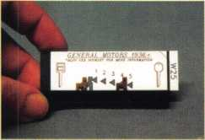

Here’s a Ford pin tumbler decoder  
card in the decoder stand. Note the five  
different sizes of top pins used for the  
Ford pin tumbler automotive locks.

(The sixth pin tumbler slot — far right —  
is not used for Ford locks.)

**GM**

The book references many GM and GM-  
related automobiles. Many of the listings on that  
index page identify information on lock tumblers  
and specific key cutting information. Some of the  
pages give other important key and lock related  
information.

The 15 different value VATS single sided key blanks along with the STRATTEC key numbers are listed. Also noted are the plastic adapter keys used with STRATTEC brand VATS interrogator devices. Plus you'll see the STRATTEC number for the metal work key used for mechanical operation of a VATS style ignition lock (but without a resistor pellet).

The various coded ignition locks used in General Motors vehicles are illustrated- some for use with VATS equipped GM cars and some for strictly mechanical ignition locks. The physical appearance of the different ignition locks is shown and the specific applications and STRATTEC part numbers listed.

32| Keynotes

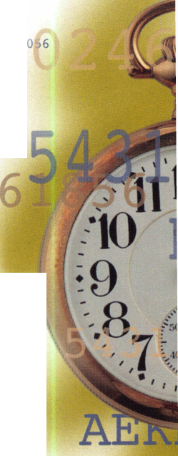

Lock Decoder

lif Sal Oaieamaro* OWL

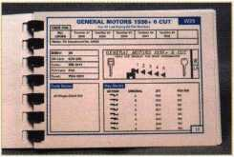

There is a page in the guide book for GM tumblers used with the  
six-cut single sided key style auto locks. GM locks in that  
category used flat wafer type side bar lock tumblers. All  
Lock brand tumbler and kit part numbers are indicated.  
Arrows show the height of the “V” shaped notch in

each of the five different size side bar tumblers.  
Again, HPC code machine and key punch acces-  
sories are referenced. Also, the eight standard  
single sided keyways are shown. The physical  
keyways are illustrated, and the lettered  
keyway references (plus Jet brand key blank  
numbers) are indicated.

The decoder card for GM 6-cut style  
tumblers has been inserted. On this side  
of the stand, each tumbler is set on a  
ridge and is visually compared with the  
arrows indicating the five different heights  
of the “V” shaped notches found on  
standard GM side bar lock tumblers.

By lining up the center of the “V” notch  
of a particular tumbler to the point of one of

five (sideways pointing) arrows, you should be  
able to determine the tumbler size.

Standard size head double sided VATS key blanks

are shown in the guide, with STRATTEC numbers  
used to identify the VATS values, and the adapter and  
work keys. Similar information is included for large head

double sided VATS key blanks.

For the GM 10-cut style, tumblers and service parts are listed using STRATTEC part numbers, and HPC code machine and punch accessories are referenced. The 10-cut system uses side bar tumblers for the ignition locks and disc tumblers for the door locks. Code series information is listed below the keyway drawing. One note: there is only one keyway referenced on this page, yet there are different length keys used for 10-cut style locks. That shouldn’t interfere with your ability to decode the tumblers, but you may have to use another reference guide to find the correct key blank for a specific application.

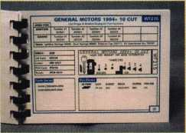

In the HPC guide, the GM 10-cut style, tumblers and service parts are listed using STRATTEC part numbers, and HPC code machine and punch accessories are referenced. The 10-cut system uses side bar tumblers for the ignition locks and disc tumblers for the door locks. Code series information is just below that.

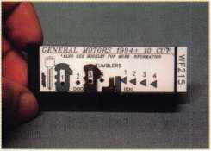

The left side of the GM 10-cut decoder card is for the disc tumblers, and the right side is for the side bar tumblers. The variously positioned black dots indicate the sizes of the disc tumblers. The disc tumbler setting on the ridge of the decoder stand is obviously a #3 tumbler. The side bar tumblers for the 10-cut GM locks are similar to the older style 6-cut side bar tumblers, but they should be gauged using the appropriate decoder card. The old style side bar tumblers have five sizes, while the new style have only four sizes. Also, the new style has false “V” notches. Make sure you decode the full depth “V” notch rather than a false notch when decoding these newer style tumblers.

**WATCH THE CARDS**

Most of the other import or domestic decoder cards will decode a single type of tumbler. The Ford 10-cut and 8-cut each have both disc tumbler and side bar tumbler references on the same card, similar to the GM 10-cut. There may also be a few others. Car locks change so fast these days, that some of the newer cars are not listed.

I presume newer versions of the kit will be more up-to-date. You should be able to buy the “In-A-Minute Auto Lock Decoder” from most suppliers that normally stock HPC brand products.

About the Author: Sal Dulcamaro, CML, has been in the locksmith business for over 23 years. He is the president of All Pro Security, Inc. in Michigan and has been an ALDA member for 16 years. A past president of the Locksmith Security Association of Michigan. Sal currently serves as editor of the association newsletter. He was named "Keynotes Author of the Year” for 1996 and 1991.

May 1998

Keynotes

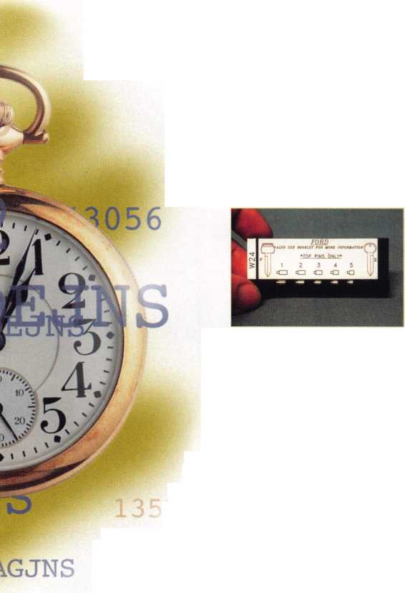

or those of you who were wondering, no ALOA ’98 hasn’t been blown away, so to speak. None of our facilities or plans were affected by Nashville’s recent tornado. So don’t worry—that whirlwind of excitment you feel is just the thought of the trade show, the classes and the fellowship. Country music stars milling around during Fan Fair, the historic downtown area including Second Avenue and Riverfront Park. The Country Music Hall of Fame. It’s all there waiting for you.

AABLE Locksmiths

Well once again GM has come out with another ignition lock design, and Frank Markisello from AABLE locksmiths has designed a tool to simplify the removal and replacement of this new lock. His tool kit will allow you to remove a steel face cap in seconds. Then with the drill guide tool you can drill an access hole in line with the side bar without hitting the hard plate or the side bar. Then you can rake the side bar in, so you can turn cylinder to the “on” position for fast removal. Then just replace the cap and reinstall same lock. The first job will more than save you the cost of the tool kit!

P| Contact

Frank Markisello at

(718) 847-1377

HI%' Booth # 7/9

ALOA had to release the unbooked rooms at the Renais­sance Hotel (the ALOA ’98 convention hotel) on May 10. If you decided to go after that and are having trouble finding a room, call the Nashville Visitors Center at (615) 259-4700. They’ll do their best to help you get situated.

There have been some slight modifications with the ALOA ’98 class  
line up. The Allstate Insurance seminar has unfortunately been canceled.  
In its place, however, is a most competent replacement seminar entitled  
“Labor Saving Devices,” something everyone can certainly use if not  
learn more about. This will be a three-hour seminar that gives various  
tips on wiring techniques, access control installation techniques and  
other assorted helpful hints.

The June 20 meeting starts at 6:30 am for those of you who want breakfast and at 8:00 am for those of you who want the extra sleep on Saturday morning. Be sure to be there this year. This is your chance to vote in the right of ALL members to vote-by-mail and to elect the directors from their regions. (See amended bylaws, p. 43.)

Now the main event for this month. Following are some behind-the- scene glimpses of the products coming to ALOA ’98 along with a foil list of exhibitors and a bird’s eye view of the Security Expo trade show floor at the Nashville Convention Center. Hope this whets your appetite to see the real thing.

About all those country stars walking around during Fan Fair, if you would like to go to the actual event, reas on. The official dates are June 15-20 and the sponsors are Tft Grand Ole Opry and the Country Music Association. Fan Fair offers over 35 hours of stage shows and other musical events, picture and autograph sessions with country music stars. Admission includes all scheduled activities and concerts, two meals and tickets to the Ryman and Country Music Hall of Fame. (Registration does not include your Grand Ole Opry ticket.)

For pricing and registration information:

Fan Fair

2804 Opryland Drive Nashville, TN 37214 (615)889-7503

A&B s new addition to its product line is the AB-3 M depository safe. This safe comes standard with a dual key lock or combination lock. Electronic locks can be installed as an option. This safe is ideal for use in trucks, carts or under the counter.

Contact: (800) 253-1267 Booth #318

34 Keynotes

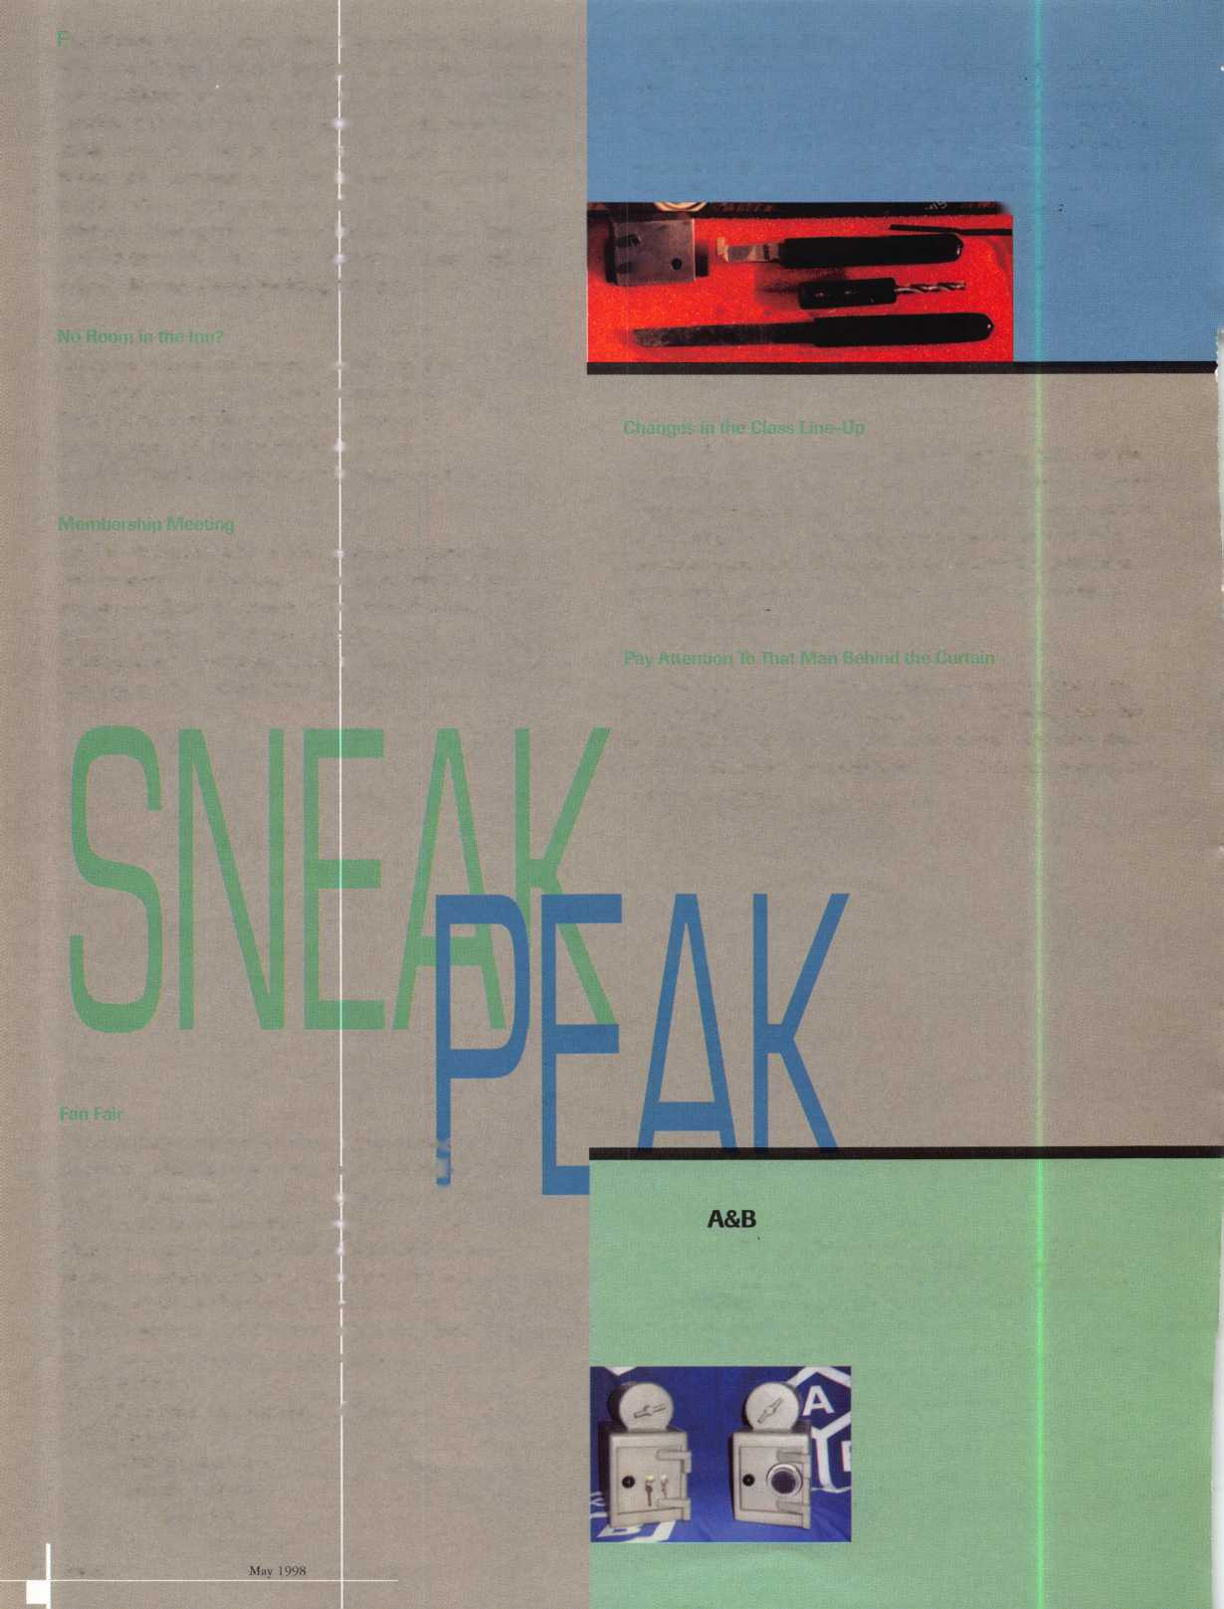

AMSEC

AMSEC’s

new Two-Hour Premium fire safes are priced comparably

with typical One-Hour fire safes. AMSEC s products has features that  
place them in a class of their own. Each safe carries the U.L. Class 350  
degree, two hour fire/impact rating and is  
, • | accented in a durable sandstone or granite

^ textured finish, decorative emblems and an

fMPr \ 11 elegant plush interior.

| Contact your AMSEC distributor.

, ... Booth #610

ADI’s newest systems catalog is cutting edge and offers the latest products and information for Access Control and CCTV applications. It serves as both a sales guide and reference tool filled with up-to-date information and charts to assist installing dealers and locksmiths.

Contact: (800) 233-6261.

Booth mi 18

Now replace most 8-cut Ford ignition locks, including those made by HUF, with ASP’s Hurd manufactured 8-cut locks. Assortment K- 42-208-C contains the two most popular design locks in uncoded, coded and PATS versions. This is a $143 value specially priced at $115 and includes a carrying case.

Contact your ASP distributor.

Booth #430

Adrian Steel Company

Designed especially for locksmiths, Adrian Steels 2255 Locksmith Package includes a workbench module and stool, catalog file, drawer cabinet module, and partition. Inside is a KMB36 sloped Key Machine Base for convenient machine operation, and a place for key blanks. Plus there is plenty of storage for small parts and lockable cabinets for tools. Contact: (800) 677-2726. Booth #536

Aiphone

Communication

Systems

Aiphone introduces the color Video Sentry Door Answering Intercom System. It provides the security and convenience of being able to both hear and see, in color, who’s at the door before answering it. Plus, the color Video Sentry uses the same two wires as an ordinary doorbell system, keeping installation costs low.

Contact: Tracy Johnsen at (423) 433-0310 Booth #338

BiLock

BiLock now offers a complete range of high security padlocks including small plastic bodies, “QC” removable core solid brass bodies, and the LocGard solid stainless steel protected shackle model. BiLock now has what the industry requires to secure almost anything. All models utilize the patented 12 pin dual side bar design and the unique dual bladed key with over 16 million combinations. These padlocks are the smart choice for large master key systems where all locks, (including doors, desk, cabinets, electric switch locks, and padlocks) are on the same master key. Key control has never been better!

Booth #207

American Lock

American Lock Company is expanding its produce offering to include brass and aluminum padlocks with 5" ^ long shackles. The longer shackle length satisfies the

||g||i| physical requirements of locking up food service

^ life1, equipment. American Lock offers this new longer length

shackle on two popular styles of brass and aluminum gOyJ models.The shackle is 5/16" diameter, precision

machined from boron alloy steel. It is case hardened for extra protection against cutting and chrome plated to resist corrosion. The 1 3/4" wide lock body can be ordered in brass or aluminum, in a choice of 5-pin or 6-pin security, and with all the standard American Lock keying and service options.

Contact: (800) PADLOCK Booth #721

S m,H ’

t'hitk

/Wix*

Keynotes

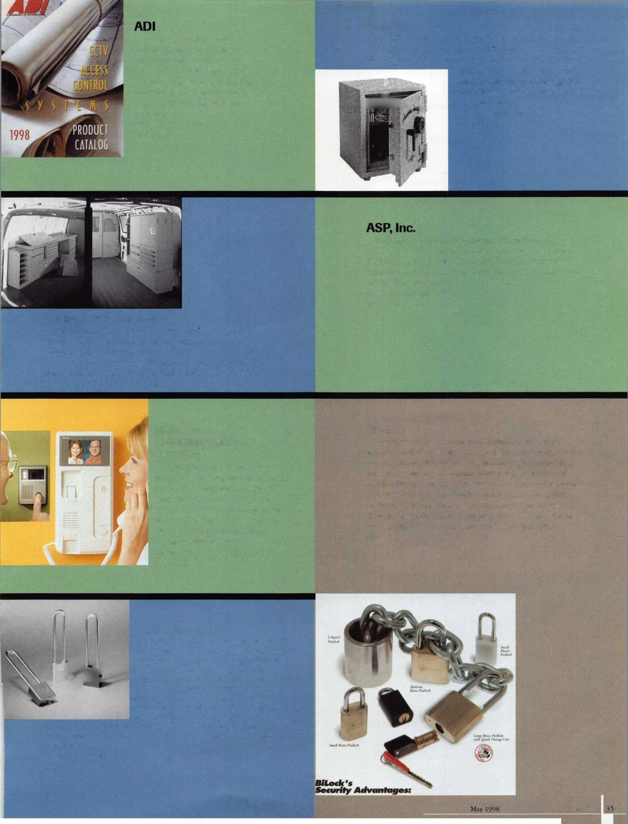

Systems Setup gu)k Cleaj Pimtet Holes

Buddy Products

New from Buddy Products is the Cash Controller. Keep your money in place with the spring-loaded money clips! The five-compartment coin tray automatically lifts with lid for easy access to the storage area. Prevent unwanted money visibility with a lid that stops 90 degrees from the resting position. The wafer tumbler lock comes with two keys.

The product is recycled textured steel with a baked-on enamel finish (available in platinum).

Contact: Bill Reed at (312) 733-6400.

Booth #307

Safe Combination versi

Generator

from Blackhawk Products

Copyright 1997. 1998 by Roger Weitzenkamp. CML

Your company name here address line city state zip

Start from any number. Turn the dial slowly and deliberately If you go past a number, start over

Blackhawk Products

The Safe Combination Generator (SCG) generates safe combinations for you. It stores the properties of each safe lock or customer’s location. Then it prints combinations (with opening instructions) for you to use each time you change the lock. You can specify ending digits, forbidden zone and number separation for each job or lock.

Contact: Roger Weitzenkamp at (970) 882-7191.

Booth #925

CCL Security Products

CCL Security Products announces the return of the K410 Sesamee Padlock for shipments this summer. The new K410 has a pressure cast body that houses a combination of brass and zinc mechanisms. It has a 11/16" chrome plated hardened steel shackle with a double locking feature for extra protection. The K410 comes with a lifetime guarantee.

Contact: Kristie Cain at (860) 229-6199.

Booth #303

Corby Industries

The 6000 Series Programmable Keypad from Corby Industries, Inc. provides an array of sophisticated access control features. Operating one door (or other relay controlled devices) for up to 36 people, it can be programmed, from the keypad, using a three-to-six digit code length. The program­mable keypad provides up to four input conditions, supporting Request-To-Exit, a silent panic input and, with the addition of a magnetic door contact, it will report a “door ajar” and/or forced enrry condition. All inputs call be assigned to any combination of the four available outputs: a Main Relay rated at 5 amps, an Auxiliary Relay rated at 1 amp, or to either or both of the two voltage output lines rated at 50 ma each. Each output can be programmed for a momentary operating time of 1-99 seconds or latching (on/off).

Contact :(6>10) 433-1412, Booth #602

Ford 8-Cut  
LC6177(U)  
LC6180

Chrysler 8-Cut  
SK6949

BWD Automotive announces the new Lockcraft brand LC6l77(U) and LC6180 Ford 8-Cut ignitions and SK6949 Chrysler 8-Cut Service Kit. Fitting virtually all 8-Cut vehicles, the new Lockcraft LC6177 (U) and LC6180 ignitions fit both transponder and non-transponder equipped Fords. The LC6177 is a coded lock supplied with non­transponder keys. The LC6180 is the same lock supplied with two transponder keys. The uncoded LC6l77Us one-lock-fits-all feature, minimizes inventory and eliminates vehicle application problems. Warranty terms and conditions available upon request Contact: (334) 874-9001 Booth 11723

Crest

Electronics, Inc.

Crest Electronics, Inc. offers the J V-4-S, a complete full feature, real time quad system with single picture enlargement that combines four separate cameras into one video signal for display, transmission or recording. 100 degree picture compression.

Contact Dennis Castelli at (888) 30-CREST.

Booth #342

Keynotes

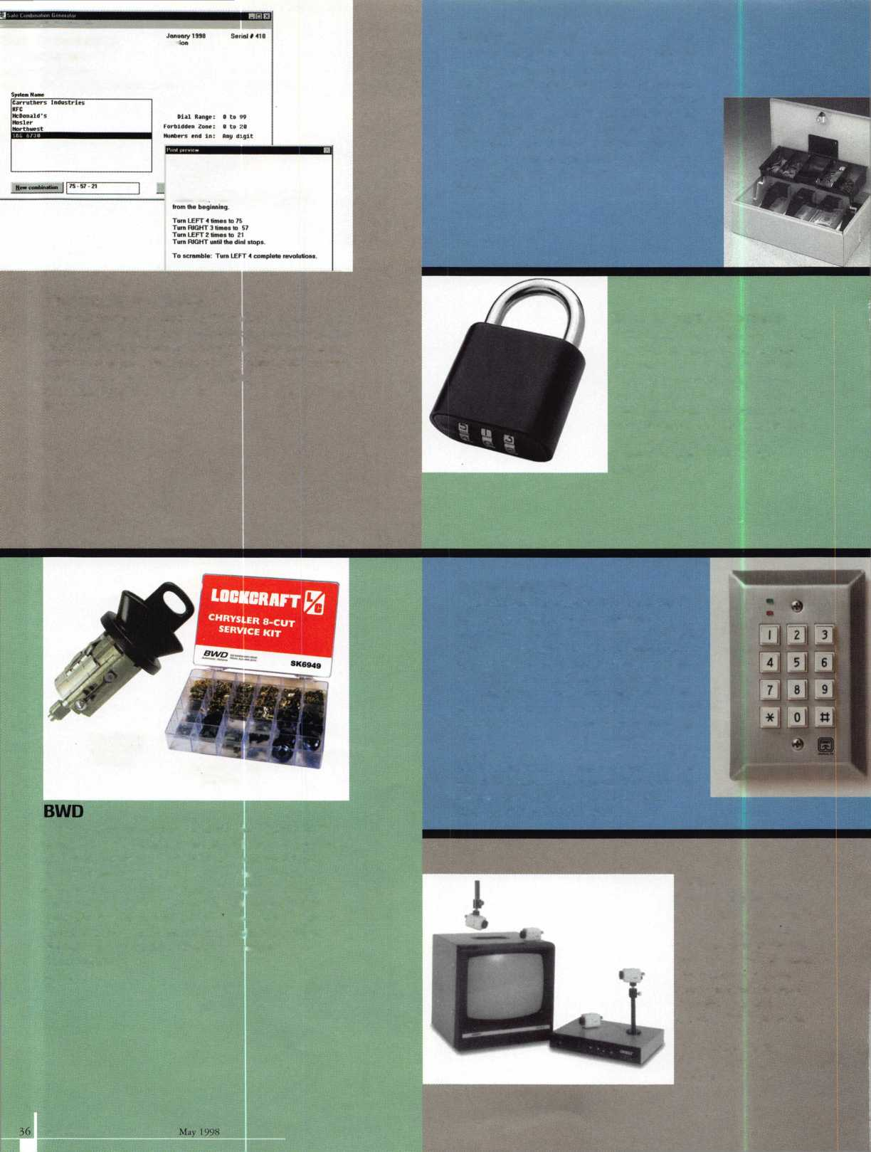

Hurd Corporation

Original Design PATS Key Blank available to the Locksmith for the first time! More durable than the current O.E.M. design, the key uses the same compounds Gcxxiyear uses in its racing tires. Reduce your returns, increase customer satisfaction. Available only from Hurd.

Contact Scot Hooper (423) 787-8800 Booth #429

Dugmore & Duncan, Inc.

The new SARGENT 8200 Series Mortise Lock is easily  
handed without disassembling and comes with a stainless  
steel 3/4" one piece, anti friction reversible latchbolt and a  
stainless steel 1" throw deadbolt with hardened steel  
rollers. It has a 12 gauge heavy duty case and cap, a  
universal non-handed curved lip strike, and can be  
electrified. The SARGENT 8200 has a stainless steel  
non-handed guardbolt, the inside front is full 1/8" cold  
rolled steel, and there are hubs and spring cartridges for  
increased security and durability.

Contact: (800) 223-1593  
Booth #337

llco Unican Corp

Ilco Unican’s new ECM 100 computer­ized code machine is designed to deliver superior performance at an affordable price. Capable of operating as an extremely versatile stand alone unit, the ECM 100 can also be connected to a PC to further enhance it's already powerful internal database. Simple to operate, the ECM 100 offers outstanding key cutting accuracy along with a full range of useful multi-purpose features designed to make your code cutting tasks easier and more efficient.

Contact Dave Fulbright at (252) 446-3321 Booths 1000 & 1100

Framon

This computer driven code machine is packed with  
features including a complete Reed Code Database. It looks  
up and cut keys by manufacturer or by code number; has a  
machine history feature that stores cutting specifications of  
any key cut on the machine; and provides complete user  
control over all aspects of the machine. The FRA-2001  
offers automatic widening of cuts; standard plunge cuts or  
laser cuts; and free program and code updates for one year.  
The machine is covered by Framon s one-year parts, labor  
and freight warranty. The control box is covered by a  
lifetime warranty. The minimum system requirements are  
Windows 3.1 or 95,386 or faster processor, 4MB RAM,

20 MB free on hard drive

Contact: (517) 354-5623, Booth #441

Jet Hardware

Locksmiths can now duplicate with confidence most of all of the automotive transponder keys with Jet’s new EDT-1.

Place the original key in the slot, push button #1 to identify the manufacturer and decode. Remove and place the blank in the same slot, push button #2 and the code is duplicated to the transponder in the blank. The EDT-1 comes with five each transponder key blanks to fit Accura, Audi, Cadillac Catera, Honda, Mazda and Volkswagen.

A colorful window advertising decal is included.

Contact: (718) 257-9600 Booth #301

HES/Hanchett Entry Systems, Inc.

The HES 5000 Series is a revolutionary new concept in electric strikes, designed with only a l'-l/l6" backset for low profile installations but with the strength of a high security product (2,385 lbs holding force). In addition, this product comes with six interchangeable face plates and field changeable fail-safe or fail-secure function. Contact: Laurie D. Webb at (602) 582-4626 Booth #637

High Tech Tools

The High Tech Tools 1998 Model 2600 Lockout set includes 35 tools including all specialty tools; a remote access system; domestic and import car, truck and van lockout manuals with Instructions; computer generated diagrams; and step by step photo instructions. Also included are an information manual; an auto lock service manual, safe side airbag and door panel service manuals; wedge system; strip savers; probe light; Instructional video; and hard molded carrying case.

Contact: High Tech Tools (800) 323-8324. Booth #1021

JLM Wholesale

JLM stocks Locknetic s new “pm” line of stand alone single door access control locks. The line is available in cylindrical and mortise locks; is easy to program via digital keypads (three to eight digits), and supports a standard of 20 users, with 150 optional. It is a perfect replacement for mechanical push button locks, which only provide one user code at a time.

Contact: Ken Andridge (800) 522-2040 Booth #606

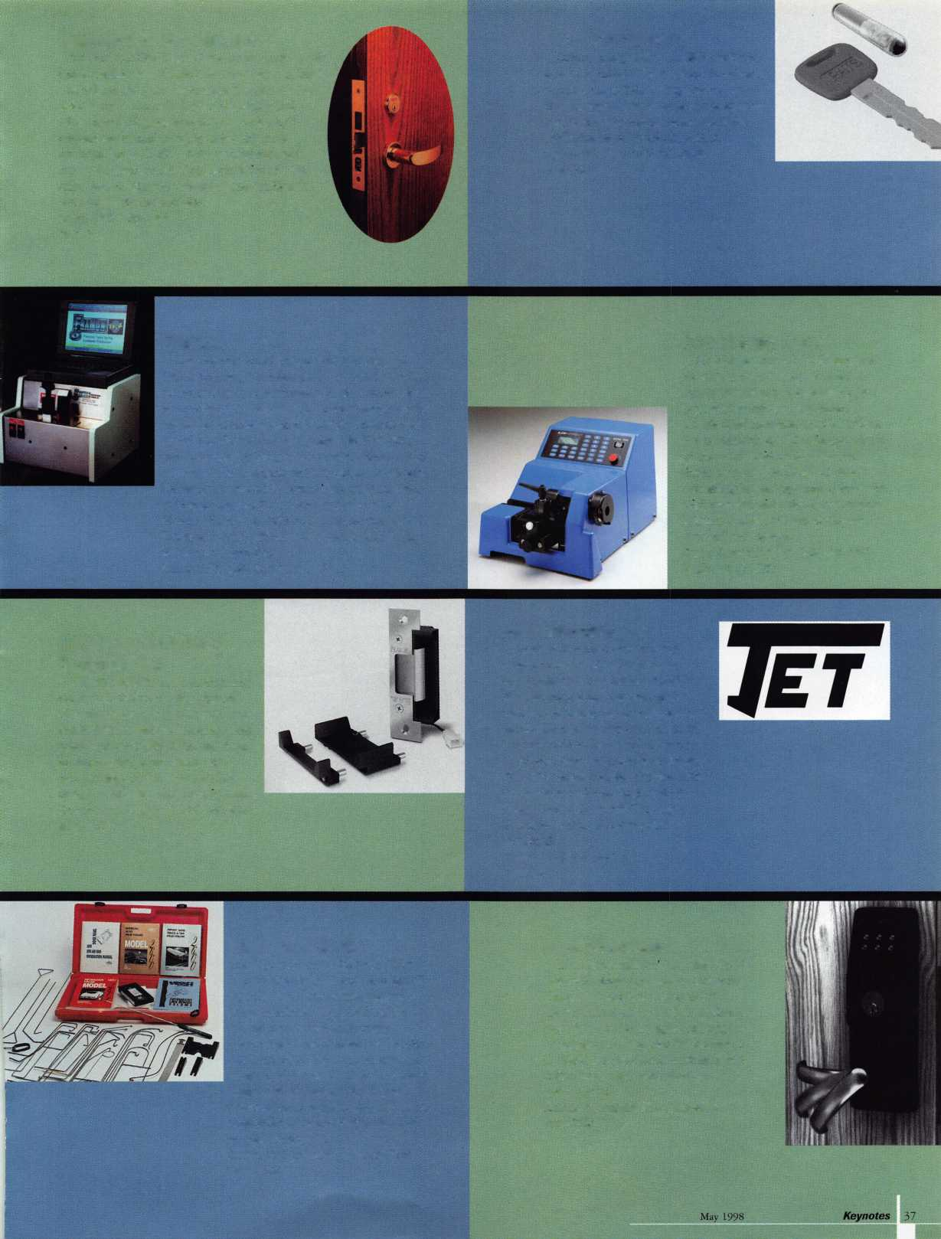

Keedex, Inc.

The SPIN OUT by Keedex, Inc. removes even the most stubborn cam screws from mortise cylinders. The SPIN OUT features a screwdriver with an oversized handle for extra torque and includes four sizes of interchangeable screwdriver bits - two slotted and two Phillips.Visit the Keedex home page at: [www.keedex.com](http://www.keedex.com) for more information. Free catalog available.

Contact Cormac ‘'Mac” Dorsey at (714) 636-5657 Booth #1119

Lockmasters

The 457 Magnum has long been the fixed-position safe drill rig of choice. The improved 457 Magnum is lighter weight, easier to set up and has a new-style barrel assembly. The new barrel assembly has no exposed threads. The bearings, top and bottom, guide the drill assembly accurately and without effort. The most improved new feature is a quick release coupling that attaches to the frame allowing complete removal of the barrel assembly. Will retrofit with the older 357 Magnum and 457 Magnum and can be purchased separately.

Contact: (800) 654-0637 Booth #807

KJEY-BAK, a division of West Coast Chain Mfg. Co., offers the SUPER 48-all new in 981 The product has a 90 degree Cable exit, easy pull and a long life. The ball/socket feature protects the springs, secures heavy items; and the clip/loop design serves a dual function with the “Anti Snatch” feature. KEY-BAK Super 48 has a contemporary, rugged appearance; an oversize split ring that carries more; bullet proof plastic & stainless steel construction; and the option of a customized or private label.

Contact: Shirley Paugh at (909) 923-7800 Booth # 712

Lucky Line Products, Inc.

Stock the most affordable key organizer available - the Lucky Line Key Organizer No.6l000. Made of shatter-resistant polypropylene, this rugged key cabinet hold up to 24 keys. The product installs in minutes (screws provided). It measures 8-l/2"W x 10~I/2"H x 1 3/4"D and is perfect for home, office or garage. Contact: (800) 654-6409. Booth #902

The Knight Safe “DS” Series  
(Depository Safe) is designed for  
daytime protection of cash and  
deposits. Complete with  
oversized doors to accept cash  
trays, the “DS” Series is available  
in top load recessed rotary, font-  
load mailbox type and slot

models.

Will accept any type of

combo, digital or key locks. New this year is the mini version,which is  
21” and comes in both rotary and front loads.

Contact: Bernadette Adams at (800) 872-2458 Booth #1011

Labor Saving  
Devices, Inc.

Labor Saving Devices, Inc. offers the  
most complete line of original, value-  
added, professional tools to run and  
conceal wires and cables in pre-wire or  
retrofit applications. The lint; includes  
flexible and specialty drill bits; fiberglass  
wire running kits, push/pull rods and  
fish tapes; telescoping push/pull poles;  
wire and cable testers and identifiers,  
and numerous accessory tools.

Contact: Carol Simian at (800) 648 4714  
Booth #340

MBA Mini-Safes are the perfect way to protect small, easily stolen items. The user selects any four number combination to lock the safe. The safe can then be opened only by entering these same four numbers. An anti-manipulation feature prevents unautho­rized persons from trying to “guess” the combination. An optional activator key makes the Mini-Safe ideal for hotels, firing ranges, athletic clubs-anywhere!

Contact: Mark Bates or Barry Boston at (888) 622-5994 Booth #837

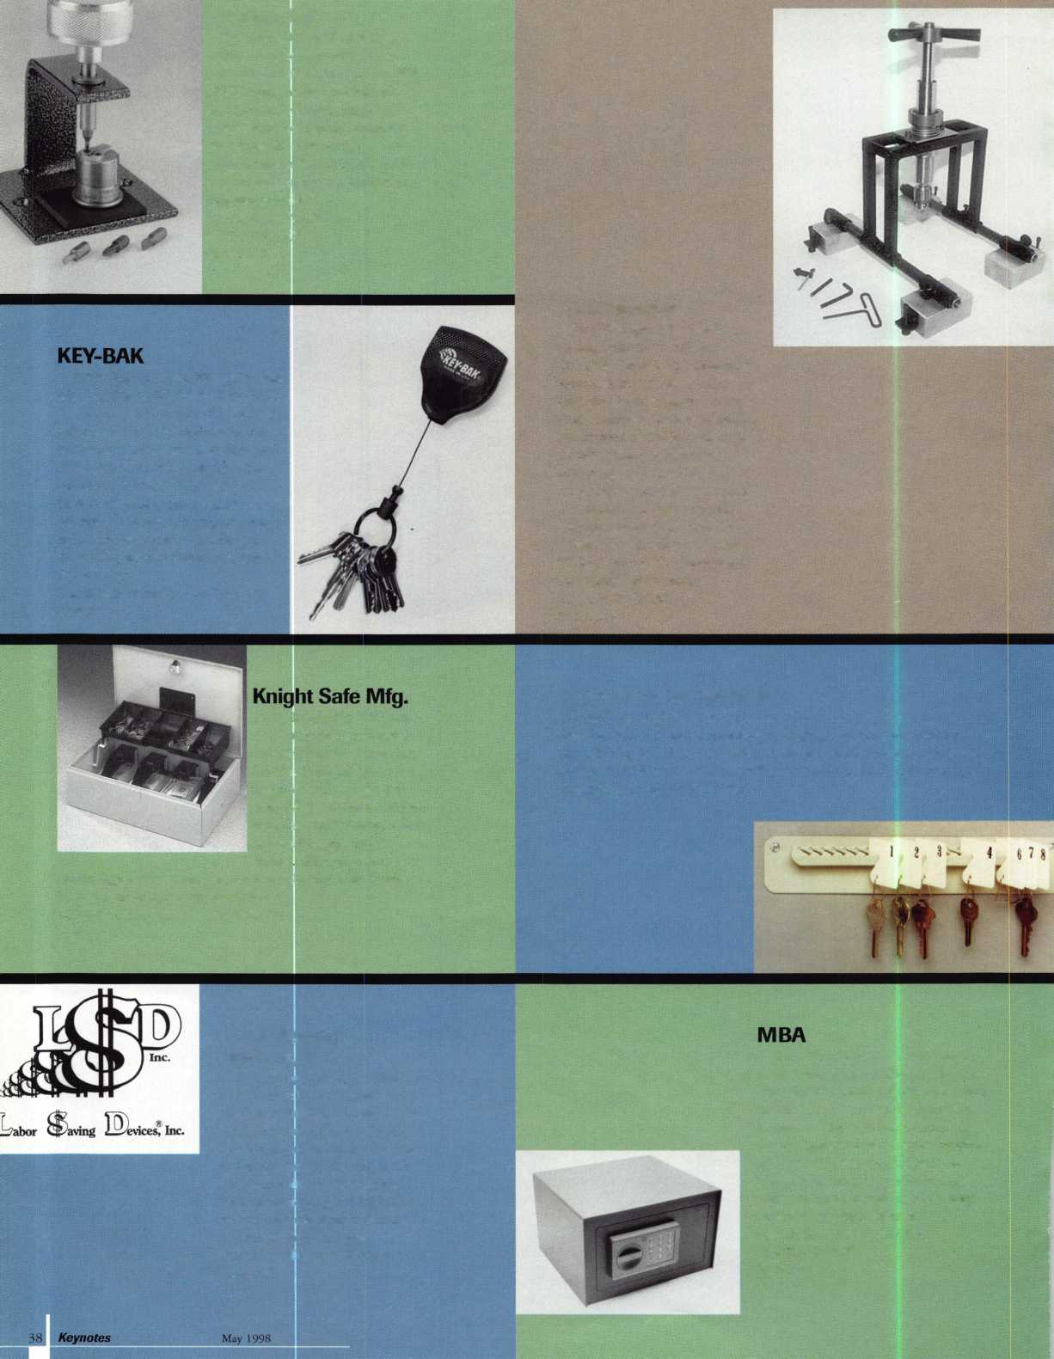

Meilink

Introducing the ultimate  
weapon for protecting valuable  
documents against fire-the  
Meilink 2-hour file. These files  
are the only American-built  
insulated files with a two-hour  
rating from Underwriters  
Laboratories. If you want to  
have the world’s very best  
protection for your important  
documents, add the Meilink  
2-hour to your arsenal.

Contact:

(800) 634-5465;

Booth #500

This year we will display our new Focuscope System with 55 acces­sories to choose from! Also, our low cost state-of-the-art cameras and monitors will be displayed for hands-on demonstrations. Our rod lens borescopes now come in standard 25" lengths with “corrected” views (no mirror images) for changes key safe openings.

Contact. Paul Butler at (813) 653 1180 Booth #817

Markar Products, Inc

Markar Products, Inc.

Markar is displaying their continuous pin & barrel detention hinge: FM 3500, FS 3501 and FS 3502. The products is 12 gauge 304 stainless steel and supports a maximum of900 lbs. and 4' width. The Markar hinge is fire rated; has torx screws with security studs; a standard hospital tip; is symmetrically templated and non-handed; and is ideal for 2" thick swing style doors, gates, prison doors and extra tall/heavy doors.

Contact: Kevin Hamilton at (116) 685 4104 Booth #213

MIWA’s Patio Guard is a security dead lock for sliding doors. The product can be keyed from the outside or non-keyed for the inside as well. It comes in three finishes - dull chrome, brown or white. This attractive lock will give extra security for older or new patio doors that slide and is easily installed. It works also on cabinets doors, camper shells, etc. Ask your distributor for MIWA’s NDS Patio guard. It’s a winner!

Contact: Pete Wilson at (800) 397-4631 Booth #212

Medeco Security Locks

Medeco will be exhibiting their Embassy Cylindrical Locks Sets at ALOA ’98. These locksets have a limited lifetime warranty and feature a durable clutch. The product was cycle tested over 1,000,000 times. Embassy levers & knobs accept Medeco high security cylinders, Key Mark key control cylinders and other popular cylinders. There is an added bonus of ADA compliance with the Medeco name. Embassy comes in Grade 1 heavy duty and Grade 2 plus.

Contact Jeanie Calhoun at (540} 380-5000 Booth#800

Keynotes

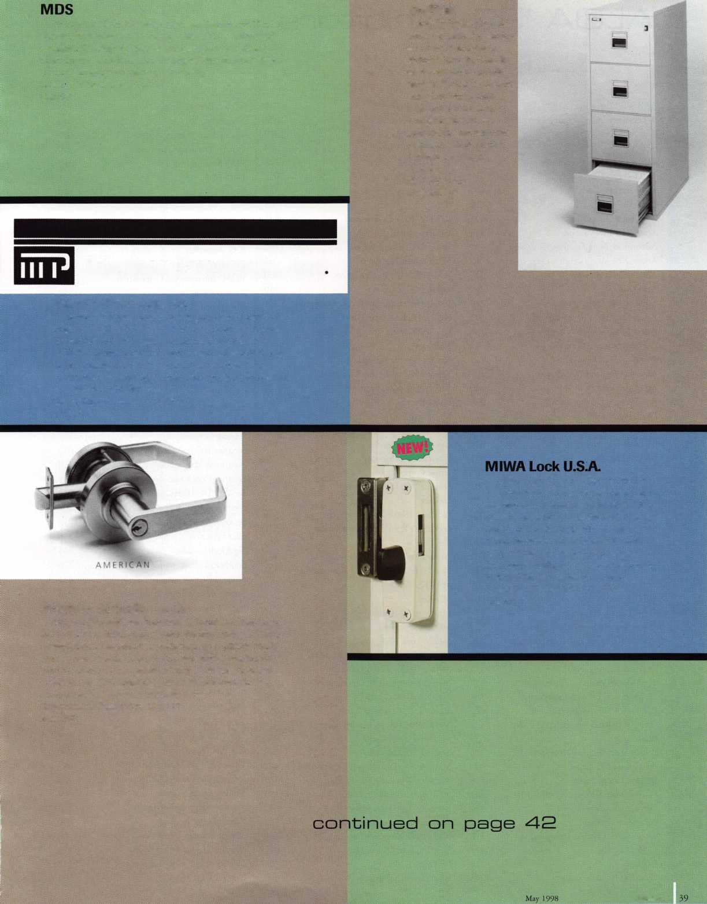

**ALOA ’9E3 Exhibitors**

A&B Safe Corporation 318

A-l Security Manufacturing Corporation 409 ADI Incorporated 1118

ALOA 722

ALOA Legislative Committee 1023

ASP Incorporated 430

ASSA Incorporated 1101

Aable Locksmiths 719

Abus Lock Company 601

Access Hardware Supply 818

Adams Rite Manufacturing Company 345

Adesco Safe Manufacturing Company 917

Adrian Steel Company 536

Aero Lock 239

Aiphone Intercom Systems 388

Alarm Lock Systems Incorporated 402

Alarm Monitoring Services 700

Allstate Insurance Company 605

American Lock Company 721

American Security Distribution 206

American Security Products 610

Architectural Control Systems 227

BWD Automotive 725

BiLock North American Incorporated 207

Blackhawk Products 925

Buddy Products 307

CCL Security Products 503

Chicago Lock Company 507

Cincinnati USA 1110

Clark Security Products 1009

Commercial Van Interiors 1113

Corbin Russwin Architectural Hardware 1129 Corby Industries Incorporated 602

Crest Electronics Incorporated 542

Curtis Industries 729

DETEX Corporation 1208

Defiant Safe Incorporated 231

Direct Security Supply Incorporated 224

Don-Jo Manufacturing Incorporated 826

Door Controls International 702

Doorking Incorporated 815

The Dorma Group 217

Dugmore and Duncan Incorporated 337

ESP Lock Products Incorporated 612

Emergency Road Service Incorporated 322

Enhance 1024

Folger Adam Security Incorporated 413

Ford Motor Company 344

Fort Lock Corporation 713

Framon Manufacturing Company Inc. 441

Gardall Safe Corporation 326

Geoffrey Industries 824

Global Door Controls Incorporated 218

Glynn Johnson 312

G.P.L.A. 219

Guardian Personal Security 1246

H.E.S. Incorporated 637

HPC, Incorporated 1008

Handi Disc/Handi Bits 1212

Harloc Incorporated 205

The Hartford 828

High Tech Tools 1021

Hurd Corporation 429

IDN Incorporated 408

INTELLIKEY Corporation 841

ISC Exposition 221

Ilco Unican, Corporation 1000,1100

J.S.A. International 237

JLM Wholesale Incorporation 606

Jackson Corporation 230

Jet Hardware Manufacturing Company 301 KABA High Security Locks 830

KEY-BAK/West Coast Chain Mfg. 712

KSP 916

Keedex Manufacturing 1119

Knaack Manufacturing Company 836

Knight Safe Manufacturing 1011

LAB Security 900

L .C. Clark 914

LCN Closers/Div of Ingersoll 316

Labor Saving Devices 340

Liberty Safe & Security 742

Linear Corporation 1016

Lockmasters, Incorporated 807

Locknet 803

Locknetics Security Engineering 336

Locksmith Publishing Corporation 321

Lori Lock 813

Lucky Line Products Incorporated 902

M.A.G. Engineering & Manufacturing 526 MARKS, U.S.A. 530

MB Key 406

MBA 837

MDS Incorporated 817

MIWA Lock USA 212

MUL-T-LOCK USA, Incorporated 617

Markar Products Incorporated 213

Marray Enterprises Incorporated 1020

Mas-Hamilton Group 518

Master Lock Company 611

McDonald Dash Locksmith Supply 1014

Medeco Security Locks 800

Meilink Safe Company 500

Midwest Safe Distributors Incorporated 427 Midwest Wholesale Hardware 1105

NKL Industries Incorporated 1137

National Auto Lock Service 642

National Cabinet Lock 711

National Security Safe Company 1109

New England Lock & Hardware 921

Newman Tonks 300

Noble Security Products 202

Norton Door Controls 1125

Nostalgia 540

Olympus Lock Incorporated 603

Omaha Wholesale Hardware 320

PDQ Manufacturing 210

PRO-LOK 331

Papaiz USA Ltd. 820

Perma Vault Safe Corporation 927

Perry Blackburne Incorporated 201

Prime-Line Products Company 1107

R. Q. Associates 1029

RA-Lock Company 1103

ROFU International Corporation 501

Reilor Incorporated 1232

Rose Products 438

Rutherford Controls Incorporated 607

S. Parker Hardware Manufacturing 1026

SARGENT Manufacturing Company 639

SERLAC 225

STRATTEC Security Corporation 426

SAVTA 638

Sargent & Greenleaf Incorporated 821

Schlage Lock Company 412

Schwab Corporation 517

Securitech Group Incorporated 1032

Securitron Magnalock Corporation 310

Security Door Controls 739

Security Lock Distributors 937

Security Solutions 704

Sentry Group 1013

Silent Auction 236

Slydelock Canada 543

Southern Lock & Supply Company 226

Stone & Berg Wholesale 431

Strong Arm Security Incorporated 831

Supra Products Incorporated 923

TESA Access Control 330

Taymor Industries Incorporated 1130

Tech-Train Productions 303

The National Locksmith 926

Top Notch Distributors Incorporated 706

Trans Atlantic Company 604

Trine Products Company 613

Turn 10 Wholesale 1136

U.S. Lock Corporation 508

USCAN Lock Distribution 636

United Business Computers Inc. 643

United States Auto Club 444

Vigilante Burglar Bars 200

Von Duprin, Incorporated 314

Weiser Lock Company 600

Wilson Bohannan Company 740

Winfield Architectural Lock 1133

Yale Security Group Incorporated 1121

Zipf Lock Company 505

***\Keynotes***

May 1998

I



'

I

I

ASSOCIATED LOCKSMITHS OF AMERICA  
June 14-20,1998

DENOTES 5*10"x 5'10* COLUMNS

May 1998 Keynotes | 41

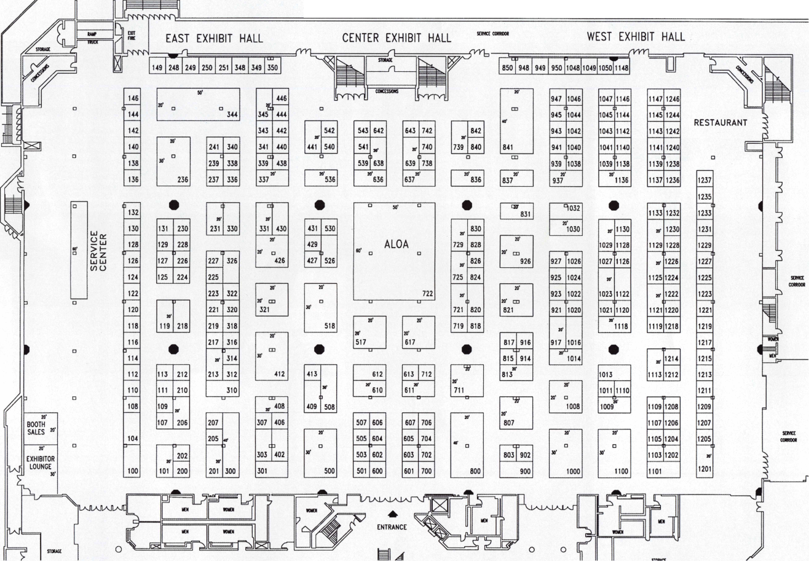

STRATTEC Security Corp.

The new Chrysler vehicles utilize an immobilizer system (RFID) to prevent theft. By obtaining a password from Chrysler, and using the D.A.R.T., you can program the key to the vehicle. The tool will also erase the keys from the vehicles Sentry System if lost or stolen.

Contact: Joy Skouron at (414) 247-3415 Booth #426

PAC is a membership program for the professional auto entry  
technician. It includes: a full color quarterly newsletter; $1,000  
accidental airbag deployment coverage; a Technical Hotline; special  
offerings and discounts; the latest product announcements first; ID  
membership card, decals and more! Join today for only $19-95 (U.S  
Membership) per year!

Contact: PRO-LOK

at (714) 633 0681 ■

Rutherford Control Inc.

Rutherford Controls, the electric locking specialist, is offering top- notch customer service and an outstanding selection of quality electric locking products. We’re your source for electromagnetic locks (standard, delayed egress, or small sizes for cabinetry). We also carry a full line of electric strikes: heavy-duty, fire rated, commercial or residen­tial grade, and a wide selection of accessories, such as switching devices, key pads, power supplies, and specialty locks.

Contact: (800) 899-5625 Booth #607

This Victor Firemaster Media Safe sets a new standard for convenient storage and fire protection of each person s magnetic or film files. U. L. has classified this safe as 125- degree one hour. Advanced insulating materials allow a compact, portable, low cost media safe that offers each person their own free standing, mobile file next to (or under) the desk.

Contact: (800) 848-9790;

Booth #1136

Sargent

& Greenleaf, Inc.

S&G offers the COMPTRONIC 6124 and 6125 electronic safe locks with motor- driven deadlatching bolts. The 6125s “push/pull” motor provides an open and close bolt force of six pounds. They auto­matically open and close, with nothing to turn and have three user configurations: single, dual and multiple. Options include audit trail and duress. COMPTRONIC is U.L. Type 1 and VdS Klasse 2 listed. Contact: Gary Kepler at (606) 883-9411 Booth #821

Schwab Corp.

For 125 years, Schwab has helped protect businesses against the devas­tating effects of fire. Now Schwab has combined their class 350-1 hour fire protection with U.L. classified theft protection. With 16TL-15 andTL-30 models to choose from, Schwab offers quality fire and theft protection composite safes to meet any storage needs-one great solution!

Contact: Debbi Landis at (763) 447-9470 Booth #517

Vigilante  
Burglar Bars, Inc.

The Vigilante heavy duty locking hasps “turn your service vehicle  
into an armored car.” The products is vandal resistant with a galvanized  
finish. It secures van, sheds, freezers, cellar doors, etc. There are four  
models to choose from.

Contact: Larry Kaufman at (718) 328-3700  
Booth #200

JOHN T SMITH

exp i2m?l§M|

0000-0000000

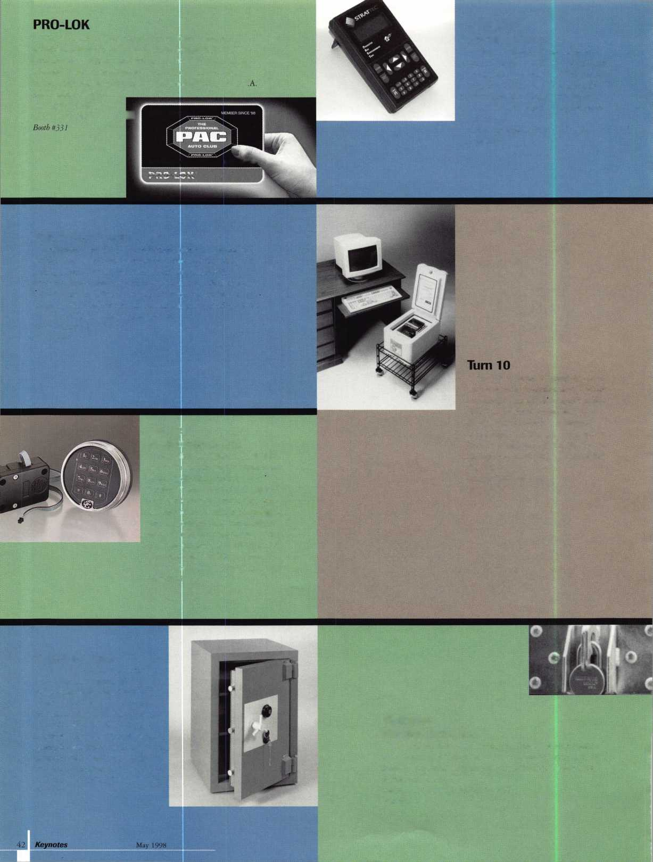

PROPOSED ALOA

anlaois

Proposed Amendments

To ALOA Certificate Of Incorporation

RESOLVED, that the Board of Directors of the corporation recommends to the members that the third paragraph of Article FIRST of the Certificate of Incorporation of the corporation which begins with the words “The object and purpose” be deleted and replaced with the following paragraph:

office of the corporation is then located, exclusively for such purposes or to such organizations, as said Court shall determine, which are organized and operated exclusively for such purposes.

FURTHER RESOLVED, that the Board of Directors of the corporation recommends to the members that Article FOURTH of the Certificate of Incorporation be deleted and replaced with the following Article FOURTH:

The objects and purposes of the corporation are to serve as a trade association as defined in Section 501(c) of the Internal Revenue Code as amended, including but not limited to:

1. Educate, and to encourage, promote, aid in, and effect the voluntary interchange of data, information, experience, ideas, knowledge, methods, and techniques relating to the profession of locksmithing among members of the profession.
2. Elevate the position of those engaged in installing and servicing security products, in all its branches, and establish a standard of qualification for membership.
3. Work with the manufacturers and distributors of security products toward a sympathetic understanding of our mutual problems.
4. Establish a uniform code of ethics and promote and maintain friendly cooperation among all locksmiths.
5. Cooperate with organizations related to the industry.
6. Perform and do any and all such acts as are necessary and proper to the attainment of these objects and purposes.

RESOLVED, that the Board of Directors of the corporation recommends to the members that Article THIRD of the Certificate of Incorporation of the corporation be deleted and replaced with the following new Article THIRD:

FOURTH. The county within the State of New York in which the office of the corporation is located is Ulster County.

FURTHER RESOLVED, that the Board of Directors of the corporation recommends to the members that Article FIFTH of the Certificate of Incorporation be deleted and replaced with the following Article FIFTH:

FIFTH. The number of directors of the corporation shall be set forth in the corporation’s Bylaws.

FURTHER RESOLVED, that the Board of Directors of the corporation revokes the designation of Harry Gold as the corporation’s registered agent and recommends to the members that Article EIGHTH of the Certificate of Incorporation be deleted and replaced with the following new Article EIGHTH:

EIGHTH. The Secretary of State of New York is designated as agent of the corporation upon whom process against the corporation may be served, and the Secretary of State of New York may mail a copy of any process served upon him or her to the corporation at 3003 Live Oak Street, Dallas, Texas 75204-6186.

FURTHER RESOLVED, that upon receiving the approval of the members with respect to the foregoing amendments to the Certificate of Incorporation, the appropriate officers of the corporation be, and the same hereby are, authorized and directed to execute such documentation and take such other action as is necessary to amend the corporation’s Certificate of Incorporation.

THIRD, (a) No part of the net earnings of the corporation shall inure to the benefit of, or be distributable to its members, directors, officers, or other private persons, except that the corporation shall be authorized and empowered to pay reasonable compensation for services rendered and to make payments and distributions in furtherance of the purposes set forth in Article FIRST hereof.

Proposed Bylaws of the

Associated Locksmiths of America, Inc.

NAME

The name of the corporation shall be Associated Locksmiths of America, Inc.

(b) Upon the dissolution of the corporation, the Board of Directors shall, after paying or making provision for the payment of all of the liabilities of the corporation, dispose of all of the assets of the corporation exclusively for the purposes of the corporation in such manner, or to such organization or organizations as shall at the time qualify as an exempt organization or exempt organizations under Section 501(cX6) or Section 501(cX3) of the Internal Revenue Code of 1986 (or the corresponding provision of any future United States Internal Revenue Law), as the Board of Directors shall determine. Any assets not so disposed of shall be disposed of by the Circuit Court of the county in which the principal

NOT FOR PROFIT CORPORATE STATUS; PURPOSES  
Not For Profit. The corporation is organized under and shall operate as a

New York not-for-profit corporation, and

shall have such powers as are now or as  
may hereafter be granted by the  
New York Not-For-Profit  
Corporation Law, as amended.

May 1998

Keynotes

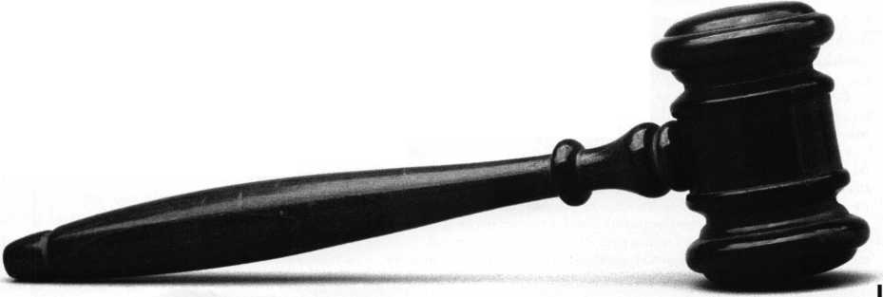

PURPOSES. Hie purposes of die corporation are those set forth in its Articles of Incorporation.

MEMBERS

Classes of Members. The corporation shall have seven classes of members: Active, Apprentice, Retired, Life, Allied, Associate and Honorary, all with the respective rights and privileges as herein described.

Active Members. Persons who have been actively engaged in the locksmith/access control industry for a minimum of two years and can provide at least two of the following items: Character reference from a member of the corporation or a local locksmith association; Character reference from two locksmith/access control industry related sources; Proof of employment in the locksmith/access control industry.

Apprentice Members. Persons who are undergoing training to qualify as an Active member. No person shall be an Apprentice member for more than two years.

Retired Members. Persons who have been: Active members for at least fifteen (15) years, have reached the age of sixty-two (62) and have withdrawn from active engagement in the locksmith/access control industry; or Active members who have become disabled and have withdrawn from active engagement in the industry.

Life Members. Persons who are past Presidents of the corporation, or who have provided exceptional service to the corporation, as determined by at least a two-thirds vote at a meeting of the Board of Directors.

Allied Members. Persons who have a position in the locksmith/access control industry that relates to locksmiths, meet requirements 1 and 3 of Active membership, and can qualify for no other class of membership.

Associate Members. Firms that manufacture or distribute material or equipment, or provide services, for the locksmith/access control industry.

Honorary Members. Persons who have made a significant contribution to the locksmith/access control profession or the attainment of the corporation’s objectives, as determined by at least a two-thirds vote at a meeting of the Board of Directors.

Eligibility; Admission of Members. No person shall be eligible for membership if he or she has been convicted of any crime involving fraud, dishonesty or breach of trust. Applicants for all classes of membership (other than Life and Honorary membership) shall be admitted to membership upon the full and accurate completion of a membership application, certification by the applicant that he, she or it meets the relevant membership criteria and payment of applicable dues.

Rights of Members. Only Active, Apprentice, Retired, Life, and Associate members shall have the right to vote, and each such member shall be entitled to one vote on each matter submitted to a vote of members. Only Life members and persons who have been Active members or Associate member representa­tives for the prior three years are eligible to serve as officers and voting directors of the corporation. An Associate member shall notify the Secretary of its employee who shall be its designated representative to vote on behalf of the Associate member and be eligible to serve as an officer or Director. All members and designated Associate member representatives are eligible to serve as non-voting directors.

RESIGNATION. Any member may resign by sending a written resignation to the Secretary at the principal office of the corporation. Such resignation shall not relieve a member of any outstanding obligation to the corporation.

Termination of Membership. Membership in the corporation shall auto­matically terminate whenever a member is ninety (90) days in default of any dues, assessments or other financial obligations to the corporation. Membership in the corporation may be terminated by action of the Board of Directors for conduct deemed detrimental to the corporation, for conviction of any crime involving fraud, dishonesty or breach of trust, or for violation of these Bylaws, the corporation’s

Code of Ethics, or any rule of the corporation. Termination by action of the Board of Directors shall be by at least a two-thirds vote at a meeting of the Board of Directors; provided, however, that prior to any such action, the member involved shall be given due notice and shall be entitled to a hearing before the Board of Directors. Any member who is terminated by the Board has the right to appeal the decision to the membership at the annual membership meeting. Such an appeal must be made in person, or by represen­tative, and the corporation must be provided with a written notice of the intent to appeal that must be received no less than 30 days prior to the annual membership meeting. Termination of membership shall not relieve a member of any outstanding obligation to the corporation.

Reinstatement. A former member terminated by reason of default in the payment of dues, assessments or other financial obligations to the corporation may be reinstated by showing proof of qualification and paying all moneys due and owing to the corporation.

Dues and Assessments. The Board may determine from time to time the amount and method-of payment of any and all applicable dues and assessments. MEETING OF MEMBERS

**Annual Meeting.** An annual meeting of the members shall be held at such time and place as the Board of Directors may determine for the purpose of conducting such business as may come before the meeting.

Special Meeting. Special meetings of the members may be called by the President, by the Board of Directors, or by not less than ten percent (10%) of the members having voting rights. In addition, in every year after 1998, there shall be one or more special meetings of the members having voting rights, to be held prior to the annual membership meeting, for the purpose of electing approximately one-half of the directors and, in odd numbered years, the officers.

Notice of Meetings. Unless otherwise required by the New York Not- For-Profit Corporation Law, as amended, written or printed notice stating the place, day and hour of any meeting of members shall be delivered, either personally or by mail, to each member entitled to vote at such meeting, not less than twenty (20) nor more than fifty (50) days before the date of such meeting, by or at the direction of the President, or the Secretary, or the persons calling the meeting. In the case of a special meeting, or when required by statute or by these Bylaws, the purpose or purposes for which the meeting is called shall be stated in the notice. If mailed, the notice of a meeting shall be deemed delivered when deposited in the United States mail addressed to the member or the Associate member representative at his or her address as it appears on the records of the corporation, with postage thereon prepaid. Any member may waive notice of any meeting.

Quorum and Manner of Acting. A quorum of the voting members shall be the lesser of one hundred voting members or one-tenth of the voting members. If a quorum is not present at any meeting of members, a majority of the members present may adjourn the meeting without further notice. If a quorum is present, the affirmative vote of the majority of the members repre­sented at the meeting and entitled to vote on a matter shall be the act of the members, unless the vote of a greater number is required by law, the Articles of Incorporation or these Bylaws.

Proxies. A voting member may vote by proxy solely with respect to the election of officers and directors and the amendment or modification of these Bylaws, provided the proxy is executed in writing by the member or the Associate member representative or his or her duly authorized attorney-in-fact. No proxy shall be valid after eleven months from the date of its execution unless otherwise provided in the proxy.

OFFICERS

Officers. The officers of the corporation shall be a President and a Secretary. The offices of President and Secretary shall not be filled by the same person.

Election and Term of Office. The officers shall be elected by the voting members for a two year term. A person may serve as the President of the corporation for no more than one (1) term, and may serve as the Secretary for no more than four (4) consecutive terms. The officers shall be elected in odd- numbered years at a special meeting of the members, and shall serve until their successors have been duly elected and qualified. Candidates for offices shall be nominated in accordance with policies adopted by the Board of Directors.

Removal. Any officer elected by the members may be removed by the members. Any officer elected by the Board of Directors to fill a vacancy may be removed by the Board of Directors.

Vacancies. A vacancy in the office of President or Secretary because of death, resignation, removal, disqualification or otherwise, shall be filled by the Board of Directors for the unexpired portion of the term.

President. The President shall be responsible for the integrity of the Board of Directors’ governance in accordance with policies adopted by the Board. He or she shall preside at all meetings of the Board of Directors, and shall be the Chairman of the Board. He or she may sign, with the Secretary, any deeds, mortgages, contracts, or other instruments which the Board of Directors has authorized to be executed, except in cases where the signing and execution thereof shall be expressly delegated by the Board of Directors or by these Bylaws or by statute to some other officer or agent of the corporation.

Keynotes

May 1998

SECRETARY. In the absence of the President or in the event of his or her inability or refusal to act, the Secretary shall perform the duties of the President by action of the Board, and when so acting, shall have all the powers of and be subject to all the restrictions upon the President. The Secretary shall be respon­sible for the integrity of the Board’s documents, including Bylaws, policies and minutes; shall see that all notices are duly given in accordance with the provisions of these Bylaws or as required by law; and shall perform such duties as set forth in policies adopted by the Board.

BOARD OF DIRECTORS

General Powers. The corporation shall be governed by its Board of

Directors. Composition. The number of directors shall be between 9 and 23. The Board of Directors of the corporation shall be composed of the President, the Secretary, the directors elected by the Associate Region and the six geographic regions (the Northeast, Northwest, Northcentral, Southeast, Southwest and Southcentral Regions) established and modified by the Board (all seven regions collectively, the “Regions”) and the non-voting directors described in Section 3 of this Article VI (the “Non-Voting Directors”).

All directors other than the President, the Secretary and the Non-Voting Directors shall be elected on a Regional basis. Each member shall be deemed to be from the Region where the member has listed his or her business address with the corporation, except Associate members shall be deemed members of the Associate Region. A voting member may vote only for a director or directors to represent his or her Region.

Each Region shall be represented on the Board of Directors according to the following formula:

1. or fewer voting members - one director
2. to 2,000 voting members - two directors
3. or more voting members - three directors

The number of voting members in each Region shall be determined by the membership census report in effect on the April 1 of the preceding year. Candidates for Regional director positions shall be nominated in accordance with policies adopted by the Board of Directors. Directors shall be elected by a plurality vote. Each voting member in a Region may cast only one vote for each open position.

Notwithstanding anything in these Bylaws to the contrary, the Board of Directors shall adopt policies to effect the appropriate transition in governance of the corporation for 1998 and 1999-

Non-Voting Directors. As long as the number of directors does not exceed twenty three (23), the President may appoint no more than two (2) non­voting directors to serve on the Board of Directors.

Term. The term of the directors (other than the Non-Voting Directors) shall be for a duration of two years. Non-Voting Directors shall serve at the pleasure of the President. No individual (other than the President and Secretary) may serve more than three (3) consecutive terms as director without an absence from the Board of at least one (1) year. Time served filling a vacancy or serving as an officer shall not count towards the director term limits. The terms of the directors (other than the Non-Voting Directors) shall be staggered so that approximately one-half of the directors are elected each year. Directors from the Northeast, Southcentral and Northwest Regions shall be elected in even- numbered years, and directors from the Southeast, Northcentral and Southwest Regions shall be elected in odd-numbered years.

Regular Meetings. A regular annual meeting of the Board of Directors shall be held at such time and place as may be designated by resolution by the Board of Directors without other notice than this Bylaw and such resolution.

Special Meetings. Special meetings of the Board of Directors may be called by or at the request of the President or the greater of three directors or twenty-five percent (25%) of the directors. The person or persons authorized to call special meetings of the Board may fix any place, either within or without the State of New York, as the place for holding any special meeting of the Board called by them.

Notice. Notice of any special meeting of the Board of Directors shall be given at least three days prior thereto in writing, delivered personally or sent by mail or facsimile transmission to each director. If notice be given by mail, such notice shall be deemed to be delivered on the day following the day such notice is deposited with postage prepaid to a nationally recognized overnight courier service. If notice be given by facsimile transmission, such notice shall be deemed to be delivered upon confirmation of the receipt of the transmission. Any director may waive notice of any meeting.

**Quorum.** Shay-percent (60%) ofthe Board of Directors shall constitute a quorum for the transaction of business at any meeting of the Board, provided, that if less than sixty-percent (60%) of the directors are present at said meeting, a majority of the directors present may adjourn the meeting without further notice.

Voting; Manner of Acting. Each director other than the Non-Voting Directors shall have one vote. The act of a majority of the voting directors present at a meeting at which a quorum is present shall be the act of the Board of Directors, except where otherwise provided by law, the Articles of Incorporation or these Bylaws.

Informal Action By Directors. Any action required to be taken at a meeting of the Board of Directors or any action which may be taken at a meeting of directors may be taken without a meeting if all the voting members of the Board consent in writing to the adoption of a resolution authorizing such action.

Vacancies. If a director (other than the President, the Secretary or the Non-Voting Directors) resigns, is removed from office or otherwise ceases to serve, the members of the Region who elected such director shall fill such vacancy in accordance with policies adopted by the Board.

Attendance by Communications Equipment. Members of the Board of Directors may participate in and act at any meeting of the Board through the use of a conference telephone or similar communications equipment allowing persons participating in the meeting to hear each other at the same time. Participation in such meeting shall constitute attendance and presence in person at the meeting of the person or persons so participating.

Removal. Any director (other than the Non-Voting Directors) may be removed for cause by the members electing such director. Directors shall be automatically removed upon missing three Board meetings during any two-year term. A director elected by the voting members in a Region shall be automatically removed upon changing his address of record to outside of the Region.

COMMITTEES

Committees, not having and exercising the authority of the Board of Directors in the management of the corporation, may be designated by a resolution adopted by a majority of the directors present at a meeting at which a quorum is present. Except as otherwise provided in such resolution, the President of the corporation shall appoint the members thereof.

BOARD OF TRUSTEES

The corporation shall have a Board of Trustees composed of the three most recent past Presidents of the corporation. Trustees may attend all Board Meetings to serve as advisors to the Board.

CONTRACTS AND CHECKS

The Board of Directors may authorize any officer or officers, agent or agents of the corporation, in addition to the officers so authorized by these Bylaws, to enter into any contract or execute and deliver any instrument, including but not limited to checks, drafts, and notes, in the name of and on behalf of the corporation and such authority may be general or confined to specific instances.

AMENDMENTS TO BYLAWS

These Bylaws may be altered, amended or repealed, and new Bylaws may be adopted, by a majority of the directors present at any regular meeting or at any special meeting, provided that at least fifteen days’ written notice is given of the intention to alter, amend or repeal, or to adopt new Bylaws at such meeting and, provided further, that any such alteration, amendment, repeal or adoption is approved at a subsequent meeting of the voting members, who shall be given at least thirty (30) days prior written notice of such proposed alteration, amendment or repeal.

INDEMNIFICATION

The corporation shall indemnify all officers and directors of the corporation to the fullest extent permitted by the New York Not-For-Profit Corporation Law, as amended, and shall be entitled to purchase insurance for such indemni­fication of officers and directors as determined from time to time by the Board of Directors of the corporation.

CHAPTERS

The corporation may recognize chapters pursuant to policies adopted by the Board of Directors from time to time. Any such chapters shall operate in accordance with rules and guidelines adopted by the Board of Directors.

May 1998

***Keynotes*** 145

It seems that every time you pick up a newspaper, leaf through a  
magazine, watch television, or listen to the radio, you are inundated  
with violence. The crime wave that is sweeping our country today is  
not a temporary social phenomena, nor is it limited to the major  
urban areas. Crime in general has permeated every aspect of our very  
existence from the smallest towns in the most remote rural areas to  
the most expensive exclusive suburban developments!

I am often asked, “What can we do as locksmiths to improve the  
security of our customers?” Believe me, there is much that can be  
done to increase the security of the average home. In order to  
understand those things that you can do to help your customers  
better secure their homes, you must first understand one of the most  
fundamental concepts in the field of security. The Theory of Displace-  
ment targets specifically the most common types of crimes in this

country. We refer to them, appropriately as  
“Crimes of Opportunity.”

A crime of opportunity must contain three  
elements. I know you are familiar with these  
three elements if you have ever watched any law  
enforcement or legal drama on television. The  
three elements are motive, means and opportu-  
nity. Anyone who’s involved in the law enforce-  
ment community knows that you can’t take  
away the variety of incentives from which the  
criminal mind derives the rationale for  
committing a crime in the first place. It is  
almost impossible to prevent the criminal  
element from obtaining the tools, however

specialized, or materials needed to compromise the most common

forms of security. It is, however, possible to limit the opportunities for  
crime through education by creating an informed public.

A crime of opportunity occurs because the individual whose security has been compromised did not take the proper steps to secure his house because he was not given the proper security recom­mendations by a knowledgeable source. It is my intention to point out the most common ways to enhance a homeowner’s (your customer’s) security.

I have chosen to show you the picture of a typical house. Notice that there are 12 different methods by which we enhance security and deter the potential thief. We frighten him, not because this house is impossible to compromise, but because it is so much more difficult to compromise than a standard, non-secured house that the potential prize is no longer worth the greatly increased odds of being caught.

461 Keynotes May 1998

by Steven Spiwak. CRL

Many experts in the field of security heartily concur with the fact  
that properly positioned lighting (number 1) is one of the thief s  
greatest enemies. A thief simply does not want to get caught,  
especially through simple exposure. By properly positioning the  
correct types of lighting around your house, you can eliminate what I  
like to call “Dead Zones.” These are areas of darkness where a  
potential thief can lie in wait for the right moment, and where he can  
hide should he be surprised and need a safe haven along his escape  
route off your property.

Additional lamp posts (number 2) not only provide additional  
lighting, but they also provide easy identification for suspicious  
passers-by, neighbors or law enforcement personnel. They enable  
these people to locate, identify and respond quickly to the house in  
question during an emergency situation. Metal window grates

(number 3) are often overlooked as a means of  
security, because many home owners feel that  
they have an unsightly appearance. However,  
with today’s manufacturing procedures, the  
most durable wrought iron gates can be  
attractive and foldable (for easy escape in an  
emergency which complies with current life  
safety codes) as well as providing an unparal-  
leled physical barrier against the potential thief.

Another ally of the thief is cover of  
concealment from the authorities or especially  
his intended victims. A good place to hide is  
a necessity. Therefore it is in your best  
interest to trim all shrubbery (number 4) to

below the height of the bottom pane of glass. Aesthetically, they will  
still be pleasing to you and your neighbors, but it will no longer be a  
place for the potential thief to conceal himself.

For customers who are willing to spend a little more money for  
sophisticated electronic equipment, there are devices that can be hard  
wired (using an exterior key or touch pad entry system) or radio  
signal activated (number 5) to detect the motion (using an interior  
time delayed touch pad entry system like number 9) of anyone or  
anything entering the protected area in and around the perimeter of  
your house (number 7) including points of entry, such as doors,  
windows, sliding glass patio doors (number 8), etc. In addition, it is a  
good idea to add physical locking devices to windows and sliding  
glass doors.

There are internal threats to the security of your home and family  
as well as external threats. Every home should (and according to law

“(Dany experts in the field  
of security heartily  
concur unth the fact that  
properly positioned  
lighting is one of the  
thief ’s greatest enemies."

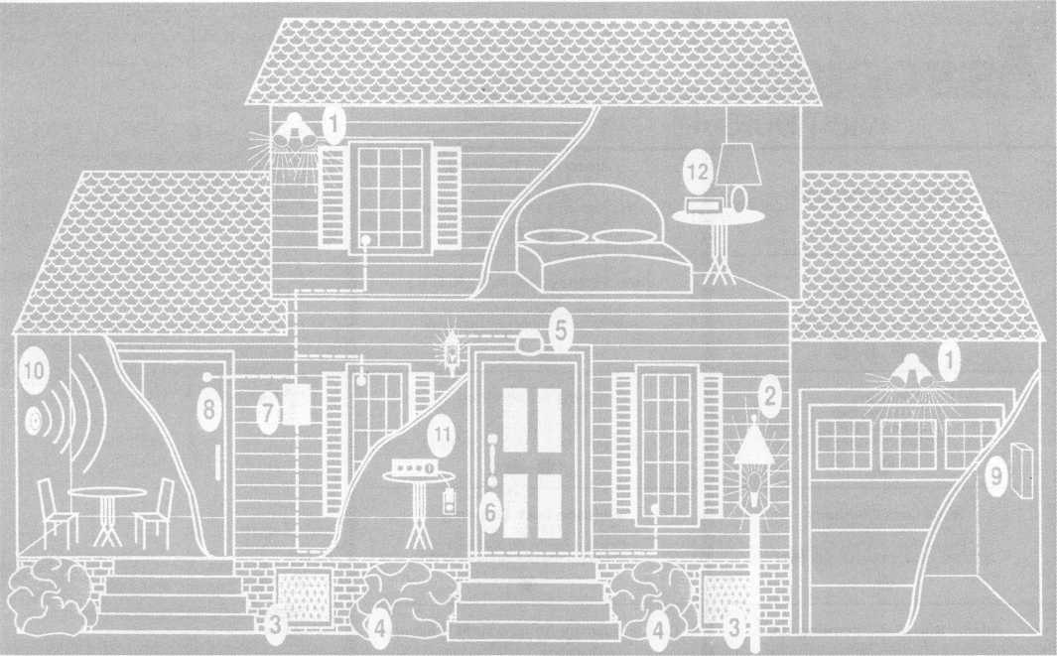

Diagram of Security Enhancements

in many states must) have both smoke and heat detectors (number 10) to provide an early alert that will even wake up people who are in a deep sleep to give them enough time to safely exit their house. It is a good idea to have prearranged routes for the entire family to follow depending on what area in which the fire may be confined. Regular “fire drills” are not just a good idea, but a necessity to do the right things during a real fire.

Many doors on some of today’s newly constructed houses are ideal for cost efficiency and are environmentally sound. However, they are not constructed of solid 2 1/4" oak as they were many years ago. For this reason, I always recommend that customers install a security door. Either a good, strong heavy gauge metal door with perpendic­ular support braces located at strategic points, or a thick, solid wood door. Either of these options in combination with a heavy duty deadbolt lock (number 6) will significantly increase the exterior against standard forms of physical attack. By the way, any door with a glass insert large enough to enable a thief to break the glass and insert his arm through the opening to unlock the lock by operating the turnbolt should be considered for a double-sided deadbolt lock. However, other mitigating factors should be taken into account before making a final decision such as the age of the children at home or the physical condition of any young adults or elderly who may be in the home.

One of the greatest periods of opportunity for the thief occurs when the home is empty. Everyone may be away for just one day or a two week vacation. Perhaps, the most important thing that you can do during this time is to put timers on all your lights and appliances (number 11) to create the feeling that “someone is at home.” Even after you have taken all the necessary precautions, it is still possible that an intruder may gain entrance to your home. Should this

happen, do not panic! Simply press your “bedside” panic alarm button (number 12). This clever device is found in a variety of ways. Even if the standard telephone lines into your house have been cut, many bedside panic switches rely on cellular telephone or other ingenious methods to make sure that a silent or quite loud warning is immediately sent to the local authorities for an emergency response.

Home security is on the minds of every American. It should also be on the minds every locksmith. These suggestions form the basis for a home security survey that you could offer each and every one of your customers. These suggestions can also be applied to commercial, institutional and industrial situations with just a little bit of imagination.

Remember, that you are just beginning to see the almost infinite possibilities and benefits to both you and your customer by becoming involved in the ultimate niche market (home security) within a niche market (locksmithing).

I About the author: Steven B. Spiwak, CRL is a fourth

generation locksmith who specializes in a variety of variety of areas including  
crime prevention and institutional security. His broad experience in the security  
field spans 20 years ofivriting, teaching and consulting. Spiwak’s lengthy  
client list includes Ford Motor Company, Exxon, The Chicago Tribune,  
Sears, Westin Hotels, the U.S. Treasury Department and the Federal Bureau  
of Investigation. Most recently he formed Lockport, Inc.—a security consulting  
company for industrial, commercial, institutional and governmental clients.  
Readers with article suggestions or requests for him can contact ALOA at email  
[publ@anet-dfw.com](mailto:publ@anet-dfw.com) or fax to (214) 827-1810.

May 1998

Keynotes

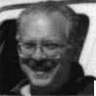

**Associate**

Members

|  |  |
| --- | --- |
| Manufacturers | Arrow Lock Company  10300 Foster Avenue  Brooklyn, NY 11236 (718) 257-4700; FAX (718) 649-9097 |
|  | see# |
| A & B Safe Corp.  171 S. Delsea Dr.  Glassboro, NJ 08028 (800) 253-1267; FAX (609) 863-1208 | Auto Security Products (A. S. P.)  P.0. Box 10  Redmond, WA 98073-0010 (425) 556-1900; FAX (425) 558-1205 |
| • • • • | • • |
| ASSA Inc.  10300 Foster Ave.  Brooklyn, NY 11236 (800) 235-7482; FAX (718) 257-2772 | BWD Automotive  900 Ravenwood Dr.  Selma, AL 36701  (334) 874-9001; FAX (334) 874-6011 |
| • | • • |
| Abus Lock Company  3555 Holly Lane North  Plymouth, MN 55447-0507 (800) 352-2287; FAX (612) 509-9939 | Chicago Lock Company  10100 88th Ave.  Pleasant Prairie, Wl 53158-0069 (800) 445-3204; FAX (414) 947-7178 |
| • | # |
| Adams Rite Manufacturing Co.  P.0. Box 1301  LaPuente.CA 91749-1301 (562) 699-0511; FAX (562) 699-5094 | Corbin Russwin Architectural Hardware  P.0. Box 25288  Charlotte, NC 28229 (800) 543-3658; FAX (800) 447-6714 |
| • • | • • • • |
| Adesco Safe Manufacturing Co.  16720 S. Garfield Ave.  Paramount, CA 90723 (800) 821-6803; FAX (310) 408-6427 | DETEX  302 Detex Dr.  New Braunfels, TX 78130 (800) 729-3839; FAX (210) 620-6711 |
| • | ^ (0 <0 0 |
| Adrian Steel Company  906 James St.  Adrian, Ml 49221  (800) 677-2726; FAX (517) 265-5834 | Don-Jo Manufacturing, Inc.  P.O. Box 929  Sterling, MA 01564 (508)422-3377; FAX (508) 422-3467 |
| • | • • |
| Alarm Lock Systems, Inc.  345 Bayview Ave.  Amityville, NY 11701 (800) ALA-LOCK; (516) 789-3383 | Door Controls International  2362 Bishop Circle East  Dexter, Ml 48130  (800) 742-3634; FAX (800) 742-0410 |
| e | • • • • |
| Aiphone Intercom Systems  1700-130th Avenue, NE  Bellevue, WA 98005 (206) 455-0510; FAX (206) 455-0071 | ESP Lock Products, Inc.  375 Harvard Street  Leominster, MA 01453 (508)537-6121; FAX (508) 537-1699 |
| see | • |
| American Lock Co.  3400 West Exchange Road  Crete, IL 60417-2099 (708) 534-2000; FAX (708) 534-0531 | Federal Lock Company  14247 E. Don Julian Rd.  City of Industry, CA 91746 (800) 682-9851; FAX (708) 378-4767 |
| • • | © |
| American Security Products (AMSEC)  11925 Pacific Ave.  Fontana, CA 92337-6963 (800) 423-1881; FAX (909)685-9685 | Folger Adam Security, Inc.  16300 W. 103rd Street  Lemont, IL 60439  (630) 739-3900; FAX (630) 739-6138 |
|  | 0 0 |
|  |  |



Associate members of the Associated Locksmiths of America (ALOA) manu­facture or distribute materials or equip- meat, or provide services, for the securi­ty industry. Many have donated money, services and equipment to ALOA in addition to their annual dues. Their sup­port of ALOA projects enhances overall membership benefits and we encourage our members to patronize these firms. If you know of a potential candidate for associate membership, please contact the ALOA Sales staff at (214) 827-1701. Associate member dues are $500 per year and entide the payor to use the ALOA logo, and selected discounts on ALOA products and services.

Le**gend**

Alarms: Personal, vehicle, electronic, fire, burglar, and exit

V Automotive: Lockout equipment, key chains/rings

© Builders Hardware: Door closers, fumiture/decorative hardware, viewers, emergency exit devices

® Business/Technical & Educational: Books, reference guides, publications, computer software

© CCTlf/Photo Imaging: Cameras, monitors, photo ID equipment, cables

© llectric/Electronic Security: Card access control and readers, surveil­lance, electric/magnetic locks and strikes, keypads

© Lock Devices: Auto locks, cylinders, emergency exit/entrance control, locks (various types), strikes

© Tools & Supplies: Key blanks, cutters, picks, rings/hooks, custom van/truck

***Keynotes***

**May 1998**

|  |  |  |
| --- | --- | --- |
| Fort Lock Corp.  3000 N. River Rd.  River Grove, IL 60171 (708) 456-1100; FAX (708) 456-9476 | LAB Security  700 Emmett St.  Bristol, CT 06010  (800)243-8242; FAX (203) 583-7838 | National Cabinet Lock  200 Old Mill Road, P. 0. Box 200  Mauldin, SC 29662 (864) 297-6655; FAX (864) 297-9987 |
| • ••••• | • | ® |
| Grobet File Co. of America  750 Wasahington Ave.  Carlstadt, NJ 07072 (800) 962-7242; FAX (800) 243-2432 | LCN Closers (Division of Ingersol)  121 W. Railroad Ave.  Princeton, IL 61356 (815)875-3311; FAX (815)875-3222 | Newman Tonks  805 N Buckman St.  Shepardsville, KY 40165 (800) 826-5792; FAX (800) 777-8229 |
| • | • | • • |
| H.E.S., Inc.  2040 W. Quail Ave.  Phoenix, AZ 85027 (602) 582-4626; FAX (602) 582-4641 | La Gard, Inc.  3330 Kashiwa Street  Torrance, CA 90505 (310)325-5670; FAX (310)325-5615 | ROFU International Corp.  2004-B 48th Ave.; Court E  Tacoma, WA 98424 (800) 255-7638; FAX (253) 922-1728 |
| • • • | • | • |
| HPC, Inc.  3999 N. 25th Avenue  Schiller Park, IL 60176 (847) 671 -6280; FAX(847) 671 -6343 | Lori Lock  P.O. Box 1040  Southington, CT 06489 (860)621-3605; FAX (203) 621-5972 | Rutherford Controls Inc.  2697 Internal Pkwy, Bid 5 #100  Virginia Beach, VA 23452 (757)427-1230; FAX (804) 427-9549 |
| ^ ^ | <0 • | • |
| Hurd Corporation  503 Bohannon Rd.  Greeneville, TN 37744-1450 (423) 787-8800; (423) 787-8817 | Lucky Line Products  7890 Dunbrook Rd.  San Diego, CA 92126 (619)549-6699; FAX (619) 549-0949 | STRATTEC Security Corp.  3333 W. Good Hope Rd.  Milwaukee, Wl 53209 (414) 247-3333; FAX (414) 247-3329 |
| ^ (Q) | • | • • • |
| llco Unican  400 Jeffreys Road  Rocky Mount, NC 27804 (919) 446-3321; FAX (919) 446-4702 | M.A.G. Engineering & Mfg. Inc.  15261 Transistor Lane  Huntington Beach, CA 92649 (714) 891 -5100; FAX (714) 892-6845 | Sargent & Greenleaf, Inc.  P.O. Box 930  Nicholasville, KY 40340-0930 (606) 885-9411; FAX (606) 887-2057 |
| ••••••• | • • • | • • • • |
| Industries, C.L. Inc.  9730 Gouin Blvd. West  Pierrefonds (PQ) H8Y 1R5 (514)683-6282; FAX(514) 683-9015 | MARKS USA  5300 New Horizons Blvd.  Amityville, NY 11701 (516)225-5400; FAX (516) 225-6136 | Schlage Lock Co.  1915 Jamboree Suite 165  Colorado Springs, CO 80920 (800)847-1864; FAX (800) 452-0663 |
| • • | • | • • |
| Jet Hardware Mfg. Co.  800 Hinsdale Street  Brooklyn, NY 11207 (718)257-9600; FAX(718) 257-0973 | MUL-T-LOCK USA, Inc.  300-1 Route 17 South Suite A  Lodi, NJ 07644  (800) 562-3511; FAX (201) 778-4007 | Schwab Corporation  3000 Main St  Lafayette, IN 47903-5088 (765) 447-9470; FAX (765) 447-8278 |
| • | • • • | • |
| KABA High Security Locks  P.O. Box 490  Southington, CT 06489 (860)621-3601; FAX(860) 621-9727 | Master Lock Company  2600 North 32nd Street  Milwaukee, Wl 53211 (414) 444-2800; FAX (414) 449-3114 | Securitron Magnalock Corp.  550 Vista Blvd.  Sparks, NV 89434  (800) 624-5625; FAX (702) 355-5636 |
| • | • • | • • |
| KEY-BAK; Div. of W. Coast Chain Mfg. Co.  1460 S. Balboa Ave.  Ontario, CA 91762 (909)923-7800; FAX0O9) 923-0024 | Medeco Security Locks  P.O. Box 3075  Salem, VA 24153  (540) 380-5000; FAX (540) 380-5010 | Security Door Controls  3580 Willow Lane  Westlake Village, CA 91361 (805) 494-0622; FAX (800) 959-4732 |
| • • • • | • • • | ® |
| Kenstan Lock Company  101 Commercial St.  Plainveiw, NY 11803-2412 (516) 271 -2700; FAX(516) 271 -2759 | Meilink Safe Company  111 Security Parkway  New Albany, IN 47150 (800) 634-5465; FAX (800) 896-6606 | Security Solutions  1640 W. Hwy. 152  Mustang, OK 73064 (405)376-1600; FAX (405) 376-6870 |
| • t | • | • • • |
| Knaack Manufacturing Co.  420 E. Terra Cotta Ave.  Crystal Lake, IL 60014 (800) 456-7865; FAX(815) 459-9097 | NKL Industries Ltd.  1111-13 Cavalier Blvd.  Chesapeake, VA 23323 (800) 528-9900; (757) 485-0271 | Sentry Group  900 Linden Ave.  Rochester, NY 14625-2784 (716) 381-4900; FAX (716) 381-8559 |
| • | • • • • | • |
|  |  |  |
|  | |  |

**May 1998**

Keynotes

|  |  |  |
| --- | --- | --- |
| Sully Tools Inc.  3515 Nodding Pine Ct.  Fairfax, VA 22033  (703) 689-3416; FAX (703) 787-0869  • • • | DiMark International  3117 Liberator St., Unit A  Santa Maria, CA 93455 (800) 235-2435; FAX (805) 928-8034  • • | Hardware Agencies, Ltd.  1220 Dundas Street East  Toronto, ON M4M 1 S3 (416)462-1921  •••••••• |
| Trine Products Corporation  1430 Ferris Place  Bronx, NY 10461  (718) 829-4796; FAX (718) 792-9127  • •• | Dive’s Lock & Key Co.  2201 Broadway  Denver, CO 80205 (303) 294-0176 | Hardware Suppliers of America  P.O. Box 2208  Winterville, NC 28590 (800) 334-5625  e • |
| Yale Security Inc.  P.O. Box 25288  Charlotte, NC 28229-8010 (800) 438-1951; (800) 338-0965  • • • • | Direct Security Supply, Inc.  36 Lincoln Street  Boston, MA 02135 (800) 252-5757; FAX (800) 452-8600  $ (01 (0 ^ | IDN, Inc.  1000 S. Main, Suite 280  Grapevine, TX 76051 (817)421-5470; FAX (817) 421-5468 |
| Distributors | Doyle Lock Supply  2211 W. River Road N.  Minneapolis, MN 55411 (800)333-6953; FAX (612) 521-0166 | Intermountain Lock & Supply Co  3106 South Main Street  Salt Lake City, Utah 84115 (800) 453-5386; FAX (801) 485-7205 |
| Accredited Lock Supply Co.  P.O. Box 1442  Secaucus, NJ 07096-1442 (800) 652-2835; FAX (201) 865-5031  ••••••• | Dugmore & Duncan Inc.  30 Pond Park Rd.  Hingham, MA 02043 (800) 225-1595; FAX (617) 740-4043  ^ $ <U) (0 ^ | JLM Wholesale, Inc.  3095 Mullins Ct  Oxford, Ml 48371-1643 (800) 522-2940; FAX (800) 782-1160  • • • |
| Ace Lock & Security Supply Co.  565 Rahway Ave.  Union, NJ 07083-6631 (800) ACE-LOCK; (800) ACE-FAX4 | E. L. Reinhardt Co., Inc.  3250 Fanum Road  Vadnais Heights, MN 55110 (800)328-1311; FAX (612) 481-0166  •••••• | Jo-Van Distributors Inc.  929 Warden Ave.  Scarborough, Ontario MIL 4C6 (416) 752-7249; FAX (416) 752-3845 |
| Akron Hardware Consultants, Inc.  2579 South Arlington Road  Akron, OH 44319  (800) 321-9602; FAX (800) 328-6070  • • • | Ewert Wholesale Hardware  4709 W 120th St  Alsip II 60658 (800) 451-0200  • • • • • | Lockmasters, Inc.  5085 Danville Road  Nicholasville KY, 40356 (606) 885-6041  • •99 |
| American Security Distribution  4411 E. La Palma  Anaheim, CA 92807 (714)996-0791; FAX (714) 579-3508  ••••••• | Fairway Supply, Inc.  2631 Lombardy Lane  Dallas, TX 75220  (214) 350-0021; FAX (214) 352-4299  ^ ^ @ (0 (Q (H | Locks Company  2050 N.E. 151 St.  N. Miami, FL 33162 (800)288-0801; FAX (305) 949-3619  ^ @ (0 (Q (£} |
| Andrews Wholesale Lock Supply  544 S. 9th St.  Lebanon, PA 17042-6608 (717) 272-7422  • | Foley-Belsaw Company  6301 Equitable Road  Kansas City, MO 64120 (800) 821-3452; FAX (816) 483-5010  • • • • | The Locksmith Store Inc.  1229 E Algonquin Rd. Suite E  Arlington Heights, IL 60005 (847) 364-5111; FAX (847) 364-5125  ^ ^ |
| Boyle & Chase Inc.  P. 0. Box 74  Accord, MA 02018-0074 (800) 325-2530; FAX (617) 335-5342  • • • | Fried Brothers, Inc.  467 N. 7th St.  Philadelphia, PA 19123 (800) 523-2924; FAX (800) 541-3489  •••••••••• | M. Zion Company  69 Reade Street, 4th Floor  New York, NY 10007 (212) 349-8677; FAX (212) 964-0495  9999999 |
| Clark Security Products, Inc.  4775 Viewridge Ave.  San Diego, CA 92123-1641 (800) 854-2088 | HS&S Wholesale Distributors  12915 West 8 Mile Road  Detroit, Ml 48235 (800) 521-2202  (Q) @ (0 ^ | McDonald-DASH Locksmith Supply  5767 E. Shelby Dr.  Memphis, TN 38141 (800)238-7541; FAX (901) 366-0005 |
| Cook’s Building Specialties  2441 Menaul Blvd. NE; P.O. Box 37320 Albuquerque, NM 87176-7320 (505)883-5701; FAX (505) 883-5704  •••••• | Hans Johnsen Company  8901 Chancellor Row  Dallas, TX 75247  (214) 879-1550; FAX (214) 879-1530 | McManus Locksmith Supply, Inc.  P.O. Box 9231,1309 Central Ave.  Charlotte, NC 28299 (702)333-9112  (Q ^ |
|  |  |  |
| V'V^.^Lock-Deifees _ ‘ - '' . | | |

***Keynotes***

**May 1998**

a number for "information on each item.

dr

Reader Service

KGynOtGSMay 1998

Use this card to obtain more information about the products and services advertised or described in this issue

**Card valid until Sept. 1,1998.**

Name _

Company Street Address _ City

_Title

Phone_

_State

_Country

FAX

_ZIP_

|  |  |  |  |  |  |  |  |  |  |  |  |  |  |  |  |  |  |  |  |
| --- | --- | --- | --- | --- | --- | --- | --- | --- | --- | --- | --- | --- | --- | --- | --- | --- | --- | --- | --- |
| 1 | 6 | 11 | 16 | 21 | 26 | 31 | 36 | 41 | 46 | 51 | 56 | 61 | 66 | 71 | 76 | 81 | 86 | 91 | 96 |
| 2 | 7 | 12 | 17 | 22 | 27 | 32 | 37 | 42 | 47 | 52 | 57 | 62 | 67 | 72 | 77 | 82 | 87 | 92 | 97 |
| 3 | 8 | 13 | 18 | 23 | 28 | 33 | 38 | 43 | 48 | 53 | 58 | 63 | 68 | 73 | 78 | 83 | 88 | 93 | 98 |
| 4 | 9 | 14 | 19 | 24 | 29 | 34 | 39 | 44 | 49 | 54 | 59 | 64 | 69 | 74 | 79 | 84 | 89 | 94 | 99 |
| 5 | 10 | 15 | 20 | 25 | 30 | 35 | 40 | 45 | 50 | 55 | 60 | 65 | 70 | 75 | 80 | 85 | 90 | 95 | 100 |

m

Card valid until Sept. 1,1998.

Reader Service

Keynotes May 1998

Use this card to obtain more information about the products and services advertised or described in this issue.

**Card valid until Sept. 1,1998.**

Name _

Company

Street Address _ City

Phone_

_Title

_State

_Country _FAX _

_ZIP_

|  |  |  |  |  |  |  |  |  |  |  |  |  |  |  |  |  |  |  |  |
| --- | --- | --- | --- | --- | --- | --- | --- | --- | --- | --- | --- | --- | --- | --- | --- | --- | --- | --- | --- |
| 1 | 6 | 11 | 16 | 21 | 26 | 31 | 36 | 41 | 46 | 51 | 56 | 61 | 66 | 71 | 76 | 81 | 86 | 91 | 96 |
| 2 | 7 | 12 | 17 | 22 | 27 | 32 | 37 | 42 | 47 | 52 | 57 | 62 | 67 | 72 | 77 | 82 | 87 | 92 | 97 |
| 3 | 8 | 13 | 18 | 23 | 28 | 33 | 38 | 43 | 48 | 53 | 58 | 63 | 68 | 73 | 78 | 83 | 88 | 93 | 98 |
| 4 | 9 | 14 | 19 | 24 | 29 | 34 | 39 | 44 | 49 | 54 | 59 | 64 | 69 | 74 | 79 | 84 | 89 | 94 | 99 |
| 5 | 10 | 15 | 20 | 25 | 30 | 35 | 40 | 45 | 50 | 55 | 60 | 65 | 70 | 75 | 80 | 85 | 90 | 95 | 100 |

Card valid until Sept. 1,1998.

|  |  |  |  |  |
| --- | --- | --- | --- | --- |
|  | |  | | |
|  |  |  |  |  |
| Name | | PRP A LOA# | | |
|  |  |  |  |  |
| Ci ty | | State Zip | | |

Years Experience

Areas of Lac ksm i_th i ng tha t you are proficient in:

ODomestic Auto OCommercia L OMaster Keying

OForeign Auto OResidentiaL OAccess Control

OAuto Opening OSafe Servicing OSafe Opening

OCCTV OComputers OBusiness

Other

Avai LabLe for calls:

Phone numbers

Weekdays

Saturday

Sunday

|  |  |  |  |  |
| --- | --- | --- | --- | --- |
|  | am to |  | pm Days |  |
|  | | |  |
|  | AM to |  | pm Nights |  |
|  | | |  |
|  | AM tO |  | pm Pager |  |



BUSINESS REPLY MAIL

FIRST-CLASS MAIL PERMIT NO 16501 DALLAS TX  
POSTAGE WILL BE PAID BY ADDRESSEE

NO POSTAGE  
NECESSARY  
IF MAILED  
IN THE

UNITED STATES

PO BOX 11602 RIVERTON NJ 08076-7202

III...I..I.II...I...I.II..I...I..I.III I,II..1.1

J



BUSINESS REPLY MAIL

FIRST-CLASS MAIL PERMIT NO 16501 DALLAS TX

NO POSTAGE  
NECESSARY  
IF MAILED  
IN THE

UNITED STATES

POSTAGE WILL BE PAID BY ADDRESSEE

PO BOX 11602 RIVERTON NJ 08076-7202

IIIiiiIiiIiIIiiiIiiiIiIIoiIimIiiIiIIIiiiiiIiIIiiIiI

P La ce **Stamp Here**

Robert DeWeese, CPL Bear Lock & Security, Inc. 205 Cleveland Ave. Baltimore, MD 21222-4237

|  |  |
| --- | --- |
| McMaster-Carr Supply Company  600 County Line Rd,  Elmhurst, IL 60126-2081 (630) 833-0300; FAX [630) 834-9427  •••••• | Service |
| Monaco Lock Co.  339-345 Newark Ave.  Jersey City, NJ 07302 [800) 526-6094; FAX [800) 845-LOCK  • •• | Alarm Monitoring Service, Inc.  5021 Fairfield St.  Metairie, LA 70006 (504) 454-2163; (504) 456-8737  • |
| Omaha Wholesale Hardware  1201 Pacific Street PO Box 3628  Omaha, NE 68108 [800) 238-4566  •••••••• | Allstate Insurance Company  2775 Sanders Road, Suite A5  Northbrook, IL 60062 (847) 402-8196; FAX(847) 326-7509  • |
| Security Lock Distributors  40 A Street  Needham Heights, MA 02194 [800) 847-5625; FAX (800) 878-6400  • • • | GEICO  One Geico Blvd.  Fredericksburg, VA 22412 (540) 286-4399; FAX (540) 286-7106  • |
| Sentry Security Fasteners  8109 N. University  Peoria, IL 61615  (309) 693-2800; FAX (309) 693-2872  • ® | The Hartford Financial Services Co.  55 Farmington Ave.; P.O. Box 2908  Hartford, CT 06104 (860) 520-2915; FAX (860) 520-2264  • |
| Southern Lock and Supply Co.  Box 1980,10910 Endeavor Way  Pinellas Park, FL 34664 (800) 237-2875; FAX: (800) 447-2299  ••••••••• | Locksmith Publishing Corp.  850 Busse Hwy.  Park Ridge, IL 60068 (847) 692-5940; FAX (847)692-4604  • |
| Stone & Berg Wholesale  99 Stafford Street  Worcester, MA 01603 (800) 225-7405; FAX (800) 535-5625 | The National Locksmith Magazine  1533 Burgundy Parkway  Streamwood, IL 60107 (630) 837-2044; FAX (630) 837-1210 |
| Strauss Safe & Lock Company  1801 Second Avenue  Des Moines, IA 50314 (515)288-9571; FAX: (515)288-9752  •••••• | Pine Technical College  1000 4th Street  Pine City, MN 55063 (800)521-7463; FAX (612) 629-7603  • |
| Timemaster, Inc.  127 SE 29th Street  Topeka, KS 66605  (785) 232-8705; FAX (800) 798-8463  • •••••• | Unlocks, Inc.  3505 Tarpon Woods Blvd. G409  Palm Harbor, FL 34685 (800) UNLOCKS; FAX (813) 787-7960 |
| Top Notch Distributors, Inc.  3151 Goni Rd.  Carson City, NV 89706-7922 (800) 722-4210; FAX (800) 248-3620  • • • |  |
| Turn 10  P. O. Box 746  Marietta, OH m45750 (800) 848-9790; (800) 391-4553  • • |
| U.S. Lock Corporation  77 Rodeo Drive  Brentwood, NY 11717 (800) 925-5000; FAX (800) 338-5625  • • • • • |
| Webster Safe & Lock Company, Inc.  3020 Millbranch  Memphis, TN 38116 (901) 332-2911; FAX (901) 332-2878  • •••••• |
|  |

It pays

to have new faces  
in the crowd.



During 1998  
each ALOA member  
who sponsors  
a new applicant  
will receive $40 cash  
(upon clearance,  
and payment

of application fee and dues).

**May 1998**

Keynotes in

Keynotes

Classified



Deptl

■ Employment

Security Technician Wanted

3/F/3: Suburban Chicago compa­ny seeking top notch security technician for permanent full- time position, top pay, health insurance, paid vacation, retire­ment plan, company vehicle pro­vided. Ninety percent commer­cial work, this is an excellent opportunity for the right person. **Contact: Ron at (847) 272-2211**

Locksmith Wanted

4/F/3: Seeking professional outside field technician. Clean driving record, professional appearance, good communica­tions skills and must meet requirements for an Illinois locksmith Permanent Employee Registration Card. General locksmith background along with electronic access control and safe penetration and servicing required. Salary commensurate with experience. Benefits include family health insurance, paid sick leave, and paid vacation. Pension plan available. We have been in the locksmith business for 90 years. Located 40 miles south of Chicago in Joliet, Illinois.

Contact:

Bob or Spero (815) 722-2431 (815) 722-6635 fax

Experienced Locksmith

5/F/3: Experienced Locksmith with a minimum of two years. Residential and commercial, auto foreign and domestic. Must have good driving records. Paid vacations, holidays and insur­ance. Neat appearance. 40 hours per week. Four days per week. **(313) 563-6270 (313) 563-3617 fax**

Employment Wanted

4/P/2: Well-known industry figure looking for the perfect career opportunity with quality, teamwork oriented manufacturer or distributor. Certified Master Locksmith, Certified Master Safe Technician, Certified ALOA Instructor, recipient of several major industry service awards, strong teaching and technical writing skills, more. Willing to relocate for the right opportunity. Resume on request. **All inquiries to:**

Keynotes 3003 Live Oak Dallas, TX 75204 (214)827-1701 (214) 827-1810fax

Automotive Locksmith Wanted

3/F/3: Relocate to south Florida and throw away your deadbolts and three keys for a dollar. We run over 300 calls per week. You must own a truck with tools and code equipment to cut all foreign and domestic keys. You can earn $800 to $1,500 per week. Please, no calls if you don’t have a truck or tools.

Contact: South Florida Lack and Safe (800) 928-2926

Locksmith Wanted:

4/F/3: Experienced locksmith. Good with hands excellent with people. Room to grow with expanding company in Texas. Five day week, health and life insurance, paid vacation and holidays, profit sharing plan, and uniforms. If you want a professional work place with multiple locations.

Resume with references and salary history to:

4021 Belt Line, Ste. 104 Dallas, TX 75244-2322

Sales Representative Wanted

5/F/3: Chicago Lock Company, the leader of Security Lock Prod­ucts, is seeking an individual to service and expand existing accounts as well as develop new accounts in a designated sales territory. This individual must have a strong mechanical aptitude and be willing to travel extensively. Must have the ability to communicate with our engineering department as well as our customer base. Resumes without salary requirements will not be considered.

Send resume and salary requirements to Human Resource Director PO Box 0069

Pleasant Prairie, Wis. 53158 (414) 947-0626

Excellent Job Opportunity

5/F/3: Experienced locksmith needed for immediate full-time position. Excellent salary and benefits provided as well as fully equipped radio-dispatched van. Must be committed to quality workmanship, good communication skills, neat appearance. Dependable and hard working as well as good driving record. Great team to work with. Located in the suburb of Kansas City.

Call/Fax Greg:

(816) 838-3639 (816) 836-3933 fax

Technician

5/F/3: Immediate opening in North Carolina for technician to service bank equipment. Experience preferred.

Write or call:

Driver Safe Co., Inc.

PO Box 623 Dunn, NC 28335 (910) 892-3055

Locksmith/Technician

5/F/3: Locksmith/bank equipment technicians familiar with safes, vaults, safe deposit work. Drive-through systems and electronic security for Allentown, Pa. and upstate New York and Connecticut. Century old regional security company, competitive salary, full benefits including 401K and company vehicle.

Fax resumes with salary history:

(215) 396-8712fax

Experienced Technician

5/F/3: Family owned business since 1911, serving Middle and Eastern Tennessee. Large and Lock Co. Located in Knoxville is in need of experienced commercial industrial and residential locksmiths. Must supply background check and work and personal references. Must have a clean driving record. Hard working, neat, honest and good communication skills. Hours: 8 to 5, Monday - Friday. Salary negotiable, monthly and yearly bonuses, insurance, retirement, paid vacations.

Resume cover letter to:

The F.M. George Safe and Lock Co., Inc. PO Box 3398

Knoxville, TN37927-3398

■ Businesses for Sale

For Sale

5/F/3: Storefront and mobile service in Tulsa, Okla. Commer­cial, residential and automotive work. Many established accounts and loyal customers. Family owned and operated for over 50 years. Owner wishes to retire. Please make offer.

Respond to:

Travis Lock and Key 6041 So. Sheridan Rd.

Tulsa, OK 74145 *(****918****)****481-6116***

***Keynotes***

**May 1998**

For Sale

3/F/3: Locksmith shop for sale in upper-Midwest town of over 60,000. Business is 10 years old and still growing. Average gross for ’93-97=1236,000. Three person operation, but could easily support more. Very little competition, with 80% commercial and automotive accounts. Two fully-equipped service vans (1200s Adrian steel cabinets, 110 vt. power, etc.).

Good lease on shop with option to buy. Buyer must be competent in all aspects of the trade. Owner will stay on as needed to insure smooth transition. This is a turn-key operation, and a good buy for the right person. Local banker willing to prepare and finance a SBA loan. Owner wishes to relocate out of state. Selling price of $181,000 - includes all inventory, equipment, vans, accounts, and a very good reputation. No CDs. Serious inquiries only.

Respond to:

Keynotes Classifieds 3003 Live Oak Dallas, TX 73204

For Sale

5/F/3: Shop for sale. Est. 1945 in Arcadia, Calif. Asking stock and equipment. Want to retire.

Respond to:

(626) 443-0808, (626) 443-8131 or (626) 443-0190,

(626) 446-0233 fax

For Sale

5/F/3: Mobil Locksmith shop business for sale in beautiful Tennessee. Established in 1980 at same location. Well-equipped van owner willing to stay during transition. Owner retiring. Respond to:

Ernest R. Langley, Sr PO Box 16822 Baxter, TN 38344-0162

Classified Advertising Policy

Classified advertising space is provided free of charge to ALOA members, and for a fee of $.60 per word, $15 minimum for non-members. Classified ads may be used to advertise used merchandise and overstocked items for sale, “wanted to buy” items, business opportunities, employment opportunities/positions wanted and the like. Members or non-members wishing to advertise services or new merchandise for sale October purchase a “Commercial Classified Ad,” for a fee of $1.30 per word, with a minimum of $40. Each ad will run for two issues. For blind boxes there is a $5 charge to members and non-members. All ads must be submitted in writing to the ALOA office by the fifteenth of the month, two months prior to issue date. Send to **Keynotes** Classifieds, 3003 Live Oak St., Dallas TX 75204-6186. ALOA reserves the right to refuse any classified advertisement that it deems inappropri­ate according to the stated purpose of the classified advertising section.

For Sale

3/F/3: Well established locksmith business, many commercial, and industrial accounts, residential and automotive work is also a part of this very successful shop. Established in 1971, we have continued to grow reaching a $180K Gross. Located in central Wisconsin near good fishing, hunting, and recreational areas. This community is growing, with a strong base of industry, large office complexes, and a state university. Our service area is unlimited in the surrounding counties. This is the right opportunity for the right individual. Owner wants to retire, but will stay on for a smooth transition. The asking price is negotiable according to equipment and vehicles desired. Call: (713) 341-9163

■- Wanted to Buy/Sell

For Sale

5/F/3: A most unusual and unique safe lock. About 10 pounds of solid brass and steel MP, punch proof, key (tool) change with a patent date of Feb. 25, 1973. Could it be that this is the last one left? From the exam­ination of the lock, it appears that at least seven (if not 10 or 12) were made. Parts are machined but hand finished. Besides the original back, it has now a plastic back to show the internal operation.

Respond to:

Michael Eelsenstein, CRL, CCL 1830 Alice St. # 913 Oakland, CA 94612-4108 (310) 273-0712 phone/fax

For Sale

3/F/3: Safe Dialer for sale. ITL1000 auto safe dialer without the new dial clamp. $1000. Serious inquiries only.

Call: (618) 466-9347

Wanted

3/F/3: Lefebure 7301 and 7302 double big and big nose little safe deposit locks or hornplates, with or without keys.

Call Harold at (800) 697-6033 (233) 846-2291 fax

For Sale and Wanting to Buy

5/F/3: Ilco Universal Code Machine, used - $300. Also, wanting best IC cores, and other brands. Prefer used or new.

Respond to:

Randy Main Main’s Lock Supply 13630 Second St.

Yucaipa, CA 92399 (800) 332-1773

For Sale

4/F/3: Reed Code Books for sale. General volume one through nine, Padlock volume one through three, Foreign auto volume one through two. Take all for $200. Also, HPC General Code Book Volume One for $195.

Call Don Brown:

(803) 487-3949

Master Key Systems

5/P/3: Let our 30 years experience and quick turn around establish any level master key system. Ship us any manufacturers cylinders.

We will cut/stamp keys, master key locks and ship back to you. Respond to:

Locknology Industries, Inc.

(888) 730-LOCK locknology @ torch lake, com

For Sale

4/F/3: Framon 2 Code Machine.

New model. New condition.

All cutters parts. D & S Book, Calipers never used. $795.

For information, call (316) 262-0393

* Commercial Classifieds

Quality Master Key System

3/P/3: Let our 30 years experience and quick turn­around establish any level master key system. Ship us any manufacturers cylinders. We will cut/stamp keys, master key locks, and ship back to you.

Contact:

Locknology Industries, Inc.

(888) 730-LOCK [locknology@torchlake.com](mailto:locknology@torchlake.com) email

* **Situation Wanted** Roommate wanted for ALOA ’98

5/F/3: Gentleman locksmith from Singapore has room for the week of ALOA Nashville Show at Crowne Plaza, one block north of convention center. Would like to share with another gentleman locksmith in order to cut expenses. Respond to:

David Parrott Aero Lock

3673 New Getwell #9 Memphis, TN 38118-6033 (901)368-2147 (901) 362-1197fax aerolock@ix. netcom. com

* Web Service

Web Services

5/F/3: Let a retired locksmith design your Web-pages, or check out my user friendly software at FIYPERLINK http:// www. admaxgold .com/dona Respond to: Don:

(704) 370-6761

May 1998 Keynotes | 53

**541** Keynotes **May 1998**

*UNITED STATES* POSTAL SERVICE™

Statement of Ownership, Management, and Circulation

(Required by 39 USC 3685)

|  |  |  |
| --- | --- | --- |
| 1. Publication Title  KEYNOTES | 2. Publication Number | 3. Filing Date  Dec. 1997 |
| 0277-0792 |
| 4. Issue Frequency  Monthly—except July/Aug, Nov/Dec. | 5. Number of Issues Published Annually  10 | 6. Annual Subscription Price  $15 (members only |
| 7. Complete Mailing Address of Known Office of Publication (Not printer) (Street, city, county, state, and ZiP+4)  Associated Locksmiths of America, Inc.  3003 Live Oak Street; Dallas TX 75204 | | Contact Person  Anne Davis |
| Telephone  (214) 827-1701 |

8. Complete Mailing Address of Headquarters or General Business Office of Publisher **(Not printer)**

Same as above

**9. Full Names and Complete Mailing Addresses of Publisher, Editor, and Managing Editor (Do not leave blank)** Publisher **(Name and complete mailing address)**

Same as above

**Editor** (Name and complete mailing address)

Anne McDonald Davis, ABC; 3003 Live Oak St.; Dallas TX 75204

**Managing Editor** (Name and complete mailing address)

John Cannon, CML; Publications Chair; 3003 Live Oak St.; Dallas TX 75204

**10. Owner** (Do not leave blank. II the publication is owned by a corporation, give the name and address of the corporation immediately followed by the names and addresses of all stockholders owning or holding 1 percent or more of the total amount of stock. If not owned by a corporation, give the names and addresses of the individual owners. If owned by a partnership or other unincorporated firm, give its name and address as well as those of each individual owner. If the publication is published by a nonprofit organization, give its name and address.)

|  |  |
| --- | --- |
| Full Name | Complete Mailing Address |
| Associated Locksmiths of America | 3003 Live Oak St.; Dallas TX 75204 |
|  |  |
|  |  |
|  |  |
|  |  |

11. Known Bondholders, Mortgagees, and Other Security Holders Owning or Holding 1 Percent or More of Total Amount of Bonds, Mortgages, or

Other Securities. If none, check box ■■■■ **—**► B None

|  |  |
| --- | --- |
| Full Name | Complete Mailing Address |
| None |  |
|  |  |
|  |  |
|  |  |
|  |  |

**12. Tax Status** (For completion by nonprofit organizations authorized to mail at special rates) (Check one)

The purpose, function, and nonprofit status of this organization and the exempt status for federal income tax purposes: Q Has Not Changed During Preceding 12 Months

**□ Has Changed During Preceding 12 Months** (Publisher must submit explanation of change with this statement)

PS Form **3526,** September 1995

(See Instructions on Reverse)

|  |  |  |  |  |
| --- | --- | --- | --- | --- |
| 13. Publication Title  KEYNOTES | | | 14. Issue Date for Circulation Data Below  October 1997 | |
| 15. | Extent and Nature of Circulation |  | Average No. Copies Each Issue During Preceding 12 Months | Actual No. Copies of Single Issue Published Nearest to Filing Date |
| a. Total Number of Copies (Net press run) | | | 11,000 | 10,500 |
| b. Paid and/or Requested | (1) Sales Through Dealers and Carriers, Street Vendors, and Counter Sales (Not mailed) | | -0- | -0- |
| Circulation | (2) Paid or Requested Mail Subscriptions (Include advertiser's proof copies and exchange copies) | | 10,500 | 9,417 |
| c. Total Paid and/or Requested Circulation (Sum of 15b(1) and 15b(2)) | | ► | 10,500 | 9,417 |
| d. Free Distribution by Mail  (Semples, complimentary, and other free) | | | -0- | -0- |
| e. Free Distribution Outside the Mail (Carriers or other means) | | | 400 | 350 |
| f. Total Free Distribution (Sum of 15d and ise) | | ► | 400 | 350 |
| g. Total Distribution (Sum of 15c and 15f) | | ► | 10,900 | 9,767 |
| h. Copies not | (1) Office Use, Leftovers, Spoiled | | 100 | 733 |
| Distributed | (2) Returns from News Agents | | -0- | -0- |
| i. Total (Sum of 15g, 1Sh(1), and 15h(2)) | | ► | 11,000 | 10,500 |
| Percent Paid and/or Requested Circulation (ISc/ISgxtOO) | | | 96% | 96% |

1. Publication of Statement of Ownership „ . loop

Js Publication required. Will be printed in the **fep\*** issue of this publication.

**□ Publication not required.**

1. Signature and Title of Editor, Publisher, Business Manager, or Owner % Date

*f* MSG - *\lhol<n*

I certify that all information furnished on this form is true and complete. I understand that anyone who furnishes false or misleading information on this form or who omits material or information requested on the form may be subject to criminal sanctions (including fines and imprisonment) and/or civil sanctions (including multiple damages and civil penalties).

Instructions to Publishers

1. Complete and file one copy of this form with your postmaster annually on or before October 1. Keep a copy of the completed form for your records.
2. In cases where the stockholder or security holder is a trustee, include in items 10 and 11 the name of the person or corporation for whom the trustee is acting. Also include the names and addresses of individuals who are stockholders who own or hold 1 percent or more of the total amount of bonds, mortgages, or other securities of the publishing corporation. In item 11, if none, check the box. Use blank sheets if more space is required.
3. Be sure to furnish ail circulation information called for in item 15. Free circulation must be shown in items 15d, e, and f.
4. If the publication had second-class authorization as a general or requester publication, this Statement of Ownership, Management, and Circulation must L. > it must be printed in any issue in October or, if the publication is not published during October, the first issue printed after L^.ober.
5. In item '' adicate the date of the issue in which this Statement of Ownership will be published.
6. Item 17 must be signed.

Failure to file or publish a statement of ownership may lead to suspension of second-class authorization.

PS Form 3526, September 1995 **(Reverse)**

Buyer’s

* Guide



Alternative Tools

Here are new  
tools that  
address

problems from  
an alternative  
point of view.  
When the  
“usual” methods  
can’t get it done,  
try an alternative  
tool. “The  
Tool” tension

wrench is designed especially to allow more  
room for picks in SCI and KW1 keyways.  
“Lever Up” lifts vertical auto lock linkage  
without disconnect danger and without the  
tool entering the vehicle. “Paddle Pusher”  
operates paddles and crash bars like you were  
standing inside. $12.95 each (+$4.95 S/H).  
Allow four to six weeks for delivery. Send  
order on back of business card with check or  
m/o to: Alternative Tools, Inc.; 162 Robin  
Dr.; Loveland, CO 80537.

Reader Service #21

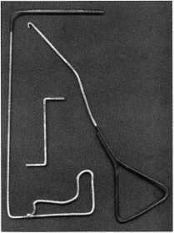

Door Controls International

Door Controls  
International  
announces our  
new champion  
lever trim. UL  
certified  
ANSI/BHMA  
156.3—1994,  
grade 1. The  
08L lever trim is  
to work in

conjunction with our fire rated security  
alarmed rim exit device, Pannex. The vandal  
resistant lever is available for standard or  
narrow stile doors, and can also be supplied  
with electric release. Phone (313) 426-0400.

Reader Service #22

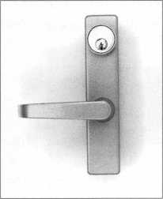

Custom Key Tags

Every dollar  
counts, so let us  
help you keep  
your customers  
coming back.

Key Tags are an  
inexpensive way  
to advertise and  
keep your  
customers  
coming back to  
you. Add a tag

to a set of new keys or key chain and the next  
time your customer needs a new key cut,  
they’re sure to remember you. We customize  
key tags to hold your store’s name or logo on  
one side and telephone number on the other.

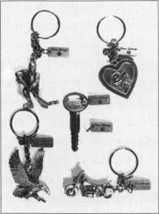

Each key tag is made from buffed pewter and measures 3/8"x7/8" in size, and comes with its own ring. Our minimum order is 250 @ $1.20 each = $300.00 including set-up charge. Simply send us your store name and telephone number and we’ll do the rest: Milman Manufacturing, at either Commercial Street, Box 113, Roxboro, Quebec H8Y 3E8, Canada; or Champlain Mall Rd., P.O. Box 1641; Champlain, NY 12919; USA. Phone (514) 425-5794 or fax (514) 425-5793.

Reader Service #23

"Urban

Diskus® is

available in a

rekeyable

the 24RK/70. An

stainless steel lock

to attacks by boltcutters, hacksaws, pry bars, and hammers. The shackle is chrome hardened moly steel that's even tougher than our boron steel shackle, and it's double deadlocked for additional strength. The body of this Diskus® is a solid 2.2 mm thick. Compare that to cheap knockoffs, that are only around 1.5 mm thick. You can remove

and inner mechanism make the Diskus® The "key" difference this lock's cylinder in only 3 seconds, the "go to" padlock when you need ’n^is Diskus® is its jhe rekeyable 5-pin tumbler cylinder

maximum security, with real resis- rekeyable cy in er. tm|y makes our Qjskus® the best solu-

tance to harsh environments. It has tion for your most difficult security

been tested to over 6,000 lbs of problems,

pulling force. And the patented design ^The Diskus® 24RK/70 and repinning of the new rekeyable Diskus® is virtually impervious kits are available at full-line ABUS distributors.

Now Our Diskus9 Is Rekeyable!

**Made in Germany • ISQ-9000 certified**

ABUS Lock, USA 3555 Holly Lane North Plymouth, MN 55447-0507 800-352-2287

Contact any of these full-line ABUS distributors for same-day shipment!

Accredited Lock & Supply

East Coast 800-652-2835

Clark Security Products

New England 800-746-5625

Washington, DC 800-578-5625  
Denver 800-282-5625

San Diego 800-854-2088

Chicago 800-755-5625

Seattle 800-942-5275

|  |  |
| --- | --- |
| Bells Security  East Coast | 800-772-2266 |
| Hans Johnson  Southern Area | 888-879-1500 |
| IDN - Hardware Sales | |
| Livonia | 800-521-0955 |
| Locks Company  Miami | 800-288-2801 |
| McDonald Dash  Southern States | 800-238-7541 |

R & H Supply

Northern CA 800-367-5625

Stone **&** Berg

New England 800-225-7405

Worldwide Lock Supply

Los Angeles 800-729-5444

Zipf Lock Company

Ohio Valley 800-848-1 577

**Call toll-free: 1-800-352-2287 Visit our Web site: <http://www.abus.com>**

Reader Service #24

May 1998

Keynotes

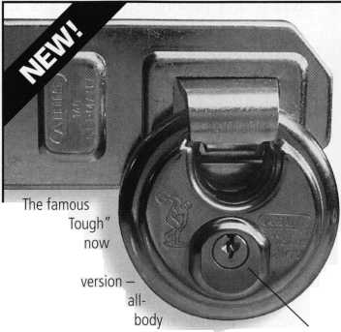

|  |  |  |
| --- | --- | --- |
| P] | d in> | Report |
| tvr | p-—— |
|  | | g David Lowell,  CML, CMS  PRP/Education Manager |

Proficiency Registration Program

Available to locksmiths worldwide, ALOA’s proficiency registration program (PRP) evaluates  
the educational and technical competence of dedicated individuals in 36  
categories such as hardware installation, high security and safe/safe vault locks, master keying,

alarms and access control devices. There are four levels of PRP certification:

Registered Locksmith (RL)

Certified Registered Locksmith (CRL)

Certified Professional Locksmith (CPL)  
and Certified Master Locksmith (CML)

PRP DATES *Two week application period.

May 10,1998

Washington, D.C.

Clark Security Products Terri Burges [800] 854-2088 May 16,1998 Boston, Mass.

North Bennett Street School Jack Hobin, CPL [617) 227-0155 May 23,1998

King of Prussia (Valley Forge], Penn. SAFETECH

David M. Lowell, CML, CMS [214] 827-7233

May 31,1998

Chicago, III.

ALOA Education Conference at ISC David M. Lowell, CML, CMS [800] 532-2562 June 18-19,1998 Nashville, Tenn.

ALOA ’98 Security Expo David M. Lowell, CML, CMS [800] 532-2562

30-day application period required August 2,1998 St. Charles, III.

Clark Security Products Terri Burges [800] 854-2088 September 2,1998 New York, N.Y.

ALOA Education Conference at ISC David M. Lowell, CML, CMS [214] 827-1701

September 13,1998

Philadelphia, Penn.

Greater Philadelphia Locksmiths Association

William L. Young, CML

[610] 647-5042

September 20,1998

Burbank, Calif.

Clark Security Products Terri Burges [800] 854-2088 September 20,1998 Plymouth, Maine Doyle Lock Supply, Inc.

Paul M. Justen [612] 521 6226 October 4,1998 Independence, Ohio POLA

Martha Eggler [216] 676-8464

October 18,1998

Omaha, Neb.

MINK Locksmith Convention Elmer Howard [402] 330-8701

October 23,1998

Portland, Ore.

Tri-Regional Locksmith Convention John Kerr [503] 253-0424

At the moment, we are trying to ensure that everyone gets their PRP registration confirmations as promptly as possible.

More than likely, if you fax your registra­tion, you’ll receive a confirmation within the next day. If you mail in your confirmation, then it will probably be within a week’s time before you hear back from us, depending on where you’re located.

If you fax us and have not heard from us within 24 hours, don’t hesitate to call. In fact, call immediately. The same rule should apply to mail-in registrations except to grant us a few days to receive it, etc.

As if I had to tell you, your confirmation is extremely important. There have been cases in the past where people show up for their exams without a confirmation and find themselves in a very inconvenient position. Of course, we do take precautions for such occasions by packing “emergency kits” that will register a test taker on-the-spot. But don’t rely on those kits as there may not be enough on hand for everyone whose registration has not been processed.

As mentioned in the Focus on Education column, PRP tests can be taken right here in the Dallas office and proctored by none other than myself. Aside from that, you’ll even receive a reduced rate on your test fee.

At the moment, we are working to get more proctors, so test takers don’t have to travel out of their way should one not be available in their area. One of the areas, we know there are no proctors in is Alaska. Rest assured, this is an important issue that I’ve been investigating and will keep you updated on future developments.

Once again, please follow up on your registrations by calling us at (214) 827-1701.

Notice

If you faxed or emailed your PRP registration and did not receive confirmation within 24 hours, please contact the ALOA office at (214) 827-1701.

New Certifications

New CPLs

Davies, Glen I./Bloomfield, NJ Griffith, Randy J./Caledonia, Wis.

Lawyer, John H./Champaign, 111.

Smith, Drew A./Valley View, Ohio

New CRLs

Andrews, Kenneth N./Lake Charles, La. Bradford, Roger K./Las Vegas, Nev. Cintorino, Daniel R/Middle Island, NY Donnelly, Charles E./Stone Ridge, NY Ferraro, William A./Hasbrouck Heights, NJ Gruber, James E./Chicago, 111.

Hegel, Chuck/Wis Dells, Wis.

Jensen, Robert M./De Moines, Iowa Klejmont, Michael F./Edison, NJ Lavigne, Joseph W./Edison, NJ Leggore, Gerald A./Middletown, Pa.

Luther, Joseph A./Plainsboro, NJ Monroe, Mattheu L./Lansing Mich.

Nicholas, Michael W./North Wales, Pa. Noble, Robert C./Fort Gratiot, Mich. Rabinowitz, Arnold D./Newfoundland, NJ Selzner, Clayton D./Runnels, Iowa Skoog, Dan W./Brick, NJ Summerlin, Robert E./Brandon, Miss. Thiessen, John T./Oakridge, NJ Thoren, Christopher/Charleston, Iowa Van De Brake, Marlyn D./Holland, Mich. Whitlow, Mark Brian/Wankesha, Wis.



About the Manager: David Lowell,

CML, CMS, is ALOA’s immediate past president  
and an ALOA Trustee. David has served on the

ALOA board for 10 years. He owns and operates Phoenix Lock & Key in Arizona, and has been an ALOA member since 1981.

Keynotes

May 1998

Chapter

Roster



Dept

**Y rhe best way to leam about ALOA’s programs  
and to network with locksmiths in your area is by  
participating in local ALOA chapter activities. This  
is your opportunity to exchange management and  
technical information, build your professional image,  
and share trade tips with your fellow locksmiths.**

**If you want to start a chapter in your area, please  
call ALOA, (214) 827-1701.**

Alabama

Alabama Locksmiths Association

2980 Hartford Hwy, #2 Dothan, AL 36305 (334) 793-5060 *James Turner, CPL- Chairman

Arizona

Grand Canyon Chapter

South West Region 3114 N. 68th Street Scottsdale, AZ 85251 (602)425-9566 *John Ilk, CRL-Chairman

California

Los Angeles/

Orange Counties Chapter

P.O. Box 697

Alhambra, CA 91820-0697 (562) 869-2555 *John H. Cosby, CPL

San Diego Chapter

1049 Island Ave.

San Diego, CA 92101-7228 (619) 234-4829 Burt Fieser-Chairman

Colorado

Colorado Front Range

2055 26th St.

Boulder, CO 80302 (303)443-9740 John I. Shandy, CML- Chairman (303)443-9740

Connecticut

Nutmeg Chapter

Phil’s Lock Shop 360 E. Main

Meriden, CT 06450-6022 (203) 237-4602 Phillip Hobbs, CPL- Chairman

Florida

South Florida Chapter

1710 NE Miami Gardens Dr. Miami, FL 33179 (305) 944-0469

*Jerri Moeller, CRL- Secretary

Paul Renderer, CML- Chairman

Georgia

Georgia Chapter

P.O. Box 48088 Atlanta, GA 30362-1088 (404) 455-6244 Michael D. Robinson, CRL- Chairman

*M.W. Whitman, Jr.

Hawaii

Hawaii Chapter

Beaumont-Reiz Co.

P.O. Box 88225 Honolulu, HI 96830-8225 (808) 623-5914 *David Reisz, CRL— Chairman

Indiana

Central Indiana

1237 Wabash Ave.

Terre Haute, IN 47807 (812)234-6249 *Herbert Dusenberry, CML— Chairman

Northern Indiana

P.O. Box 2469 Elkhart, IN 46515-2469 (219) 347-1754 *Steve Youngblood— Chairman

Southern Indiana

P.O. Box 185 Bloomington, IN 47402-0185 (812) 334-3737 *Daniel W. Hill, CML- Chairman

Kentucky

Kyana Chapter

510 E. Parrish Ave. Owensboro, KY 42303-3125 (502) 684-5093 *Timothy Morrison, CML-Secretary

Maryland

Chesapeake Chapter

205 Cleveland Ave. Baltimore, MD 21222 (410) 633-0111 *Bob De Weese, CPL- Chairman

Massachusetts

Massachusetts Chapter

200 Weir Street Taunton, MA 02780 (508) 823-4649

* Stephen Ehrlich, CML- Treasurer

Minnesota

Minnesota Chapter

3M Center Bldg. 223-BE-04 St. Paul, MN 55144-1000 (612) 733-6674

* Douglas Rude, CRL

Montana

Montana Chapter

Mountain Locksmithing 210 N 7th Bozeman, MT 59715 (406) 586-5187 *Jim Morrissey, CRL- Chairman

Carol Morrissey, CRL— Secretary

Nebraska

Nebraska Chapter

343 W. 2nd St.

Hastings, NE 68901 (402)463-6661 *Brad Boden

Nevada

Sierra Nevada Chapter

C/O Pamela Vankirk P.O. Box 115 Reno, NV 89504 (702) 328-9285 *Danniel F. Howard, CML-Chairman

New Jersey

Garden State Chapter

106 Ridgedale Ave. Morristown, NJ 07960 (201) 538-2737

* Steve Frei, Chairman

New Mexico

New Mexico Chapter

917 2nd St. NW Albuquerque, NM 87102 (505)242-1380

* Evelyn Wersonick, CML Marc McGrannahan,

Chairman

Sunbelt Chapter

South Central Region 1750 E. Lohman, Ste. C Las Cruces, NM 88011 (505)523-7147 *Joe Triste—Chairman

North Dakota

North Dakota Chapter

Rte. 1 Box 67 Devil’s Lake, ND 58301-3907 (701)662-5625 *James H. Strong, CRL

Ohio

Ohio North Coast Chapter

#2 Horseshoe Drive Monroeville, OH 44847 (419)465-4153

* Ronald Betschman, CML- Chairman

Ohio Valley Chapter

144 Julep

Cincinnati, OH 45218 (513) 825-7528 *James T. Brickler, Chairman

Pennsylvania

Keystone State Chapter

3 W 4th St.

Bridgeport, PA 19405 (610) 272-9292 *Barry Leas, CRL

South Dakota

South Dakota Chapter

402 S. Minnesota Ave.

Sioux Falls, SD 57102 (605) 331-6026

* Ronald Heidzig- Chairman

Tennessee

Smokey Mountain Chapter

2557 Middle Creek Rd. Pigeon Forge, TN 37863 (615)453-8344 *Jessie Swan, RL

West Tennessee

1261 Wellsville Rd. Memphis, TN 38117 (901)685-1130 *John Singleton

Texas

Sunbelt Chapter

1750 E. Lohman, Ste. C Las Cruces, NM 88011 (505)523-7147 *Joe Triste-Chairman

Washington, DC

Washington, DC Area

2987 Thomas Rd.

Bryan Road, MD 20616 (301) 283-0145 *William Smith, Jr., CML- Chairman

Wisconsin

Fox Valley Chapter

1425 N. Richmond St. Appleton, WI 54911 (920) 731-5400 e-mail [sageinc@athenet.net](mailto:sageinc@athenet.net) *John F. Engel, CRL- Chairman Matt Swoboda- Vice Chairman

Indianhead Chapter

201 N. Barstow St.

Eau Claire, WI 54703-3525 (715)832-4207 *John Dorsey, CPL- Chairman

Wyoming

Wyoming Chapter

1026 Alger Avenue

Coty,WY 82414

(307)527-5513

*J. Allen McCumber, CML

International

Chapters

Korea Chapter

Suh Man Soo, President

*Joe J. Lee

5430 Howland St.

Phila., PA 19124 Phone and fax: (215)744-5254

* Denotes contact person for this chapter.

All questions regarding chapter activities, meetings and events should be directed to this individual.

May 1998

Keynotes

|  |  |
| --- | --- |
| ALOA | / |
| Extra | \ |

- Dept

Need Help With Nashville?

ALOA had to release the unbooked rooms in its convention block at the Renaissance Hotel in Nashville on May 10. If you decide late to go the convention and have trouble finding a room, call the Nashville Visitors Center at (615) 259-4700. They’ll do their best to help you get situated. Hope to see you at ALOA ’98!

Rules for the Annual Membership Meeting

One more time! Plan to be at the membership meeting on June 20 in Nashville, TN. You’ll be voting on new bylaws (which enable members to vote by mail in the future) and the right to elect the directors from your own regions.

Breakfast is at 6:30 am, the meeting starts at 8:00 am. Following are the rules of the meeting:

1. Identification will be required for admittance — ALOA membership card preferred.
2. Ballots must be surrendered at the door by any member leaving before the election is held. The ballot will be returned upon re-entry.
3. Members wishing to speak shall approach a microphone and wait to be recognized. When recognized, the members shall state their names, membership number and city. Discussion will be limited to three minutes per subject per member.
4. Non-members must obtain a guest badge at the door and wear it prominently on their person.
5. Guests may only address the chair at the request of the President.
6. Elections will be by paper ballot. The election for all vacancies on the board will be conducted simultaneously. A candidate may appear on the ballot for only one vacancy. Therefore, once a person has been nominated for a vacancy, they may not be nominated for another.
7. Nominations may be made by any member present. Nominees must be qualified by the secretary at least 24 hours prior to the start of the membership meeting.
8. Each nominee is entitled to a nomination and two seconding speeches, limited to three minutes.
9. Candidates nominated by the ALOA Nominating Committee are entitled to two seconding speeches, each limited to three minutes.

In Memory

ALOA recently bid a reluctant farewell to Joseph Romano. Both an ALOA member and a SAVTA member, Romano had been employed at County Locksmith in Randolph, NJ.

Frank Veirs passed away at the age of 69. Frank had been an ALOA member since 1971 and was employed by IMA U.S. Government in White Hall, Md.

ALOA also said good-bye to one its earliest members, Harry Driver of Dunn North Carolina. Driver was one of ALOA’s remaining three-digit members, #586.

George LaCroix left this world at the age of 75. He had been an ALOA member since 1982 and was employed at Capistrano Lock and Safe in San Juan Capistrano, Calif.

Keith Purdy will be missed. He passed on at the age of 66. He had worked at R&K Locksmithing in Marble Hill, Mo.

ALOA lost another dear member in Ted Levine. Ted was 47 years old and worked at Mainline Security in San Francisco.

Warranty Work

Here’s a tip for everyone:

When servicing equipment that is covered by a manufacturer’s warranty, be sure to remind your customers that it covers only parts and not the additional labor. This will avoid arguments and miscommunication between all involved parties.

Need to Photocopy A **Keynotes** Feature?

We’ve gotten many compliments on the way the magazine looks (and thank you, by

the way). Sometimes we get a request from a chapter leader or an instructor who want to photocopy a feature for a class (or customer) handout and wants a plain black-and-white version with just the text (and photos for how-to features). Those are available by contacting Mike Emery on the magazine staff. Send a 9x12 self-addressed, stamped envelope with the name of the article you need along with the issue date and page numbers. (If you don’t provide all the information needed to find the article, your request may be delayed or may not be possible to fill.) Allow two weeks to receive your copy.

Follow Up on PRP Registration!

Please! If you have fax or email your PRP registration and do not receive confirmation within 24 hours, please contact David or Ashley at the ALOA office at (214) 827-1701.

Hint Word List

Following are the “hint” words for the

|  |  |
| --- | --- |
| crossword puzzle on page 60. | |
| Baseball | Bases |
| Batter | Catcher |
| Double | Foul |
| Glove | Grand Slam |
| Homerun | Runs |
| Shortstop | Single |
| Steal | Strike |
| Team | Triple |
| Umpire |  |

|  |  |
| --- | --- |
| r  Keynotes Advertisers Index  RS# Advertiser | Page |
| 24 Abus | 55 |
| 19 BWD | 21 |
| 1 ISC | 1 |
| 100 Jet Hardware Mfg., Inc. | BC |
| 25 Locknetics Security Engineering insert | |
| 20 Locksmith Publishing | 29 |
| 25 STRATTEC Security Engineering 59 | |
| 2 Timemaster | 7 |
|  | |

Keynotes

May 1998

NAME

COMPANY

ADDRESS

CITY

STATE

HOW MANY LOCKSMITHS AT THIS LOCATION?

ABOUT WHAT PERCENTAGE OF YOUR BUSINESS IS AUTOMOTIVE?

FREE CAPPING TOOL

MANUFACTURER'S SUGGESTED RETAIL PRICE $65.oo*

When you buy $200 worth of Ford original keys, we’ll send  
you a Ford 8-cut capping tool at absolutely no cost. Designed  
specifically for Ford 8-cut locks, this capping tool does the job  
quickly and easily. It’s safer and faster than using a screwdriver,

and it offers the secure, custom fit available only from the  
original equipment manufacturer. But supplies are limited,

so call your distributor and place your Ford original key

order now. Then simply fill out the information  
form below, and return it along with the receipt or  
invoice from your Ford original key purchase to:

Capping Tool Special  
Strattec Security Corporation  
3333 West Good Hope Road  
Milwaukee, Wl 53209

**SEE US AT ALOA BOOTH #426**

Mail form to:

Capping Tool Special Strattec Security Corporation 3333 West Good Hope Road Milwaukee, Wl 53209

(Please allow 4-6 weeks for delivery of capping tool. Receipts from your distributor must be dated between May 1 and July 31, 1998. This promotion ends July 31, 1998, or when capping tool supply is exhausted.)

|  |  |
| --- | --- |
| PART# | DESCRIPTION |
| 321202 | FORD ROUND HEAD KEY (5-PIN) |
| 321207 | FORD SQUARE HEAD KEY (5-PIN) |
| 321645 | FORD SQUARE HEAD KEY (10-CUT) |
| 321648 | FORD LARGE HEAD KEY (10-CUT) |
| 596758 | FORD MOLDED HEAD KEY (10-CUT) |
| 597638 | FORD MOLDED HEAD KEY (8-CUT) |
| 598333 | FORD TRANSPONDER KEY (8-CUT) |

*In Canada, prices subject to dollar exchange.

BUY $200 WORTH OF FORD OR/tyMl KEYS, GET A FORD 8-CUT CAPPING TOOL - FREE!

Reader Service #25

IwJ [wl

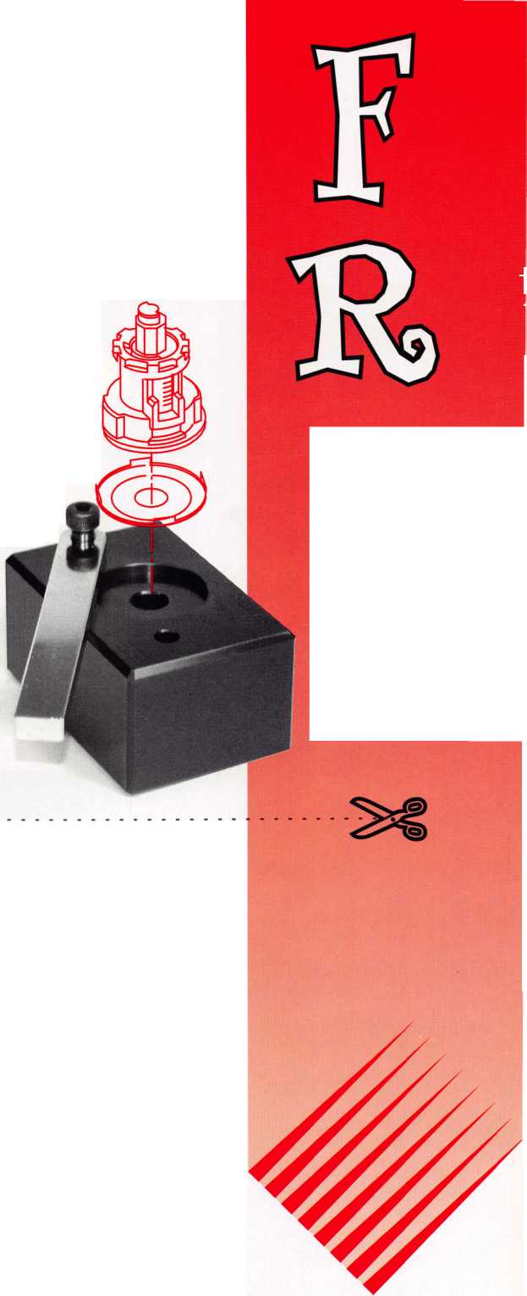

Baseball!

Across Clues:

Down Clues:

By Stam Spiivak

Hints on page 58.

Answers to last month’s puzzle:

Keynotes

May J998

3. Infield position 5. Four-base hit

8. Horesehide sphere 10. Swipe

1. Official
2. Three-base hit

15. Baseball stations

1. Four RBIs on one hit
2. Hit wide of base line
3. Two-base hit
4. Part of battery'
5. Aid in catching ball
6. Club wielder
7. Swing and miss 11. Scores

13- Nine players

|  |  |  |  |  |  |  |  |  |  |  |  |  |  |
| --- | --- | --- | --- | --- | --- | --- | --- | --- | --- | --- | --- | --- | --- |
|  |  |  | M | 1u | 2m | b| | 0 | IeI | E | Isl |  |  | B3yI |
|  |  |  |  |  | 0 |  |  |  |  |  |  | H | IaT |
|  |  |  |  |  | [il |  |  |  |  |  | E | E | TL~l |
| n | nj | E | E | E | T | E | E |  |  |  |  | M | |~e| |
|  | | | | | E |  |  |  |  |  |  | 0 |  |
| r | E | E | E | E | R | T | m | E | E | E | E | p | 1 |
|  |  |  |  |  | K |  |  |  |  |  |  | 0 |  |
|  |  | E | E | E | E | E | E |  |  |  |  | 0 |  |
|  | 0 |  |  |  | M |  |  |  | E | E | E | i |  |
|  | m |  |  |  | 0 |  | n |  |  |  |  | 0 |  |
|  | 0 |  |  | E | E | E | 0 | E |  | B |  | 0 |  |
|  | 0 |  |  |  |  |  | 0 |  |  | pn |  |  |  |
|  |  |  |  |  |  |  | 0 |  |  | E | E |  | | A1 Y | |
|  |  |  | rn | 0 | E | E | 0 |  |  | 0 |  | | |

|  |  |  |  |  |  |  |  |  |
| --- | --- | --- | --- | --- | --- | --- | --- | --- |
|  |  |  |  |  | r |  |  |  |

|  |  |  |  |  |  |  |  |  |
| --- | --- | --- | --- | --- | --- | --- | --- | --- |
| r |  |  |  |  |  |  |  |  |

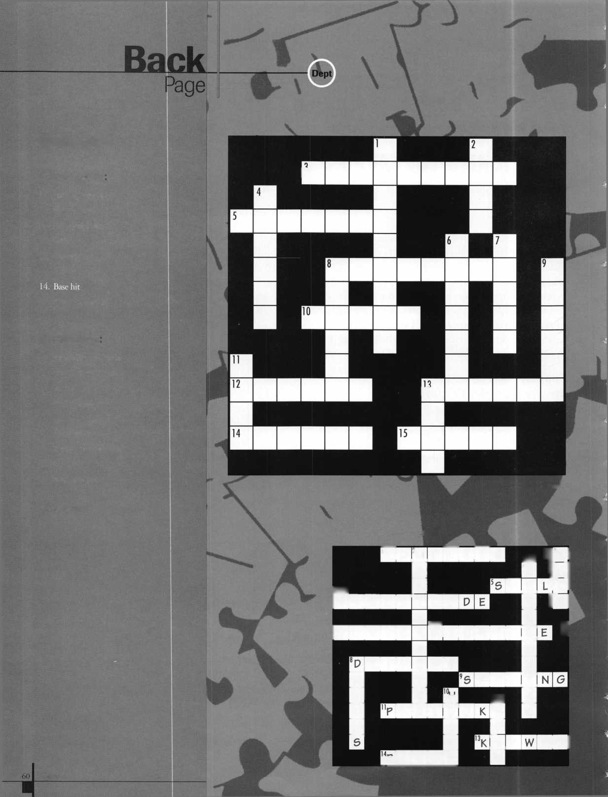

TRAINING

**We’re Right Behind You.**

Locksmithing is at war with big business.

But you have more firepower than you realize.

Your fellow locksmiths joined forces more  
than 40 years ago, understanding the need  
to fight battles together. Today, benefits of  
membership in the Associated Locksmiths  
of America, Inc. have grown far beyond

the early vision, but they still rest on one  
enduring truth: Strength in numbers.

Your best chance of surviving the struggle  
ahead is being a part of an organization  
with others like yourself. Through our  
common voice we will refuse to be

legislated out of business.

As a united front, we can command technical advice from world-renowned instructors and authors who know how to make our business boom.

It starts with you.

It ends with all of us together.

Recruit a member today.

For a supply of membership applications, contact:

Associated Locksmiths of America, Inc.

3003 Live Oak Street, Dallas, Texas 75204 Voice: 214.827.1701 Fax: 214.827.1810

Email: [aloa@anet-dfw.com](mailto:aloa@anet-dfw.com)

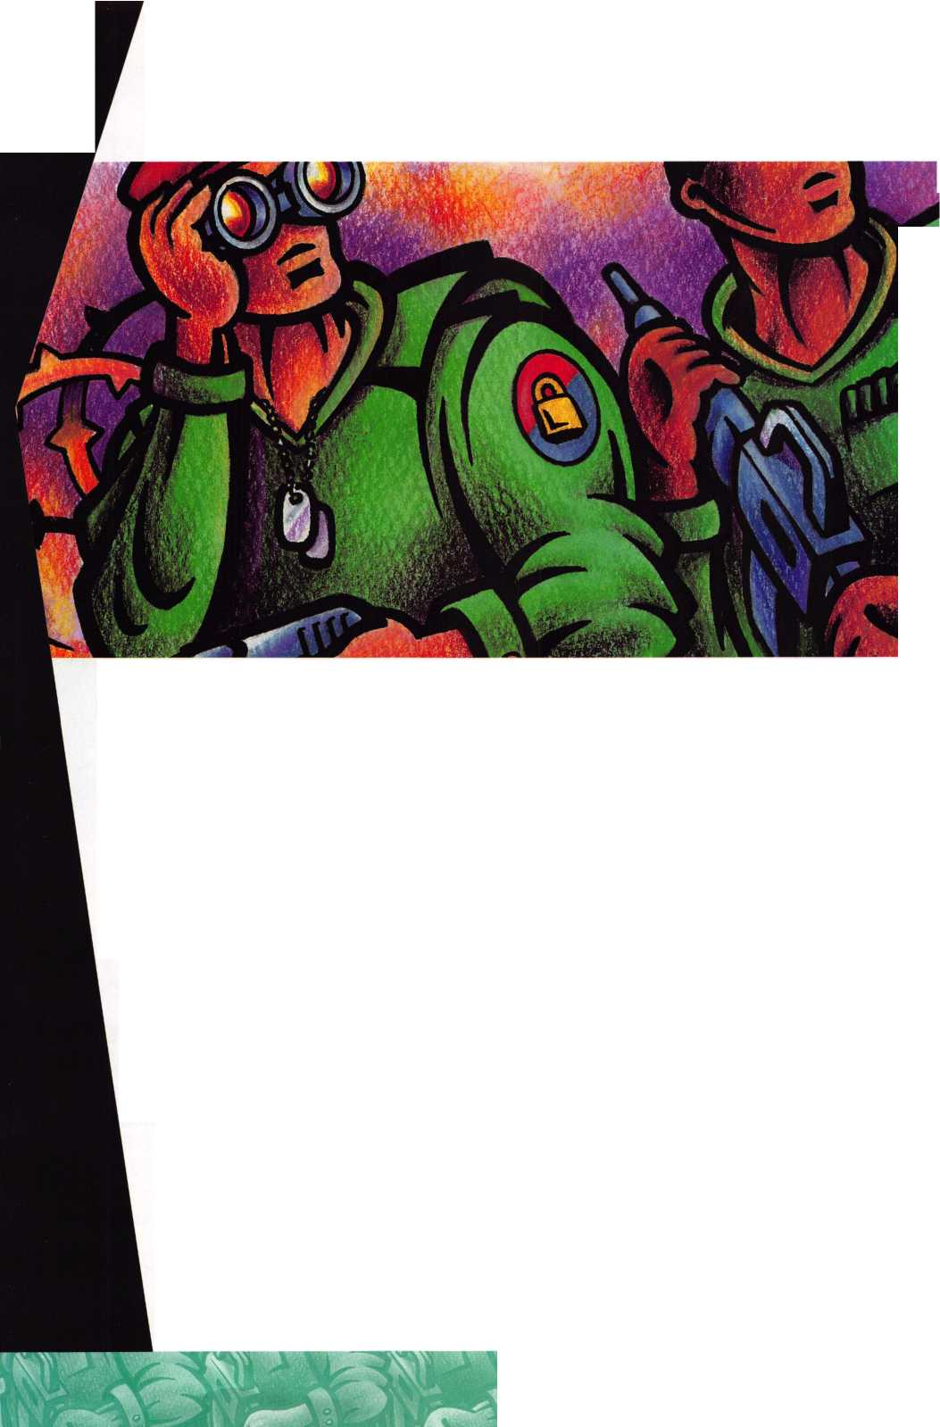

**Don't Be Locked Out of the Electronic**

**Key Market**

**Oil!**

r



**The Jet etd-1...**

Transponder Key Duplication made Easy.

Don’t be locked out of the growing market of electronic, anti-theft automotive security.This easy-to-use decoder quickly and accurately duplicates the most popular transponder keys, including: CADILLAC CATERA, HONDA, ACURA, MAZDA and AUDI /VOLKSWAGEN. Included with your purchase are 5 each of the above keys (a value of $ 295.00), along with a colorful window decal.

Available through your favorite JET distributor.

JET HARDWARE MANUFACTURING CORP

800 Hinsdale Street, Brooklyn NY 11207

